2022 Londonderry Senior Informational Expo Transportation NEeds Survey Results
  - Benjamin Herbert, Region 8 Mobility Manager
603-669-4664 | bherbert@snhpc.org
  - Southern New Hampshire Planning Commission
438 Dubuque Street
Manchester, NH, 03102

Background
In October 2022, the Londonderry Senior Resource Committee held their first annual Londonderry Senior Informational Expo at Londonderry High School. Here, a table was set up to survey attendees on their transportation needs. Surveys were conducted via paper forms and note cards with a QR code on them. An example of the note card is provided below. The purpose of the survey was to identify:
- Transportation needs for individuals who are unable to drive themselves.
- Knowledge and utilization of existing transportation services.
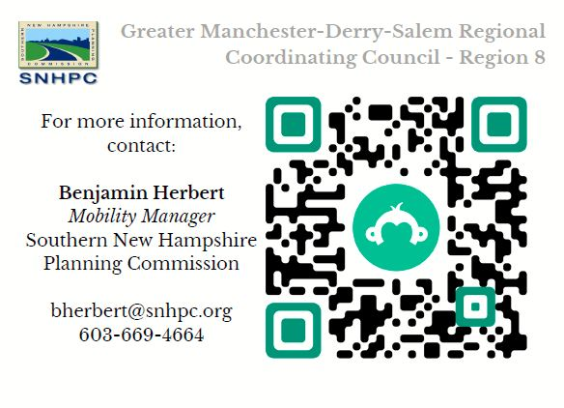
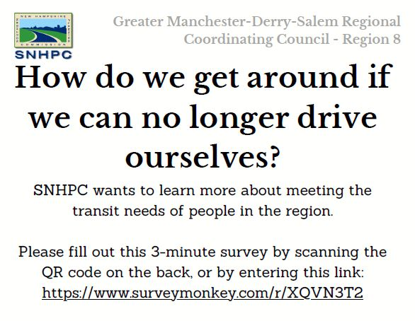
21 individuals responded to the survey.
Figure 2: Survey Notecard (back)
Figure 1: Survey notecard (front)

Survey Summary
- 18 out of 21 survey respondents (85.7%) live in Londonderry.
- Over a third of respondents need to travel to Londonderry, Manchester, and Derry during their weekly routine.
- Respondents identified 18 different locations they travel to on a weekly basis.
- Outside of a weekly routine, 42.9% of respondents would like to travel to Boston. 28.6% would travel to Concord or Portsmouth. Locations in Massachusetts had more responses than locations in New Hampshire.
- 85.7% of respondents still drive themselves for their daily routine. Rides from relatives/friends and walking each had 6 responses (28.6%).
- When asked if they couldn’t drive themselves, 76.2% of respondents found it “difficult” or “very difficult” to get around.
- Among respondents, the most common reason for not using community transportation services was not knowing any available services (28.6%). 23.8% also indicated that they would prefer driving alone. 19.1% were unsure how transit services work or were too nervous to use them.
- 15 respondents (71.4%) have not used any community transportation service. Boston Express had 2 users. Manchester Transit Authority, Cooperative Alliance for Regional Transportation, and Rockingham County Meals on Wheels each had 1 response.

Q1: Where do you live?
Out of the 21 responses:
- 18 live in Londonderry.
- 1 lives in Manchester.
- 1 lives in Windham.
- 1 declined to answer.

Q2: During your weekly routine, where do you need to go?
Respondents were able to give multiple answers. The majority of respondents indicated that getting around Londonderry and Manchester is a part of their weekly routine. 11 respondents (42.8%) also indicated that they need to travel to Derry as part of their weekly routine, and 4 (19.0%) need to travel to Pelham and Windham. 3 respondents (14.3%) need to travel to Massachusetts. The closest destination in Massachusetts is Methuen (17.5 miles) and the farthest is Newton (53.4 miles). Hanover, NH is the farthest destination out of all locations at 86.6 miles. 2 respondents skipped this question.

Figure 3: During your weekly routine, where within the region do you need to go?

Q3: Outside of your weekly routine, are there any other places you’d like to go?
Respondents were able to give multiple answers. Boston was the most popular choice for a destination, with 9 responses (42.9%). Portsmouth and Concord each had 6 responses (28.6%), and 4 respondents (19.0%) would want to go to Manchester. 3 respondents (14.3%) need to travel to Massachusetts. 8 respondents (38.1%) only want to travel to Massachusetts. 7 respondents (33.3%) would only travel within New Hampshire. 5 respondents (23.8%) would travel to both states. 2 respondents skipped this question.

Figure 4: Outside of your weekly routine, are there other places you'd like to go?.

Q4: What type of transportation do you use for daily life? This can include work, shopping, medical appointments, recreation, etc.…
Respondents were able to give multiple answers. The majority of respondents (85.7%) still drive themselves for their daily routine. Rides from relatives/friends and walking each had 6 responses (28.6%). Cycling had 3 responses (14.3%). A bus or taxi service each only had 1 response.

Figure 5: What type of transportation do you use for daily your daily routine?

Q5: Without your own car, how difficult is it to go where you need to go?
3 of the respondents found no difficulty in getting to where they need to go without their own car. 2 respondents indicated that it varies. 4 respondents said it would be difficult, and 12 respondents said it would be very difficult.

Figure 6: Without your own car, how difficult is it to get where you need to go?

Q6: If you have considered using community transportation options, why haven’t you?
Respondents were able to give multiple answers. Not knowing any services was the most popular response at 28.6%. 23.8% also indicated that they would prefer driving alone. 19.1% were unsure how they work or were too nervous to use them. 14.3% have no need for services. 9.5% said that times don’t fit their schedule, they’re concerned with costs, they’re concerned about their health accommodations, there’s no services where they live/need to go, and that they would have to use multiple services for one trip. 4.8% are concerned that they’re not eligible for any services.

Figure 7: If you have considered using community transit options, why haven't you?

Q7: What services have you used?
Respondents were able to give multiple answers. Out of 21 respondents:
- 2 use the Boston Express
- 1 uses Manchester Transit Authority (MTA)
- 1 uses Cooperative Alliance for Regional Transit (CART)
- 1 uses Rockingham County Meals on Wheels
16 respondents skipped this question.

