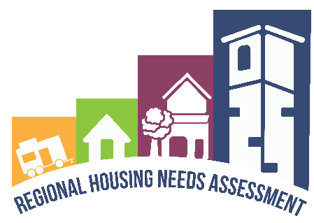
in`
 | Southern New Hampshire Regional Housing Needs Assessment
2023-2028 | SNHPC Regional Housing Needs Assessment
SNHPC’s Comprehensive Plan Housing Chapter Vision Statement
“The Residents of Southern New Hampshire have a preference for a range of different housing types and neighborhoods, but everyone values housing choices that are safe and affordable for all.”

Table of Contents
Section I – Aknowledgement 1
Section II - Executive Summary 2
Purpose of the Plan 2
Housing/Population Snapshot 2
Housing. 2
Population. 3
Key Issues 4
Recommendations 6
State and Federal Response to Housing Inequities 10
Future Housing Need 10
Resources/Toolkit for Municipalities (still under development) 10
Section III - Introduction 12
What is in the Regional Housing Needs Assessment? 12
Purpose of the Housing Needs Assessment 12
Fulfill Statutory Requirements 12
Fulfilling the Goals of the Council on Housing Stability’s Strategic Plan 13
The Housing Landscape 14
The Great Recession 14
Growing Inequality 15
Description of the Region and Geographic Context 16
Population density 19
Section IV - Existing Conditions and Historic Trends 21
Demographic and Socioeconomic Trends 21
Total Population 21
Households: Size, Type, Tenure 23
Employment by Industry and Location 25
Commuter patterns 27
School Enrollment Trends 28
Net Migration 29
Communities of Interest 29
Communities of Concern 42
Housing Unit Trends and Characteristics 45
Housing Inventory 45
Age of Housing Stock 47
Distribution of Workforce and Affordable Housing Units 47
Inventory of Income-Restricted Housing 47
The Housing Market (Cost and Affordability) 50
Housing Prices and Rents 50
Current Housing Gaps 60
New policies/laws enacted 61
Section V – Future conditions and housing projections 65
Impacts to Future Housing Supply and Affordability 65
COVID-19 65
Climate Change 66
Federal Monetary Policy 67
Construction Costs 68
Short-Term Rentals 69
Student FlucTuation in College Towns 70
Aging Populations/ Smaller HouseHolds 71
Demographic Changes 72
Housing Needs Projections 73
Fair Share Distribution 74
Methodology 79
Section VI – Housing Choices, Opportunities AND BARRIERS 82
Land Use Regulations and Other Controls 82
Exclusionary Zoning Practices 83
Review of Local Land Use Practices 87
Attitudes towards Growth 89
Innovative Policies & Techniques 91
Workforce and Employment Constraints 96
Workforce Attraction and Retention 97
Effect of job growth on housing needs 97
Transportation and housing 98
Commuting Times 100
Availability of Bicycle/Pedestrian Infrastructure 101
Water and Sewer 105
Service Coverage 107
Broadband 107
Overview: 107
Underserved Communities 107
Community Development 108
Childcare 109
Food Access 109
Parks and other Civic Resources 110
Housing related Health issues 111
Fair Housing Approaches 111
History of Fair Housing 112
Disparate Impacts and Discrimination 112
Initiatives to respond to unfair housing 114
Access to Opportunities 115
Areas of High Opportunity 115
Identifying Opportunity Areas 116
Framing approaches to access 117
Section VII – Housing Toolkit 118
Section IX - Conclusions 119
Next Steps for communities 124
Appendix A – Glossary of Terms A
Appendix B – Engagement Process B
Appendix B.1 – Engagement Documentation C
Appendix C – Quantitative Data C
Appendix D – Qualitative Data D
Appendix E – Regional Housing Entities and Services E

List of Figures
Figure 1: Canal Street Homeless Encamplement 15
Figure 2: SNHPC Member Municipalities 16
Figure 3: Regional Growth 18
Figure 4: Where The People Live 20
Figure 5: Older adult growth in SNHPC Region. Source: US Census Bureau 23
Figure 6: SNHPC Public School Enrollment by Municipality 28
Figure 7: Refugees by City of Resettlement (2012-2021) 31
Figure 8: Homeless Population 36
Figure 9: Equity Area 44
Figure 10: SNHPC Active Property Listings (12- Month Moving Average) 51
Figure 11: SNHPC Nominal Median Purchase Price (12- Month Moving Average) 51
Figure 12: Households by Income 52
Figure 13: Median Household Income 52
Figure 14: Percentage of Households by Area Median Income (AMI) in the SNHPC Region 54
Figure 15: Percentage of Households by Area Median Income (AMI) in NH 54
Figure 16: US Construction Costs Have Historically Not Driven the Rising Cost of Housing 59
Figure 17: New Hampshire's Population Growth Rate Over Time 73
Figure 18: SNHPC Age GroupS as a Percentage of the Total Population 73
Figure 19: Average Annual SNHPC Net New Housing Units 79
Figure 20: Home-Building Industry Survey Result 83
Figure 21: Title VI/EJ Population Concentrations for SNHPC Census Tracts 84
Figure 22: Average Property Value by Acreage Decile for SNHPC Single-Family Homes 85
Figure 23: Derry Single-Family Homes: Value per Acre 86
Figure 24: Chester Community Forum 92
Figure 25: Cost Burdened Households 100
Figure 26: How Transportation Decisions Drive Land Use 104
Figure 27: Off-Street Spaced Reserved for Parking in Manchester 105
Figure 28: Water and Sewer Service 106
Figure 29: Food Access Map 110
Figure 30: Radon Risk by County. 111
Figure 31: New Hampshire Housing Finance Authority Area Opportunity Index 117
Figure 32: General Public Survey Response on level of agreement for housing types 121

List of Tables
Table 1: Housing Unit Type as Percentage of Total Housing Units 2
Table 2: Percentage of Households Paying 30% or More of Their Income on Housing 4
Table 3: Total Population 21
Table 4: SNHPC Historical and Project Populations 22
Table 5: Minors per Household 23
Table 6: 2020 Persons per Household 24
Table 7: Owner Versus Renter 26
Table 8: Commuter Origin/ Destination 27
Table 9: Commuting Characteristics of Protected Classes 27
Table 10: Net Migration (2010-20) 29
Table 11: Percent of Residents 30
Table 12: Percent Racial or Hispanic/Latino Minority 31
Table 13: Percent of Population with a Disability 32
Table 14: Percent of Population Less than 18 Years Old 33
Table 15: Percent of Population 65 Years or Older 34
Table 16: Percent of Households Without a Vehicle 35
Table 17: Average Number of Homeless School Students 2017-2021 37
Table 18: Male Vs Female Residents 2020 39
Table 19: Dissimilarity Index: Comparision Between the Concentrations of Two Populations 41
Table 20: Communities of Concern 42
Table 21: Communities of Concern- Scoring Thresholds 43
Table 22: Density of Communities of Concern 43
Table 23: Total Housing units 45
Table 24: Housing Choice Voucher Program (Section 8) Participant Housing Units by Municipality 48
Table 25: NH Housing Finance Authority's Documented Assisted Housing Units 2022 49
Table 26: Percent Households by Area Median Income (AMI) 2020 53
Table 27: Rental Affordability by Occupation (Southern New Hampshire Planning Commission) 55
Table 28: Purchase Affordability by Occupation (Southern New Hampshire Planning Commission) 57
Table 29: Potential Homeowner Gap 61
Table 30: Total Population 72
Table 31: Fair Share Cumulative Net New Housing Units 75
Table 32: Fair Share Cumulative Net New Owner-Occupied Housing Units by Income 76
Table 33: Average Annual Net New Housing Units 77
Table 34: Average Annual Net New Housing Units (%) 78
Table 35: Housing and Transportation Costs as a Percentage of Income 100
Table 36: Mean Commute Time (Minutes) 101
Table 37: Walk and Bike Scores by Municipality 103
Table 38: Fair Housing Complaints in SNHPC Region 2014-2022 113
Table 39: HUD Discrimination Cases 2014- Q2 2022 114

Section I – Aknowledgement
As Executive Director of the Southern New Hampshire Planning Commission (SNHPC), I have been amazed at the coordinated effort that has guided and formed this work. It would take pages to acknowledge all the dedicated individuals and community champions who have contributed to this effort, but at the very least, please allow an acknowledgement of the many agencies and stakeholders.
Land Use Planners: First and foremost, a heartfelt thanks to the talented planners at the Office of Planning and Development (OPD) within the State Department of Business and Economic Affairs (BEA) and their fantastic consultant teams (Root Policy Research and Outwith Studio), the many experts at New Hampshire Housing, , all the thoughtful planners at the Regional Planning Commissions (RPCs) across the state, the exceptional planners at SNHPC, and those planners who dedicate themselves locally to individual communities. Your contributions to this work and guidance through all the challenges was truly amazing.
Agency, Business, and Institutional Partners: The topic of housing has dominated conversations on local, regional, and state levels with interest, support and insights coming from the building and finance industries, realtors and developers, educational leaders, transportation champions, social service providers, businesses of every sort, and of course nonprofits. Thank you for all you do and the innovative solutions you champion.
Local SNHPC Commissioners: A shout out to the dedicated Commissioners that represent SNHPC’s 14 communities. Thank you for all your assistance in this effort and especially your participation in community conversations which provided valuable insight into local housing challenges. Your dedication to your communities is inspirational.
Residents in the SNHPC Region: Housing is an emotional topic for many, and residents opened their hearts and shared their stories. We heard about single moms looking to find a safe home in a welcoming neighborhood, young adults graduating from college and trying to find housing near a new job, renters wanting housing near transit, shopping, and parks, and of course older adults with physical or mental challenges who need a final home as they age that would allow them to live the best quality of life possible. Thank you for sharing your stories and participating in the various outreach opportunities that were available during this process.
We look forward to assisting our communities in future housing endeavors; may we all rise to the challenge.
Sylvia von Aulock, SNHPC Executive Director

Section II - Executive Summary

Purpose of the Plan
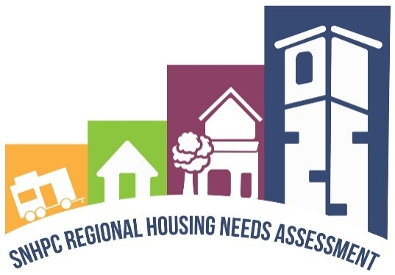
The purpose of this document is to identify and analyze baseline conditions for fair housing, equity, opportunity and housing needs in the Southern New Hampshire Planning Commission region. This housing needs assessment identifies and outlines key goals and recommendations for addressing housing needs in the region. These goals and recommendations are supported by the issues and needs identified through the RHNA public outreach process, in addition to the evaluation and analysis of background information and key data.

Housing/Population Snapshot
Housing. Housing supply in the Southern NH planning region is comprised predominantly of single-family homes, the majority of which are owner-occupied. With that said, several communities have increased their percentage of multifamily homes over the past decade including Bedford, Derry, and Hooksett. The communities with the highest percentages of housing units with two or more units are Manchester, Derry, and Goffstown.
Most often, the reason for a larger percentage of housing diversity is due to the existence of municipal water and sewer. Although well and septic systems are limiting, soil-based determination of lot size, unit density and even the number of bedrooms provides a scientific approach and provides confidence to those reviewing plans that the land can accommodate the use.
Resources:
- An excellent source of local statistics can be found here: https://www.nhes.nh.gov/elmi/products/cp/index.htm
- An excellent source of current stateside building trends can be found here:
https://www.nh.gov/osi/data-center/documents/housing-estimates-trends.pdf

Table 1: Housing Unit Type as Percentage of Total Housing Units
 | Housing Unit Type as % of Total Housing Units
 | 2010 |  | 2015 |  | 2020
 | Single-Family | 2 or More Units in Structure | Single-Family | 2 or More Units in Structure | Single-Family | 2 or More Units in Structure
Auburn | 95% | 2% | 92% | 8% | 96% | 4%
Bedford | 90% | 10% | 91% | 9% | 82% | 18%
Candia | 94% | 4% | 94% | 2% | 93% | 2%
Chester | 99% | 0% | 95% | 3% | 98% | 2%
Deerfield | 91% | 4% | 87% | 8% | 91% | 7%
Derry | 59% | 36% | 58% | 40% | 56% | 42%
Francestown | 93% | 6% | 92% | 4% | 87% | 10%
Goffstown | 68% | 26% | 69% | 27% | 71% | 26%
Hooksett | 80% | 16% | 78% | 18% | 74% | 23%
Londonderry | 81% | 15% | 80% | 15% | 82% | 16%
Manchester | 41% | 59% | 40% | 60% | 38% | 61%
New Boston | 89% | 8% | 90% | 8% | 86% | 10%
Weare | 87% | 7% | 85% | 10% | 88% | 8%
Windham | 93% | 6% | 94% | 6% | 92% | 8%
SNHPC | 61% | 37% | 60% | 38% | 59% | 39%
NH | 68% | 26% | 69% | 25% | 69% | 26%
5-Year American Community Survey
Source: US Census Bureau

Population. The total population of the region has increased by approximately 13.5% since 2000. Aside from overall growth, significant population shifts are found within the various age cohorts. For example, the numbers of youth (18 and under) have decreased in each of the region’s communities. Rural and urban communities alike on average have only 0.53 minors per household. Similar to the nation, the region’s older population (65 and over) has increased. The region’s disabled population comprises of approximately 12 percent of the total population. As the state ages, one can expect the disabled population to increase as well.
The population of the region is projected to grow by 11% over the next 20 years. Trend data for births and deaths are used to develop the population projections that are further broken down by various components, such as age, sex, and household size. This information, along with trend data for housing stock, is used to predict future housing need. This information is detailed in Section IV page 25.
In addition to including basic Census data on numbers and ages of the population, this report identifies “Communities of Interest” and “Communities of Concern.” These are people who, for various reasons, are considered to be at amplified risk of housing discrimination; they include minorities, immigrants, low-income residents, older adults, and people with disabilities. This report analyzes their status and includes state and federal programs aimed at protecting these classes of people.

Key Issues
- Looking at the Numbers:
  - Changing demographics
The two most prominent ways the demographics of the region are changing are reflected in age and race/ethnic composition. The percentage of younger people is decreasing while the percentage of older people is increasing. This is a regional as well as statewide trend observed for at least a decade in New Hampshire that has implications for housing availability and housing needs at all levels.
Ethnically, the region remains predominantly White and non-Hispanic or Latino, although this ratio is shifting, with the number and percentage of minorities increasing over the last decade. Today around 17% of SNHPC residents are a racial or Hispanic or Latino ethnic minority, up from around 7% in 2000.
  - Increase in households that are “housing burdened”
A household that is considered “burdened” is one that is paying more than 30% of its income on housing. In the Southern NH region, 48% of households responding to the general public survey judge themselves to be housing burdened. Not surprisingly, the lower the income, the greater the burden. When transportation costs are factored in, this burden is even greater. Based strictly on Census data, housing burden is 31% regionwide.
Demand for housing in the SNHPC region greatly outweighs the current supply. Between 2020 and 2030, the SNHPC region is expected to add, on average, around 1,320 new housing units each year or an annual growth rate of 1.1%. Increases slow significantly between 2030 and 2040. This slowdown reflects decelerating population growth due to an aging population and a more balanced housing market.

Table 2: Percentage of Households Paying 30% or More of Their Income on Housing
 | 2020
 | % of Households Paying 30% or More of Their Income on Housing Costs
 | All Households | Households Making $75,000 or More
Auburn | 27% | 19%
Bedford | 23% | 8%
Candia | 33% | 9%
Chester | 22% | 11%
Deerfield | 24% | 7%
Derry | 32% | 9%
Francestown | 18% | 6%
Goffstown | 25% | 4%
Hooksett | 28% | 7%
Londonderry | 25% | 7%
Manchester | 38% | 4%
New Boston | 22% | 9%
Weare | 28% | 15%
Windham | 26% | 11%
SNHPC | 31% | 7%
NH | 31% | 7%
5-Year American Community Survey
Source: US Census Bureau

- Regional and Local Challenges:
  - Housing demand, housing need, affordability and housing development
    - The issue of housing affordability is central to this report. Wages have not kept up with the cost of housing. The Southern NH region, as well as the entire state, has been and continues to struggle against a severe housing shortage. Wage limitations and housing shortages, combined with construction challenges related to the COVID-19 pandemic, has contributed to the housing crisis and rising costs of home ownership and rentals.
    - The demand for all types of housing, as well as a robust range in the cost of that housing is not being met. The list of issues and roadblocks are long, and the pandemic only amplified and added to these impacts on costs. Financing challenges, labor shortages, zoning restrictions, and other long-standing issues have all contributed to a severe housing shortage and its related affordability.
    - Housing needs are changing as the characteristics of the population in the region are changing. Existing and new housing units: the quantity, styles and even the size of homes are not meeting the changing needs of individuals and families. The stories are common: young adults wanting to find work in the region, new families who are just beginning their relationship with New Hampshire and even with the country, or longtime residents hoping to downsize and stay in their community: there are few options for any of them. Although many families enjoy a single-family home, more people – both younger and older-- are looking for maintenance-free housing styles. Modest and affordable cottage or village style housing units are difficult to find yet are extremely desirable.
    - Rising costs and labor shortages related to construction have contributed to the lack of building. Again, the pandemic has had a tremendous effect on all these costs and shortages. Related to these costs are the risks and costs associated with the permitting process. Talk to a developer and often the story is the same: process delays, regulatory roadblocks, nay-saying abutters, and negative attitudes are among the many challenges they face. Some developers are reluctant to take on the risks of creating anything except single family homes on large lots.
  - Community values, land use boards, and guiding growth
Housing development often raises concerns regardless of the type of housing. Single family, cluster-style housing, duplexes, and especially multi-family housing applications all can trigger a neighborhood or even a community in rallying against new development.
Regardless of community size, one of the common community goals discussed during Master Plan updates is the desire to ensure community character is protected. Understanding what is meant by community character may be a key to defining how a community may want to grow. Some may be referring to the community’s aesthetics, charm, or way of life. If understood, community character and growth can be balanced by a guiding vision and complimentary land use regulations.
Land use boards have the ability to guide and to an extent determine housing styles, designs, density, and even amenities. Land use regulations determined by planning boards need to embrace community character, recognize housing need, and consider community growth. How to balance these key elements is the challenge planners and land use boards face.
- Resources and Education:
  - One critical component to planner and land use board success is ensuring state and regional support for educational opportunities, resources and assistance. With these tools, planners and land use boards can evaluate strengths and identify weakness such as updating their regulations, understanding their responsibilities, and meeting the challenges they face with the changing demands in housing.

Recommendations
For some, it may seem that there is just nothing to be done, the housing crisis is too big, the lift is just too heavy. However, we believe there’s plenty to be done and that by implementing even just a few of the following recommendations, improvements will be noted and eventually housing will be built.
- Begin with the Community Goals in Mind:
  - Beginning with the Master Plan: All good land use regulations begin with a master plan. The master plan is, in fact, the foundation for all of a town’s land use regulations. It is through the development and/or updating of a master plan that a community’s vision and housing goals and objectives are identified typically through a public process.
  - Regulation Assessment: Good practice for all land use boards is to periodically review land use regulations. It is not uncommon for master plans to be developed/updated on an infrequent basis, but zoning and other regulations are reviewed more frequently. To avoid a “disassociation” between the vision and goals of the master plan with ordinances and regulation updates that are developed more regularly, the planning board should regularly compare these fundamental planning products to ensure there are synergies.
  - Review progress made since the last RHNA: It’s always good to take a look at where you’ve been and where you are headed. Reviewing the recommendations from the last RHNA and taking an inventory of regulatory, process, or policy changes can help a community, Planning Board, and staff recognize the work that has happened over the years. This review can help guide resources and invigorate the next course of action in meeting housing challenges.
- Allow Flexibility in Regulations
  - Creating Flexible Regulations: One of the most common complaints from builders and homeowners is the time and expense of navigating the permitting system. Zoning tends to be rigid, with any deviation requiring relief from the Zoning Board of Adjustment. Not only is this a time and money investment, but there is also no guarantee that relief will be granted. An alternative to this is to craft ordinances and regulations that build in options for relief from the planning board that do not require a zoning board approval. A Conditional Use Permit, for example, allows the planning board to grant waivers or modifications, subject to certain criteria. This allows an applicant to get through the process with just one board, saving time and money.
  - Adaptive Reuse: Adaptive reuse means using or repurposing existing buildings for new uses – rather than tearing them down to build new. There are a number of examples of this approach across New Hampshire and within the Southern NH region; a few of them are:
    - In Manchester, hundreds of thousands of square feet of the old mill buildings have been reused for various uses including housing, commercial and institutional enterprises.
    - In Antrim, an old mill building is being renovated into apartments.
    - In Troy, an old mill building is being reused for a mix of residential and light industrial uses.
Innovative developers often take on additional risks when repurposing an old, often abandoned building. However, such risks can benefit an entire community, or at the very least, their downtown when the redevelopment breathes new life into the community with new residents and new businesses.
  - Allowing for In-Fill Development: Infill development refers to the development of underutilized or vacant land in existing urban- or otherwise-developed areas. It is meant to encourage density on existing infrastructure, as well as offer an alternative to sprawl. This approach can be extremely advantageous in addressing the housing shortage in a state like New Hampshire that is largely rural. This provides a way to create additional housing by taking advantage of the infrastructure that does exist.
- Consider the Needs of the Community: People of all ages have shared their stories about wanting low-maintenance and affordable housing. Minimal lot sizes, smaller and accessible homes, such as cottage-style communities are some of the most desirable housing types. Listen to those in your own community: young working couples, single Mothers with children, larger families, recent retirees, and older adults needing assistance. Ask them, what is your ideal type of housing and create allowances for it.
  - Employer Housing: Many employers in the state are struggling with worker attraction and retention due to the cost and availability of housing. Some employers are taking a proactive approach and providing housing to their employees. One such example is Maggie and John Randolph who recognized as business owners they needed to build housing for their staff. Read their inspirational story here:
https://read.nhbr.com/nh-business-review/2022/09/09/#?article=4018605
  - Age-friendly housing. Age-friendly housing is housing that can accommodate people of all ages as they progress through the various stages of their lives. Universal design, one aspect of age-friendly housing, considers housing details such as stepless entryways, wider doorways, multi-level or height-adjustable counters, grab bars in bathrooms, and ample lighting. As New Hampshire’s older adult community grows in size, accommodating people of all abilities will be a critical component in building needed housing. Planning Boards can recommend or even require units built with universal design features and consider amenities for all ages and abilities.
- Density is Not a Four-Lettered Word – Whether adding one ADU, 10 single family homes, or 200 senior-friendly apartments, growth and change can alert a community and feed the fires of the “not in my back yard” (NIMBY) fires blazing. Often, it isn’t necessarily the number of units that the issue, but the concern and fear of change. Guiding the nuances of development to verify they are in keeping with community character, from aesthetics to infrastructure, and ensuring community goals are met are often more important that the number of units.
  - Slow but Steady Wins the Race, One Unit at a Time – ADUs. One of the easiest and simplest solutions to creating needed housing is the creation of Accessory Dwelling Units (ADUs). Allowed by right, ADUs can be designed a number of ways: they can be created out of space in an existing house; as an addition onto a house; as repurposing of a garage or other outbuilding; or they could be a standalone structure. They have the advantage of providing additional housing without constructing a new single-family home on a separate lot. ADUs can solve the problem of keeping an elderly resident in their community and living next to an adult child or needed caretaker. By being on an existing residential property, they provide “in-fill” development, using existing infrastructure, such as roads, water, and sewer.
  - Increasing Density Even in Rural Areas: As one moves from urban center into more rural areas, density varies dramatically. Even within a community, historical town centers have smaller lots while the outskirts of towns have larger lots. Density is often based on regulations in which one size fits all, such as two- or three-acre lot minimums. On the other hand, density could be determined scientifically by the quality of soils and availability of groundwater. The science, balanced with community vision and housing need, would result in additional housing and perhaps more diversity in housing types. For example, soils suitable to support duplexes on the same lot size as single-family homes, would double the density without much additional cost in building or infrastructure. There are many good examples of duplexes and small-scale multi-family units that fit into a variety of settings. If regulations relied on science and soil-based lot sizing, the burden would be on the developer to ensure the density could be supported by the existing soils and ground water in the desired location.
Resource: https://sssnne.files.wordpress.com/2013/03/lotsize.pdf
- Communicate the Type of Growth Desired: Developers would likely save time and money if communities worked with them and communicated the type of housing desired.
    - First, envision what could be built. It’s often good to see what other communities are building and how the new housing fits into the community.
    - Second, the community, through the Master Plan Visioning process or other outreach events, needs input from agency representatives, residents of all ages, and business owners. This feedback will provide important guidance on housing needs and housing styles.
    - Third, community planning offices along with volunteer land use boards may want to create a visual guide to help developers understand what type of aesthetics, amenities, and housing types are in line with community goals. The Town of Londonderry’s Heritage/Historic District Commission created the Londonderry Look Book for this purpose.
Resource: https://www.londonderrynh.gov/sites/g/files/vyhlif4616/f/uploads/lookbook_0.pdf
- Utilize Guidance From the RHNA Toolkit: The Toolkit is a fantastic resource for any community planning or zoning office staff, land use boards, or other stakeholders. See pages 10 and 118 for more information.

State and Federal Response to Housing Inequities
The state of New Hampshire, along with various federal agencies, have enacted numerous laws and policies to address a range of housing issues, including and importantly, inequities that exist in the marketplace for certain populations to secure decent, safe, and affordable housing. These initiatives range from New Hampshire’s Accessory Dwelling Unit and Workforce Housing laws to federal monetary policy that affects mortgage rates, low-income tax credits, and construction/funding of public housing units.
  - Statewide issues need Statewide Support
The research and data collection for this report has illustrated the housing shortage is a statewide problem, suggesting that a solution would benefit from a coordinated statewide effort. Much has already been done and is presently underway to assist communities in evaluating their housing regulations and reviewing their approach to development. For example, Governor Sununu’s $100 million InvestNH initiative includes Housing Opportunity Planning (HOP) grants that can be used in updating housing elements of a community’s Master Plan, assess land use regulations, or even turn regulatory roadblocks into opportunities. This state-supported effort is certainly the beginning of addressing housing processing and regulatory issues.

Future Housing Need
When this RHNA outline was first being debated, there were those that insisted the report should be based on data, that quantitative analysis was the key. Others argued that the data didn’t express the stories related to housing need. That people, families and their circumstances needed a platform to share their situations related to housing need. Throughout this report, SNHPC staff worked to provide a balance of quantitative and qualitative information so that the numbers and the stories would help those using this report to understand the current housing situation and the future housing needs.
If we focus on the numbers of housing units being built in the region, it appears at first glance that the historical growth rate from 1990 to 2010 of 1.1% is somewhat in line with the demand of 1.1%. However, at a closer look, more recent numbers (from 2010 to 2020) indicate that the growth rate declined to 0.7 % and that certain communities have experienced a substantial drop in the production of housing units. (See Table 33 in the Fair Share Section)
This report is robust with data on the changing demographics of the region, its aging, its diverse families, and the variety of income levels. Considering the quantitative information, coupled with feedback for desired smaller, low maintenance, and affordable housing, it is certain that the region needs to increase production of housing, provide more diversity in housing, and create innovative solutions in providing affordable units. For a more detailed look into future housing needs of the Southern New Hampshire planning region see Section V page 77.

Resources/Toolkit for Municipalities (still under development)
If you are a volunteer on a local land use board, a community planner, or an advocate of housing, this toolkit was developed with you in mind. We understand there are so many challenges to housing and if you had time to find the perfect resource, you might better guide your community. The New Hampshire Housing Toolbox is the result of multiple planners coming together and determining the most important tools needs for New Hampshire planners. There are tools related to housing options, costs, affordable and sustainable housing, multigenerational housing, infrastructure related to housing and redevelopment.
This project was part of the New Hampshire Regional Planning Commissions’ Regional Housing Needs Assessment (https://www.nharpc.org/rhna/). It was coordinated by the New Hampshire Office of Planning and Development and executed with assistance from Outwith Studio. The project was funded through the American Rescue Plan State and Local Fiscal Recovery Fund Grant.
The toolbox interactive website should be released in the spring of 2023 at www. nhhousingtoolbox.org, but a pdf is available at present and referenced below.
Elements of the Toolkit include:

- Accessory Dwelling Units
- Age-Friendly Neighborhoods
- Cluster Housing
- Community Revitalization Tax Relief (79E)
- Form-Based Codes
- Housing Opportunity Zones
- Inclusionary Zoning
- Infill Development
- Manufactured Housing
- Mixed-Use Development
- Planned Unit Developments (PUDS)
- Right-Sized Regulations
- Short-Term Rental Regulations
- (Alternative) Small Housing Types
- Transfer of Development Tights (TDR)
- Village Plan Alternative
- (Alternative) Wastewater Systems
- Workforce Housing Ordinance

Resource: https://nhhousingtoolbox.org/resource-archive/nh-housing-toolbox-draft-20230210.pdf

Section III - Introduction
Southern New Hampshire Planning Commission (SNHPC), along with New Hampshire’s eight other regional planning commissions, the New Hampshire Housing Finance Authority, and the New Hampshire Office of Planning and Development coordinated their activities beginning in late 2021 throughout 2022, to produce a state-wide housing needs assessment as well as individual housing needs assessments for each region. The goal of the coordinated effort was to create efficiencies where commonalities were identified, to ensure those utilizing the information could make valid comparisons, and learn from each other over the span of the development of this work. Naturally, SNHPC staff also identified the unique housing circumstances found within the region, which is identified throughout this report.
We invite you to explore the various sections of this report and to join us in helping each community understand the needs and desires for housing in the region and the state.

What is in the Regional Housing Needs Assessment?
SNHPC’s housing needs assessment provides data on current and future housing needs. The information provided is intended to inform the public of the region’s housing conditions and the data enclosed is to be used by municipalities in planning a balanced housing stock. This assessment includes analysis of historical trends and existing conditions and makes projections of future conditions and inventories housing needs. In addition, the assessment contains the identification of tools and techniques that communities can use to further balance housing based on proven successful housing solutions identified within the Northeast and across the nation. The assessment activities included extensive outreach to residents in every community within the region. This outreach was conducted through surveys, focus groups, a public project website, and direct communications through email, targeted social media, and public press releases. The outreach process is documented within this report and can be found in Appendix B.

Purpose of the Housing Needs Assessment
The purpose of the Housing Needs Assessment is to identify baseline conditions of the region’s housing stock and analyze future housing conditions. The assessment includes documentation of fair housing needs, equity conditions, as well as overall housing opportunity and needs in the Southern New Hampshire Planning Commission region. This housing needs assessment identifies and outlines key goals and recommendations for addressing housing needs in the region. These goals and recommendations are informed by the public outreach process conducted during the assessment period. The regional housing needs assessment is also a resource for background information and key data on current housing conditions.

Fulfill Statutory Requirements
This Regional Housing Needs Assessment report completed by the Southern New Hampshire Planning Commission (SNHPC) is done so in accordance with RSA 36:47, II which states that:
“…each regional planning commission shall compile a regional housing needs assessment, which shall include an assessment of the regional need for housing for persons and families of all levels of income. The regional housing needs assessment shall be updated every 5 years and made available to all municipalities in the planning region.”
This report has been written as an update to the Housing Chapter of the 2015 SNHPC Regional Comprehensive Plan and is also meant to aid member communities in complying with RSA 674:2, III (l), which states that a town’s master plan may include:
“A housing section which assesses local housing conditions and projects future housing needs of residents of all levels of income and ages in the municipality and the region as identified in the regional housing needs assessment performed by the regional planning commission pursuant to RSA 36:47, II, and which integrates the availability of human services with other planning undertaken by the community.”
This report provides current regional and local data on housing needs by income level, as well as future housing needs, necessary for communities to determine their compliance with RSA 674: 58-61, the Workforce Housing Statute.

Fulfilling the Goals of the Council on Housing Stability’s Strategic Plan
Through the Governor’s Executive Order 2020-22, the NH Council on Housing Stability was charged with the task of creating “a plan to create housing stability for all citizens of the State of New Hampshire”. The 2021 strategic plan began with the following six vision statements:
- Housing ends homelessness and creates stability for children, adults, families, business, and communities;
- Greater access to affordable housing will assist New Hampshire businesses and strengthen the state’s economy;
- Individuals and families experiencing homelessness and housing instability often have other conditions impacting their circumstances;
- Housing stability is one of the Social Determinants of Health and is essential for all children, adults, and families to thrive in New Hampshire;
- Investing in housing is a better solution for individuals, families, and communities creating improved health, social, educational, and economic outcomes;
- Needed services and support should be delivered in each community, based on the unique assets, resources, strengths, challenges, and needs unique to each area of the state.
Building on this vision, the Council developed six objectives:
- Promote increased housing stability at the state and local levels by improving crisis response, services infrastructure and policies that support individuals and families to maintain housing in their community;
- Remove regulatory barriers to affordable housing in order to expand New Hampshire’s housing market for all persons with special emphasis on affordable, accessible options and using innovative approaches;
- Increase production of publicly-financed affordable housing with supportive services;
- Deploy targeted financial incentives or tax off-sets designed to promote private-market housing production and use of existing structures for rental housing that is affordable to the lowest-incomes and households in need of on-going community support;
- Achieve a productive legislative strategy for the 2022 session that supports efforts to increase housing production;
- Integrate and coordinate a housing stability governance structure connecting state government with local communities through needs assessments, strategic initiatives, and data-driven decision-making.
All of these efforts were to achieve the Council overarching goals:
- Homelessness is rare, brief and one-time
- Increased housing availability is critical for NH’s future
- Increase housing units by 13,500 by 2024. Adding 13,500 housing units would increase the NH’s total housing stock by about 2%.

The Housing Landscape

The Great Recession
The economic decline of 2008, known as the Great Recession, was directly tied to the nation’s housing market. Lenders were selling risky mortgage products. Those risky loans were then sold or redistributed into the open stock market. The over-investment in housing leading up to the Great Recession allowed home prices to rise to unsustainable levels. This was followed by the major losses in household wealth. According to the Federal Reserve, U.S. households lost approximately 20% of their wealth between the end of 2007 and the middle of 2009, when the Great Recession was officially declared at an end. Generally speaking, Americans had not experienced a similar market loss in their lifetimes. The Great Recession also took its toll on people outside of homeownership. Neighborhoods where foreclosures were frequent experienced reduced property values and declining purchasing power. Individuals who lost homes and had no viable alternative were at risk of becoming homeless. HUD’s Annual Homeless Assessment Report estimated that the number of homeless families in the United States rose by 30 percent to a total of 170,000 during the recession.
In New Hampshire, the Great Recession has had long-term negative impacts on the production of housing. In particular, single-family housing production started to collapse in 2007. Between 2000 and 2007 the state averaged roughly 5,400 single-family home building permits per year. The annual average fell to just 1,500 from 2008 to 2012. For a decade, the housing market didn’t fully recover, averaging around 2,000 permits annually between 2011 and 2020. As of 2021, production has increased, but the long-term impacts of the recession on housing production led to a significant decline in housing supply alongside continuously increasing housing prices since the Great Recession. For the period since the 2008 Recession, housing costs have consistently outpaced increases in household’s real income, causing strains on household incomes and general housing affordability. The Great Recession set the stage for a widening gap in wealth within America, one which was observable within Southern New Hampshire region as well.

Growing Inequality
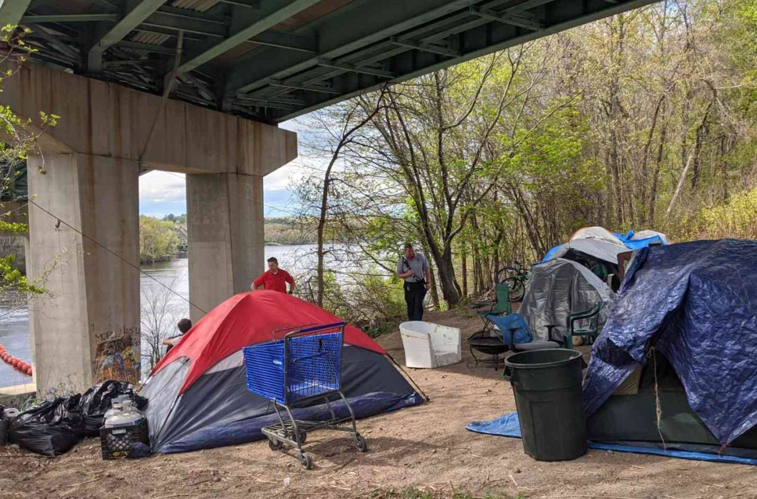
While household wealth declined as a result of the Great Recession, the period after did see a tremendous amount of concentrated wealth develop. According to Federal Reserve Notes, wealth became highly concentrated by 2016, with 80 percent of aggregate wealth being held by 10 percent of households. The pattern of inequal distribution of income had been developing for some time before the Great Recession. Pew Research identified a period of 15 years, between 2000 and 2015 in which the median household income made no gains. During this period, income and increases in wealth favored private property and asset holdings, while labor incomes made little to no gains. This created benefits and incentives for homeownership. Long-term demographic trends may see a decline in population, which would significantly change incentives. Material assets and property would experience a drop in demand while labor would become a constraint for markets.
Figure 1: Canal Street Homeless Encamplement
City Fire Chief and Emergency Director make the rounds at a homeless encampment under a bridge. Photo/Carol Robidoux

Description of the Region and Geographic Context
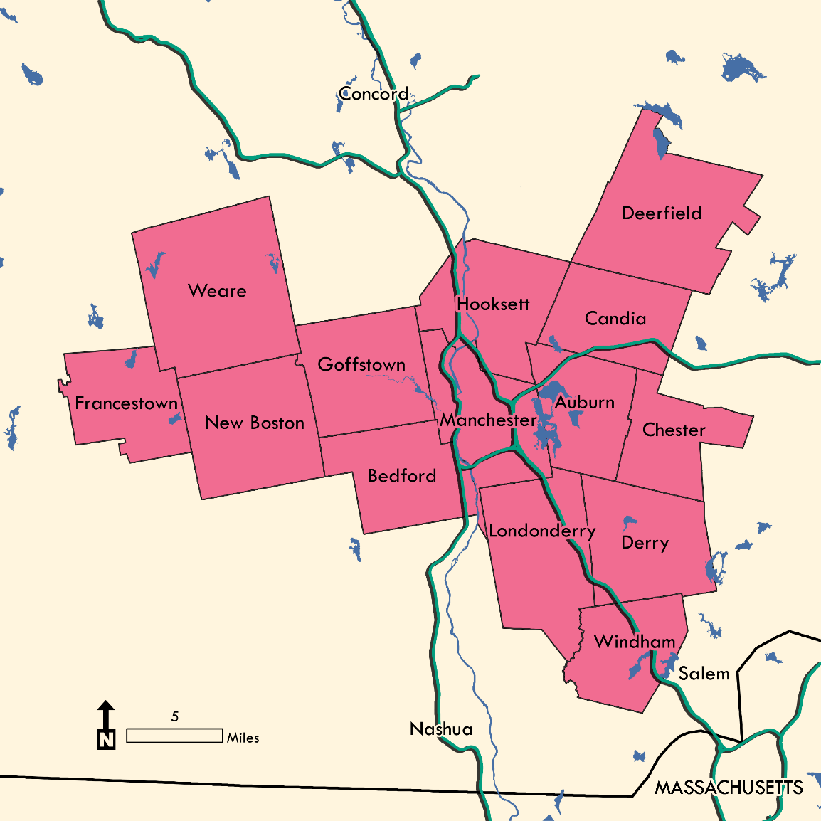
The Southern NH Planning Commission is one of nine regional planning commissions in New Hampshire. The Commission was formed under the New Hampshire Statutes in 1968 as a political subdivision of the State of New Hampshire. For more information on the structure of SNHPC and the planning products they produce, please review the SNHPC website. The SNHPC region is comprised of the municipalities of Auburn, Bedford, Candia, Chester, Deerfield, Derry, Francestown, Goffstown, Hooksett, Londonderry, Manchester, New Boston, Weare, and Windham as shown in Figure 2. The land area of the SNHPC planning region is approximately 520 square miles with a relatively flat growth pattern over the past decade.

Figure 2: SNHPC Member Municipalities
Sources: MA Department of Transportation; NH Department of Transportation; US Census Bureau; US Geological Survey.

Residential and commercial development is the largest land use, and historically the region has evolved from an agricultural and industrial base to what many consider today as a service and high-tech manufacturing economy.
The towns of Weare (38,464.3 acres) and Deerfield (33,347.7 acres) are the largest towns in the region, having the greatest total land area. Conversely, the towns of Windham (17,772.4 acres) and Chester (16,618 acres) are the region’s two smallest communities in terms of total land area. However, total land area alone is not enough to get an accurate feel for what a community is like. Even though the Town of Weare has the largest total land area in the region, 26,579.3; approximately 70 percent of those acres are undeveloped. The Town of Bedford (21,156.13 acres) on the other hand is one of the smaller communities in the region in terms of total land area, but it is approximately 75.5 percent developed at 15,970.1 acres. Other than Auburn, which has approximately 9,983 undeveloped acres, no other municipality has fewer than 10,000 undeveloped acres.
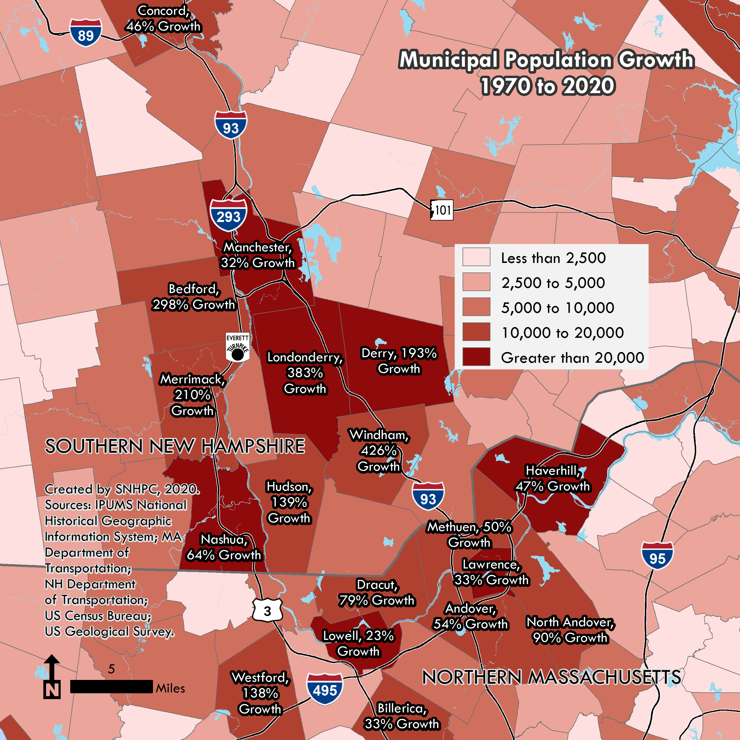
Figure 3: Regional Growth
The City of Manchester is the region’s leader in overall developed land area with approximately 17,456.6 acres. Manchester and Bedford are the only two municipalities in the region with fewer than 5,200 undeveloped acres. One reason for the development in Manchester and other communities is due to the development along the region’s state highways and major arterials.
The SNHPC region has convenient proximity to Boston, which is located just 60 miles away, tying the region to the economic influence of Greater Boston region. The SNHPC is also centrally located within Northern New England, providing one-hour access to New Hampshire’s seacoast, and its beautiful lakes and White Mountains regions. The SNHPC region is also only a few hours travel to the Green Mountains in Vermont and the rugged coast and abundant lakes of Maine. The major metropolitan areas of New York City and the City of Montreal are also readily accessible in approximately 5 hours travel time.

Population density
New Hampshire is mostly rural. That’s mostly true if you consider New Hampshire to be the land, the square footage. On the other hand, if you compare it to other states, you may wonder, is New Hampshire really that rural? It’s the 21st most densely populated state in the nation. New Hampshire’s density is twice that of Vermont and three and half times that of Maine. Three fifths of our residents live in an urban area, whether a downtown, city, or suburban sprawl. Three fifths live in a metropolitan area.
Despite this, the SNHPC region is home to a broad range of demographic conditions depending on location. Approximately 40% of all people within the region reside within the City of Manchester’s urban environment.
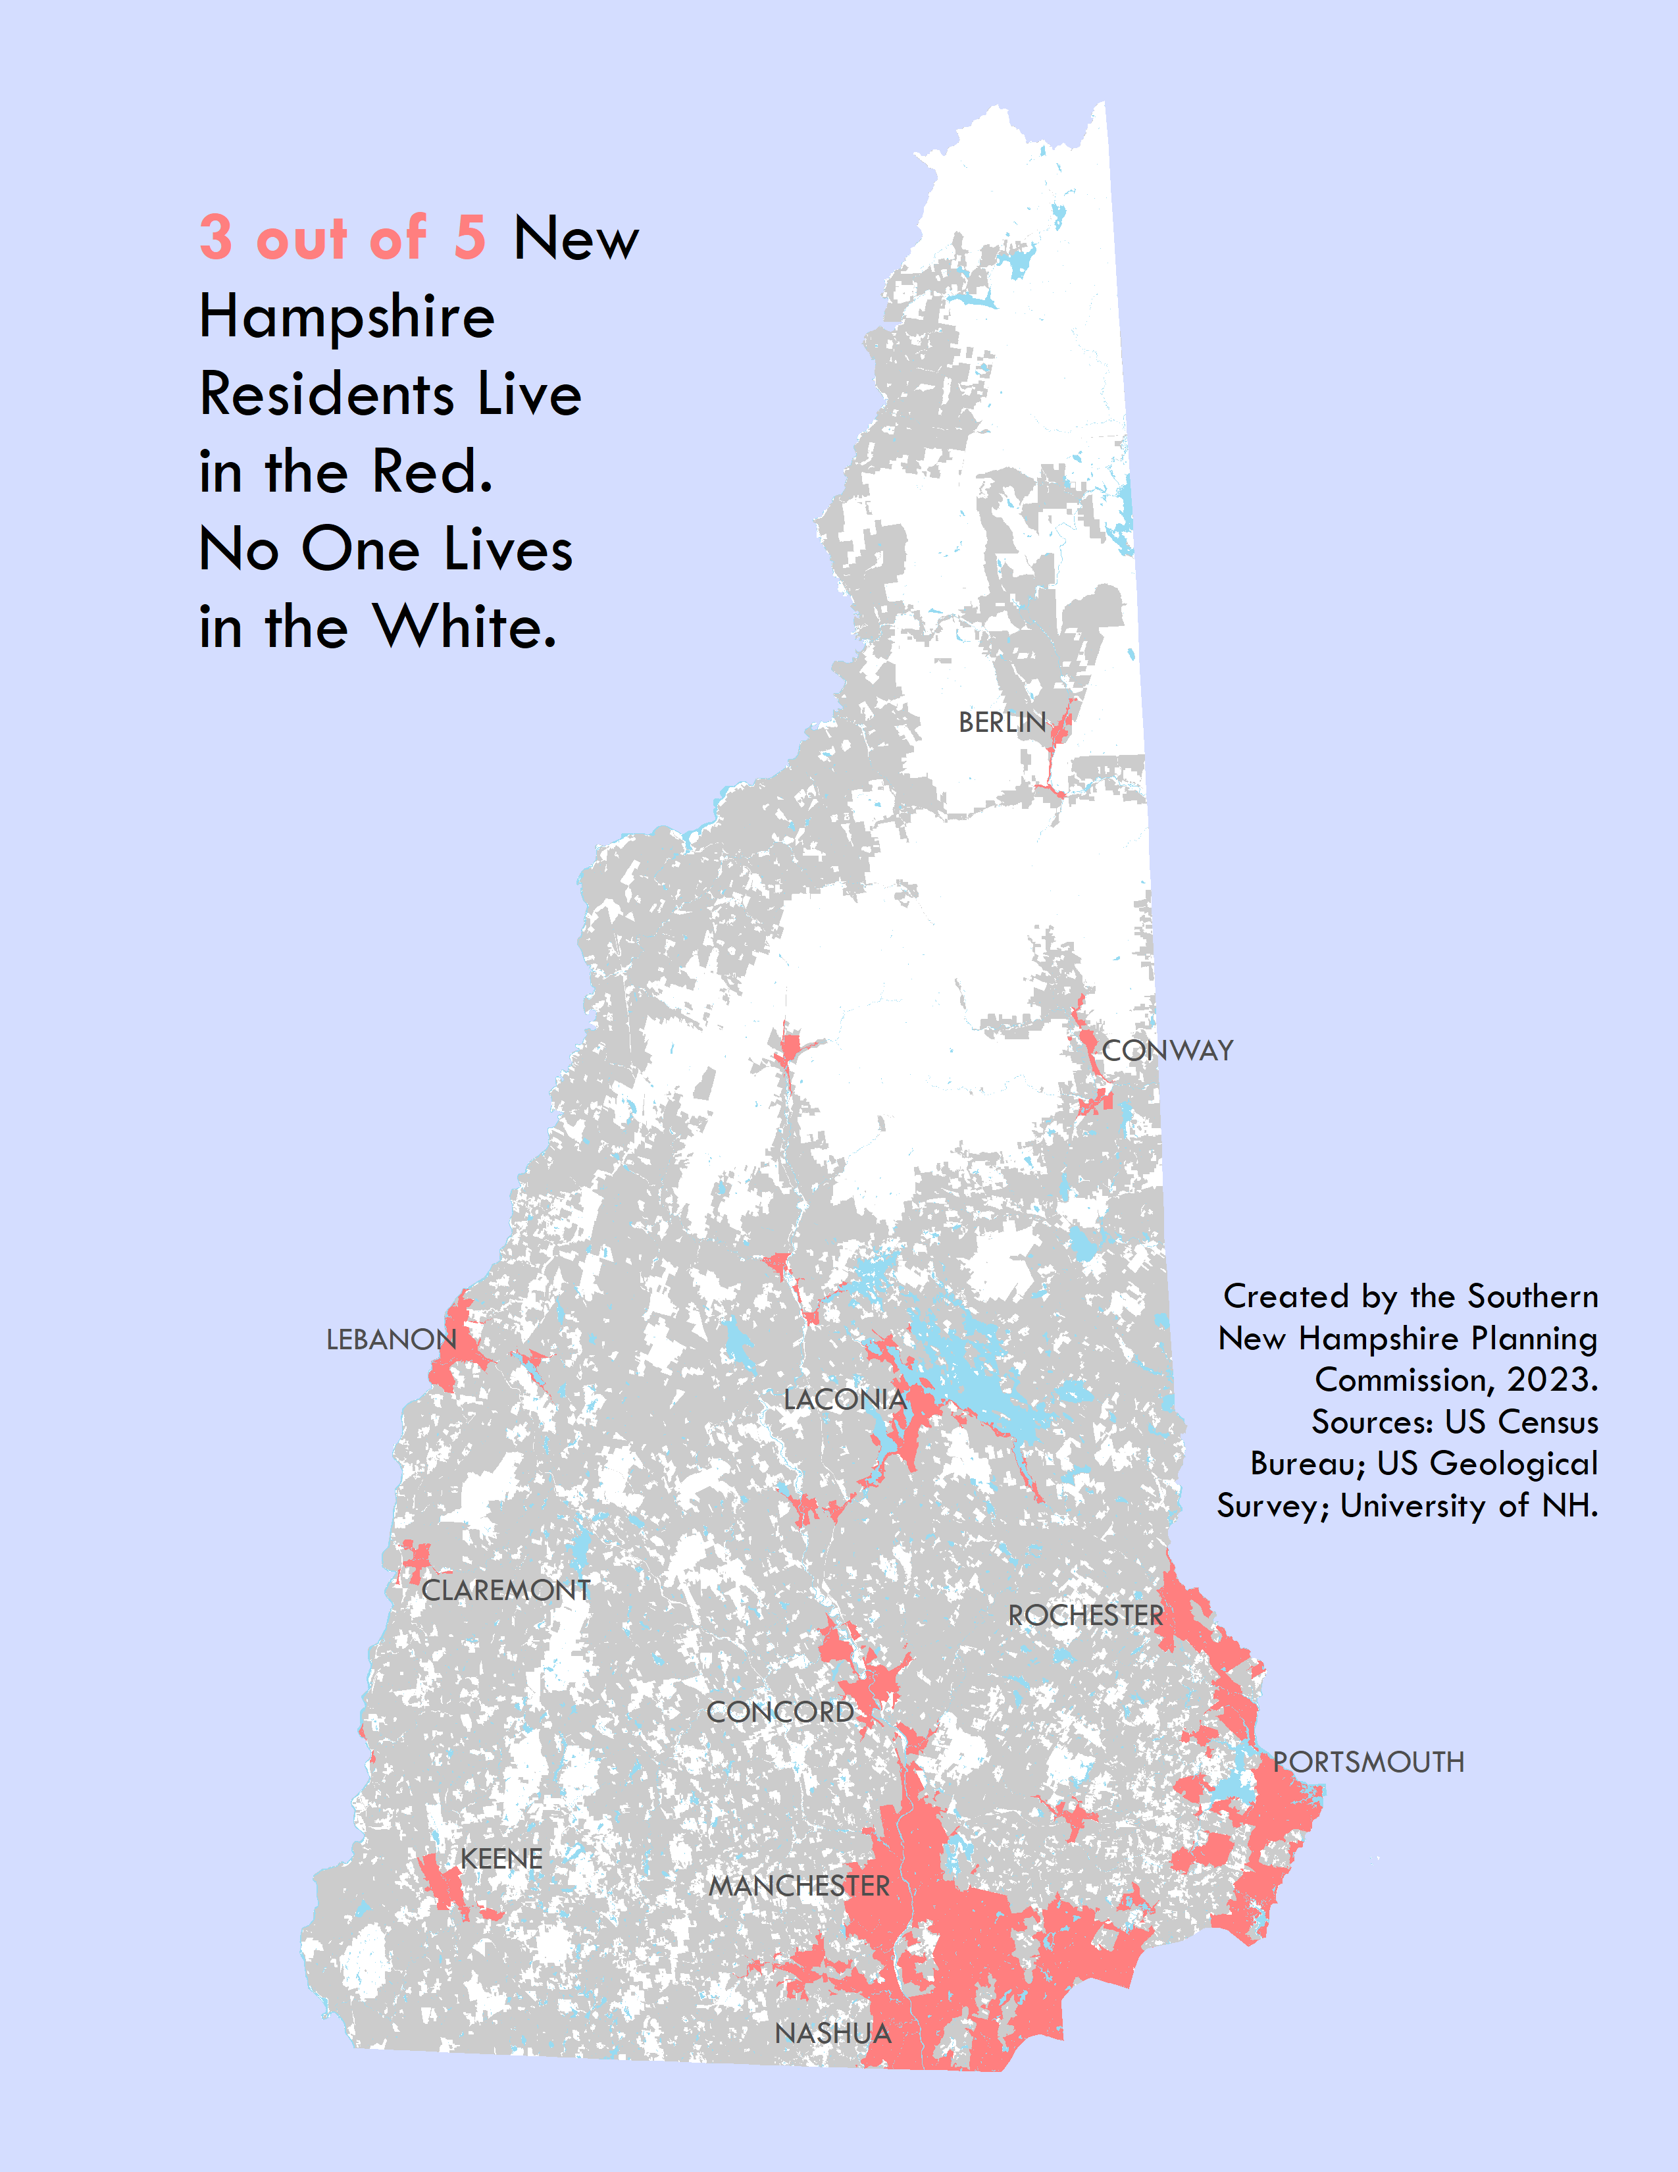
Figure 4: Where The People Live

Section IV - Existing Conditions and Historic Trends
This section of the RHNA is intended to thoroughly analyze all the data that is available related to the region’s housing needs and housing stock; these data include demographic and socioeconomic trends, and housing market for both owner and rental properties. Detailed data tables can be found in Appendix C.

Demographic and Socioeconomic Trends
This segment of the report identifies the historical patterns and current conditions of the region’s population, employment, household characteristics, labor force, educational enrollment, and migration.

Total Population
The total population of the SNHPC Region was 285,230 people in 2020. As shown on Table 3, the region grew by 13% from 2000 to 2020, with an annual growth rate of less than 1%. Communities that experienced the largest population growth over this time period were New Boston and Windham. Communities that experienced the least percent population growth were Candia and Derry.
Table 3: Total Population
Total Population
 | 2000 | 2010 | 2020
Auburn | 4,680 | 4,950 | 5,950
Bedford | 18,270 | 21,200 | 23,320
Candia | 3,910 | 3,910 | 4,010
Chester | 3,790 | 4,770 | 5,230
Deerfield | 3,680 | 4,280 | 4,860
Derry | 34,020 | 33,110 | 34,320
Francestown | 1,480 | 1,560 | 1,610
Goffstown | 16,930 | 17,650 | 18,580
Hooksett | 11,720 | 13,450 | 14,870
Londonderry | 23,240 | 24,130 | 25,830
Manchester | 107,010 | 109,570 | 115,640
New Boston | 4,140 | 5,320 | 6,110
Weare | 7,780 | 8,790 | 9,090
Windham | 10,710 | 13,590 | 15,820
SNHPC | 251,350 | 266,280 | 285,230
NH | 1,235,790 | 1,316,470 | 1,377,530
Decennial Census
Source: IPUMS National Historical Geographic Information System; US Census Bureau.

Population by Race/Ethnicity
The SNHPC Region continues to be predominantly White, not Hispanic or Latino at 83% in 2020. This compares to 93% percent in 2000 and illustrates that the region is becoming more diverse. The Hispanic or Latino population, of any race, grew more than any other population in the region, growing from 3% of the population in 2000 to 7% in 2020. The second largest for population growth in the region was multiracial residents, going from 1% of the population in 2000 to 4% in 2020. Both the Asian and Black or African American populations grew by more than 1% to around 3% of the total population in 2020.
The SNHPC Region’s population is slightly more diverse than the state as whole. The racial or Hispanic or Latino ethnic minority population in the state of New Hampshire comprises 13% of the population compared to 17% for the region. Overall, the nation is much more diverse than both the state and the region. Within the region, there are significant differences in minority composition between communities. The region’s urbanized center in Manchester contains a high concentration of minority population while the rural areas of the region are largely White, not Hispanic or Latino. Further analysis on racial distribution in the region is outlined in the Communities of Interest and Racial Diversity and Ethnic Integration sections of this report.

Population by Age
From 2010 to 2020, the SNHPC region’s population under 18 years old decreased by 7,730 people while the population 65 years or older grew by 12,170 people. The population between 18 to 24 years old also grew by 2,680 people.

Focus on Older Adults
The number of seniors in New Hampshire is projected to more than double between 2010 and 2040. By 2040, three in ten New Hampshire residents will be 65 or older and one in ten will be 80 or older. The senior population statewide will be about the same as the total population of Hillsborough County, the state’s largest county. Between 2010 and 2040 the population of 80 or older is projected to more than triple in the state. By 2040, New Hampshire will have an additional 111,000 people who are 80 or older, roughly the population of Manchester, its largest municipality. The 2010-2045 population growth of seniors is set to be 15 times the overall rate; 80 or older is 25 times the overall rate.
NHOSI (now OPD) doesn’t make projections by town and age, but if we apply the county level rates to our municipalities, the results for SNHPC are shown in Table 4. Seniors double to 64,400; 80 or more triple to 25,000. In 2040 in the SNHPC region, 2 in 10 are projected to be seniors and 1 in 10 is projected to be 80 years or older.
Table 4: SNHPC Historical and Project Populations
 | SNHPC Historical and Project Populations
 | 2000 |  | 2050 |  | Absolute Change | Relative Change
 |  | % of Total Population |  | % of Total Population
All Ages | 251,400 | 100% | 324,300 | 100% | 72,900 | 29%
65 or Older | 26,500 | 11% | 81,400 | 25% | 54,900 | 207%
80 or Older | 7,000 | 3% | 35,600 | 11% | 28,600 | 409%
Municipal rates reflect county rates which are combined to determine approximate regional rates.
Sources: IPUMS National Historical Geographic Information System; NH Office of Planning & Development.
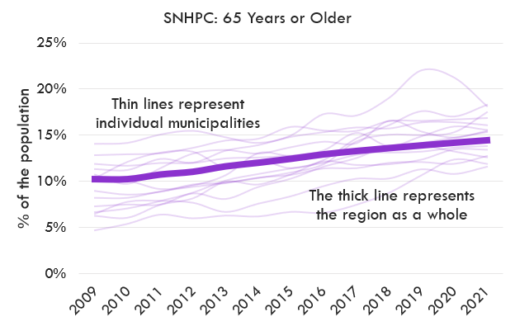
Figure 5: Older adult growth in SNHPC Region. Source: US Census Bureau

Households: Size, Type, Tenure
The number of minors per household has decreased significantly from 1980 to 2020 in the SNHPC region as well as the state. The most dramatic change was in Candia (-57%) and the smallest change was in New Boston (-32%).
Table 5: Minors per Household
 | Minors per Household
 | 1980 | 2020 | Change 1980-2020
Auburn | 1.02 | 0.65 | -0.37 | -36%
Bedford | 1.12 | 0.71 | -0.41 | -36%
Candia | 1.05 | 0.46 | -0.60 | -57%
Chester | 1.02 | 0.61 | -0.40 | -40%
Deerfield | 1.00 | 0.59 | -0.41 | -41%
Derry | 0.89 | 0.52 | -0.37 | -41%
Francestown | 0.71 | 0.45 | -0.26 | -37%
Goffstown | 0.93 | 0.54 | -0.39 | -42%
Hooksett | 0.83 | 0.50 | -0.33 | -40%
Londonderry | 1.08 | 0.59 | -0.48 | -45%
Manchester | 0.68 | 0.44 | -0.24 | -36%
New Boston | 1.05 | 0.71 | -0.34 | -32%
Weare | 0.93 | 0.60 | -0.33 | -36%
Windham | 1.20 | 0.79 | -0.41 | -35%
SNHPC | 0.81 | 0.53 | -0.28 | -35%
NH | 0.80 | 0.46 | -0.34 | -42%
Decennial Census. Minors living in group quarters included in total.
Source: IPUMS National Historical Geographic Information System; US Census Bureau.

In 2020, thirty-five percent (35%) of households in the SNHPC region were comprised of 2 people. This remained consistent with the state as well as each individual SNHPC community except Windham where thirty-seven percent (37%) of the population had 4 or more persons per household.
Table 6: 2020 Persons per Household
 | 2020
 |  | Persons per Household
 | Households | 1 | 2 | 3 | 4 or More
Auburn | 1,920 | 11% | 42% | 21% | 27%
Bedford | 7,910 | 17% | 32% | 21% | 29%
Candia | 1,480 | 22% | 42% | 11% | 25%
Chester | 1,740 | 10% | 37% | 19% | 34%
Deerfield | 1,650 | 13% | 41% | 17% | 29%
Derry | 12,710 | 22% | 36% | 20% | 22%
Francestown | 620 | 21% | 43% | 15% | 21%
Goffstown | 6,290 | 23% | 41% | 16% | 20%
Hooksett | 5,160 | 19% | 35% | 23% | 23%
Londonderry | 9,570 | 18% | 34% | 19% | 28%
Manchester | 47,240 | 34% | 34% | 16% | 17%
New Boston | 2,120 | 12% | 43% | 12% | 33%
Weare | 3,280 | 17% | 40% | 16% | 27%
Windham | 5,020 | 13% | 31% | 20% | 37%
SNHPC | 106,710 | 25% | 35% | 18% | 22%
NH | 539,120 | 27% | 38% | 15% | 20%
5-Year American Community Survey
Source: US Census Bureau

In 2020, the majority of housing units in the SNHPC region were owner-occupied (62%). Candia and Chester had the highest percent of owner-occupied housing units with 95% and 94% respectively. 71% of owner-occupied households in the SNHPC in 2020 had a mortgage. This percentage has dropped from 78% in 2010 and 75% in 2015. The communities with the greatest decreases since 2010 were Weare (20%), Francestown (16%) and Hooksett (11%). The City of Manchester had the greatest number of renter-occupied housing units in 2020 with 52% and Chester had the least with just 1%.
On average, owner-occupied housing units have a larger average household size than renter-occupied units (2.71 vs. 2.21 in the SNHPC region).

Employment by Industry and Location
The SNHPC region’s biggest industries from 2015-2019 were Health Care & Social Assistance (15.6%), Retail Trade (12.8%) and Educational Services (9.7%) followed by Accommodations & Food Services (7.9%), Manufacturing (7.9%), Administrative and Support and Waste Management and Remediation Services(7.5%), and Professional, Scientific, & Technical Services (6.7%). The industries that experienced the largest growth during this period were Health Care & Social Assistance (+2.4%) and Administration & Support, Waste Management & Remediation (+1.5%).

Top Employers
According to the NH Employment Security Economic & Labor Market Information Bureau, the region’s largest employers are Elliot Hospital, Catholic Medical Center, and Easter Seals (Social Service & Welfare Organization). These employers are all located in Manchester and employ between 1,000-4,999 people.

Change in labor force/employment
In the SNHPC region, the civilian labor force experienced steady growth over the past 20 years. There was a period of decline during the Great Recession from 2008 (154,320 people) to 2011 (151,850 people). The workforce began to grow again in 2012 but saw another decline in 2020 at the beginning of the COVID-19 pandemic.

Table 7: Owner Versus Renter
 | 2010 |  |  |  | 2015 |  |  |  | 2020
 | Total Occupied Housing Units | Owner-Occupied | Renter-Occupied | % of Owner-Occupied w/ a Mortgage | Total Occupied Housing Units | Owner-Occupied | Renter-Occupied | % of Owner-Occupied w/ a Mortgage | Total Occupied Housing Units | Owner-Occupied | Renter-Occupied | % of Owner-Occupied w/ a Mortgage
Auburn | 1,840 | 87% | 5% | 81% | 2,020 | 86% | 9% | 78% | 1,920 | 91% | 9% | 74%
Bedford | 7,480 | 84% | 13% | 73% | 7,630 | 86% | 11% | 75% | 8,160 | 83% | 14% | 68%
Candia | 1,510 | 95% | 5% | 74% | 1,560 | 92% | 5% | 71% | 1,510 | 95% | 3% | 70%
Chester | 1,620 | 94% | 2% | 85% | 1,680 | 89% | 7% | 78% | 1,850 | 94% | 1% | 75%
Deerfield | 1,630 | 79% | 10% | 74% | 1,720 | 84% | 7% | 73% | 1,890 | 75% | 13% | 76%
Derry | 13,240 | 66% | 29% | 80% | 13,610 | 60% | 35% | 78% | 13,370 | 63% | 32% | 75%
Francestown | 740 | 78% | 6% | 71% | 760 | 68% | 8% | 60% | 760 | 73% | 9% | 55%
Goffstown | 6,320 | 74% | 20% | 78% | 6,560 | 74% | 21% | 74% | 6,560 | 75% | 20% | 70%
Hooksett | 4,760 | 83% | 15% | 73% | 5,250 | 83% | 16% | 73% | 5,250 | 74% | 24% | 62%
Londonderry | 8,680 | 87% | 9% | 83% | 8,870 | 83% | 14% | 78% | 9,910 | 83% | 14% | 73%
Manchester | 49,340 | 47% | 45% | 75% | 49,070 | 44% | 48% | 74% | 50,180 | 42% | 52% | 71%
New Boston | 1,970 | 84% | 11% | 81% | 1,990 | 89% | 7% | 78% | 2,140 | 88% | 11% | 75%
Weare | 3,360 | 82% | 6% | 86% | 3,820 | 75% | 7% | 78% | 3,700 | 82% | 6% | 66%
Windham | 4,910 | 87% | 5% | 78% | 5,320 | 88% | 8% | 75% | 5,580 | 84% | 6% | 70%
SNHPC | 107,390 | 65% | 29% | 78% | 109,850 | 62% | 31% | 75% | 112,780 | 62% | 33% | 71%
NH | 607,760 | 61% | 23% | 71% | 618,950 | 60% | 24% | 68% | 638,610 | 60% | 24% | 65%
5-Year American Community Survey
Source: US Census Bureau

Commuter patterns
According to the LEHD Origin-Destination Employment Statistics from the US Census Bureau, 74,240 people in the SNHPC region commuted within the region in 2019. In the same year, the number of people who commuted out of the SNHPC region (79,690) was greater than the number of people who commuted into the SNHPC region (70,230). This equals a net of –9,460 commuters or -4%. This remained consistent for both the SNHPC region and the State from 2014-2019.
Table 8: Commuter Origin/ Destination
 | As % of Total Commutes
 | 2014 |  |  |  | 2019
 | Commuting |  |  |  | Commuting
 | Out of the Region | W/in the Region | Into the Region | Net Commutes | Out of the Region | W/in the Region | Into the Region | Net Commutes
SNHPC | 35% | 34% | 31% | -4% | 36% | 33% | 31% | -4%
NH | 36% | 32% | 32% | -4% | 36% | 32% | 32% | -4%
LEHD Origin-Destination Employment Statistics
Source: US Census Bureau
The new Census data provides some interesting data on commuting (Table S0802: Means Of Transportation To Work By Selected Characteristics). The information provided in Table 9 allows the user to do comparison of protected classes. For example, the following is a comparison for Manchester residents including racial and ethnic minorities, workers below poverty thresholds and limited English proficiency. Unsurprisingly, all three protected classes are less likely to drive alone and are more likely to carpool or take public transportation.
Table 9: Commuting Characteristics of Protected Classes
In Manchester, when compared to the general public, racial and ethnic minority workers are…
0.9 | times as likely to commute by driving alone
1.6 | times as likely to commute by carpooling
1.4 | times as likely to commute by public transportation
In Manchester, when compared to the general public, workers below the poverty threshold are…
0.8 | times as likely to commute by driving alone
3.7 | times as likely to commute by carpooling
10 | times as likely to commute by public transportation
In Manchester, when compared to the general public, limited English proficiency workers are…
0.8 | times as likely to commute by driving alone
4 | times as likely to commute by carpooling
2.7 | times as likely to commute by public transportation
Figures are not available for municipalities smaller than Manchester. 2020 5-Year American Community Survey.
Source: US Census Bureau

School Enrollment Trends
Total public school enrollment in the SNHPC region has been steadily decreasing from 2013 to 2021. This is true for nearly every community in the region except for Auburn, Deerfield, Goffstown, New Boston, and Windham. These towns have seen an increase in public school enrollment from 2013 to 2021. This is consistent with statewide enrollment, which has fallen by 20% over the past two decades. (Source: NH Department of Education)
Figure 6: SNHPC Public School Enrollment by Municipality

Net Migration
The SNHPC region saw a net migration of 11,270 people (4% of the 2010 population) from 2010-2020. Every community in the region experienced a positive net migration with the exception of Weare (-160 people or –2%). The communities with the largest net migration were Auburn (16%), Windham (14%), Bedford (13%), and New Boston (11%).
Table 10: Net Migration (2010-20)
 | Net Migration (2010-20)
 |  | As % of 2010 Population
Auburn | 810 | 16%
Bedford | 2,850 | 13%
Candia | 60 | 1%
Chester | 270 | 6%
Deerfield | 380 | 9%
Derry | 130 | 0%
Francestown | 40 | 2%
Goffstown | 1,120 | 6%
Hooksett | 970 | 7%
Londonderry | 940 | 4%
Manchester | 1,400 | 1%
New Boston | 580 | 11%
Weare | -160 | -2%
Windham | 1,890 | 14%
SNHPC | 11,270 | 4%
NH | 53,660 | 4%
Sources: NH Department of State; US Census Bureau.

Communities of Interest
SNHPC’s Regional Housing Needs Assessment sets out to engage residents and stakeholders substantively and meaningfully in the development of a shared understanding of housing needs. This includes communities traditionally marginalized from such processes. The federal Fair Housing Act (FHA) guards against housing discrimination and promotes integration of the nation. The FHA protects people from discriminatory practices based on race, religion, sex, national origin, family status, or disability. Further, the State of New Hampshire adds three additional classifications of protection through state statute. The state’s laws protect people from discriminatory housing practices based on age, marital status, and sexual orientation. For additional information on protections of state and federal law, see the History of Fair Housing, page 112 of this report. Beyond the protections of law, the identified populations are more likely to be vulnerable to shocks in the housing market, disruptions which can displace them from their homes and communities. Special attention was given to the housing needs assessment methodology to account for populations at risk of being marginalized in the housing market or by housing policy decision-making.

Low-Income Populations
Table 11: Percent of Residents
% of Residents Below the Poverty Threshold
 | 2020
Auburn | 1%
Bedford | 3%
Candia | 3%
Chester | 2%
Deerfield | 5%
Derry | 6%
Francestown | 2%
Goffstown | 7%
Hooksett | 4%
Londonderry | 2%
Manchester | 13%
New Boston | 2%
Weare | 4%
Windham | 1%
SNHPC | 8%
NH | 7%
5-Year American Community Survey
Source: US Census Bureau
A shortage of affordable housing in the state can lead to an increasing number of low-income households to suffer from housing instability. When housing demand and housing costs are high, low-income households may be less likely to be able to afford those costs or compete against households with greater purchasing power.
The US Census Bureau uses a set of nationwide income thresholds that vary by family size and composition to determine who is in poverty. The official poverty definition examines income before taxes and does not include capital gains or noncash benefits (such as public housing, Medicaid, or the Supplemental Nutrition Assistance Program). The measure is intended to weigh household income against costs to determine the minimum amount necessary to afford basic living expenses.
Around 20,700 SNHPC residents, or close to 8% of the total population, live below the poverty threshold. The rate is slightly lower for the state as a whole. Nearly 7 in 10 SNHPC low-income residents live in Manchester. While the vast majority of SNHPC low-income residents are White and not Hispanic or Latino, minority residents are more likely to be living below the poverty line. The poverty rate for Black or African American persons living in the SNHPC region is three and half times higher than it is for non-Hispanic White persons. Around 38,400 individuals in the SNHPC region, or 1 in 7, make less than 150% of the federal poverty threshold. 31,800 families with children under the age of 18, approximately 1 in 10, live below the poverty line. The figure is closer to 1 in 5 for the City of Manchester.

Minorities, Immigrants, & the Limited English Proficient
Table 12: Percent Racial or Hispanic/Latino Minority
Percent Racial or Hispanic/Latino Minority
 | 2020
Auburn | 8%
Bedford | 14%
Candia | 8%
Chester | 7%
Deerfield | 6%
Derry | 12%
Francestown | 6%
Goffstown | 10%
Hooksett | 12%
Londonderry | 11%
Manchester | 26%
New Boston | 8%
Weare | 7%
Windham | 12%
SNHPC | 17%
NH | 13%
Decennial Census
Source: US Census Bureau
Housing discrimination based on race, color, or national origin has been illegal nationally since 1968. However, instances still occur and are often difficult to monitor and prosecute. Minorities and immigrants also frequently face additional challenges in the housing market as they many times have smaller financial means than the general public. In the SNHPC region, 48,300 individuals, 17%, are a racial or Hispanic/Latino ethnicity minority. Around 60% live in Manchester and higher concentrations of Black or Latino residents are found in the city. Regionwide, Hispanics and Latinos of any race are the largest group with 19,400 residents followed by 11,200 residents of two or more races.
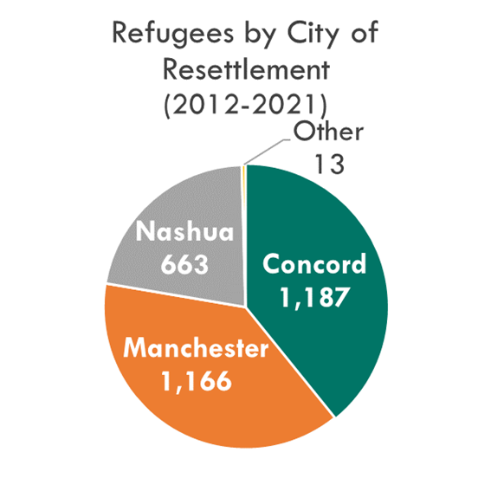
Immigration numbers are only known for Manchester as they are not tracked for smaller municipalities. Around 16,400 Manchester residents, 1 in 7, are foreign-born with 5,800 having arrived since 2010. For the counties that SNHPC is a part of (Hillsborough, Merrimack, and Rockingham), 64,100 or 7% of residents are foreign-born with 17,300 arriving since 2010. Numbers on refugees are more limited. Typically, government agencies only track the initial placement of refugees when they arrive in the state. Approximately 3,000 refugees were placed in NH between 2012 and 2021. Three quarters of them were resettled in Concord or Manchester with a smaller number going to Nashua. The remaining 26 percent were divided among Dover, Exeter, Keene, and Laconia.
The measure of the population with limited English proficiency (LEP) is defined as individuals five years of age or older who speak English less than "very well.” As English is not a primary language for this population, they may experience difficulty communicating in it, and may need an interpreter or document translation in order to have meaningful access to federally funded programs. The LEP community in the region has grown slowly over last decade with more than 4 in 5 living in Manchester and majority of those within the center city.
Figure 7: Refugees by City of Resettlement (2012-2021)

Persons with Disabilities
Table 13: Percent of Population with a Disability
Percent With a Disability
 | 2020
Auburn | 10%
Bedford | 8%
Candia | 13%
Chester | 8%
Deerfield | 14%
Derry | 12%
Francestown | 8%
Goffstown | 12%
Hooksett | 11%
Londonderry | 12%
Manchester | 14%
New Boston | 6%
Weare | 9%
Windham | 6%
SNHPC | 12%
NH | 13%
5-Year American Community Survey
Source: US Census Bureau
People living with a disability seek out community-based living conditions which provide housing dignity. Many different living arrangements can be considered appropriate based on an individuals’ needs. Families with a member living with disabilities often care for their dependents well into adulthood. According to a 2021 survey by ABLE-NH, 70% of both family caretakers and individuals with disabilities reported a need for access to appropriately supportive, accessible affordable housing. In addition, caretakers are often older, with 60% of caretaker respondents noting their own age was between 55 to 74. More than 50% of respondents expressed a desire to live independently from their family, with appropriate and nearby support. Depending on the impairment, physical housing improvements may need to be in-place for individuals to achieve a more independent housing and living arrangement.
New Hampshire Housing estimates over 47,000 households have a member with a disability who is in need of some form of housing accommodation or assistance. The civilian non-institutionalized population with a disability in the SNHPC region is 32,900 or approximately 12% of the population. Around half of the disabled population in the region lives within the City of Manchester.

Youth (People Under 18 years of Age)
Table 14: Percent of Population Less than 18 Years Old
% Less Than 18 Years Old
 | 2020
Auburn | 20%
Bedford | 25%
Candia | 15%
Chester | 20%
Deerfield | 19%
Derry | 21%
Francestown | 19%
Goffstown | 18%
Hooksett | 19%
Londonderry | 22%
Manchester | 18%
New Boston | 26%
Weare | `22%
Windham | 27%
SNHPC | 20%
NH | 19%
5-Year American Community Survey
Source: US Census Bureau
The population of residents less than 18 years old, or minors, continues to shrink in the region. The total number of minors fell by 13% between 2010 and 2020 to near 56,400. Minors also decreased as a share of the total population, down from around a third in the later part of the twentieth century. These figures are projected to begin leveling out the next few decades. The number of minors per household has also continued to fall. On average in 1980, 0.81 minors on average were found in every household in the region. By 2020, that rate had dropped to 0.53. Some communities have seen much steeper declines, with the average number of minors per household falling by 57% in Candia.
The minor population however is growing more diverse and a larger percentage are minority than the general public. Today, regionwide, minors are almost twice as likely to be a racial or ethnic minority. This phenomenon is strongest in the City of Manchester but can be found throughout all communities.
A landlord may try to impose specific rules just for families with children or reserve certain apartments for adults only. Regardless of parental status or legal guardianship for a child, or being pregnant, a housing provider cannot use this as a reason restrict access to housing.

Older Adults (People 65 Years of Age and Over)
Table 15: Percent of Population 65 Years or Older
% 65 Years or Older
 | 2020
Auburn | 13%
Bedford | 17%
Candia | 17%
Chester | 14%
Deerfield | 15%
Derry | 12%
Francestown | 21%
Goffstown | 16%
Hooksett | 15%
Londonderry | 15%
Manchester | 14%
New Boston | 11%
Weare | 12%
Windham | 16%
SNHPC | 14%
NH | 18%
5-Year American Community Survey
Source: US Census Bureau
Southern New Hampshire’s senior population, or those 65 years or older, is a quickly growing segment of the region’s population. People over the age of 65 have increased by around 50% over the past decade to almost 40,000. While around 40% of seniors live in Manchester, the majority live in suburban and exurban communities which presents unique challenges in meeting their needs as they age. Senior citizens often experience mobility challenges and other impairments with time, resulting in isolation and trouble accessing services. Seniors are more likely to need assistance with daily care that requires a caretaker or congregate living arrangement.
Seniors express a high preference for remaining in their homes and neighborhoods. According to AARP, 3 in 4 persons over 50 years old want to age in place. If they must relocate, seniors want to do so on their own timetable, and not due to adverse effects of decisions made by housing providers, politicians, or government officials. Housing providers are not allowed to reject candidates for available housing based on the age of an individual as New Hampshire state statue classifies age as a protected class. There are some federal and state exemptions to this rule, particularly for 55-plus age-restricted units. The benefits of allowing age-restricted communities within a municipality has been debated. 55-plus housing can be used a means for inclusion of seniors in a community, but restrictions can also be a tool to limit families with children from moving in.

No Vehicle Households
Table 16: Percent of Households Without a Vehicle
% of Households Without a Vehicle
 | 2020
Auburn | 0%
Bedford | 3%
Candia | 1%
Chester | 3%
Deerfield | 4%
Derry | 3%
Francestown | 2%
Goffstown | 2%
Hooksett | 1%
Londonderry | 2%
Manchester | 8%
New Boston | 2%
Weare | 0%
Windham | 1%
SNHPC | 5%
NH | 5%
5-Year American Community Survey
Source: US Census Bureau
US Census defines a vehicle as a privately owned motor vehicle such as cars and trucks available for household transportation needs. This definition excludes people living group quarters, like a college dorm and military barracks, that may or may not have access to a vehicle. No vehicle households are an important segment of the population, as they will have very limited mobility unless alternative transportations options are provided. Lacking access to a vehicle can severely limit the ability of a household to work and meet its daily needs. Changing demographics within the region suggest a need for long range planning of walkable and bikeable neighborhoods, employment centers, and increased access to public transportation. This is especially true in suburban communities where car ownership is a requisite to access employment and services. The majority of the state’s municipalities have a no vehicle household rate of less than 2.5% while census tracts in the City of Manchester reach concentrations of 1 in 3 households. Additionally, regionwide, 8% of households where residents are currently working have fewer vehicles available than workers and require some form of non-single occupancy vehicle (SOV) transportation to commute.

Homelessness
Homeless individuals face obvious barriers to securing safe and affordable housing. Those experiencing chronic homelessness may also suffer from severe mental illness or substance use disorder. The housing circumstances of homeless individuals can vary significantly. Some may be staying in temporary housing or a shelter while others are living in a place not intended for habitation. Still others may be doubling up with a friend or relative.
Calculating the number of homeless residents is always difficult and the numbers can vary significantly based on the method and definition used. Point in Time (PIT) counts have consistently placed the number statewide at between 1,400 to 1,600 for the last decade. Figures from the Continuum of Care program are much higher, around 4,700 in 2021. The homeless population is also not evenly distributed across the state, with the cities of Manchester and Nashua’s Continuums of Care serving the majority of the population. Around a third of the state’s total homeless population is served by Manchester despite the city only accounting for less than one tenth of the state’s general population.
Figure 8: Homeless Population
Sources: US Department of Housing and Urban Development; NH Council on Housing Stability.

Strategies outlined in A Home for Everyone: A 10-Year Plan to End Homelessness in the City of Manchester include: Build more affordable housing and subsidize costs to make it affordable to more people with low incomes; Help people increase their incomes through education, training, and employment at housing-wage jobs; and Provide permanent housing and intensive case management and supportive services for those with severe mental health and substance use disorders to stabilize them in housing first and then make recovery treatment services available.
The NH Department of Education is required under the McKinney-Vento Act to ensure that homeless students have equal access to an education. Homeless youth are often students struggling to stay connected to their schools while managing the crisis of not knowing where they will sleep on any given night. They often seem like an invisible population as they do not match society’s expectation of what homelessness looks like. The Department of Education estimates an average of around 3,700 homeless students statewide every year. Approximately 1 in 5 go to Manchester public schools. New Hampshire school districts continue to report many remaining barriers to the education of homeless children and youth. Lack of affordable housing, difficulty identifying homeless students, transportation to school, and meeting basic needs are the greatest concerns reported by local homeless education liaisons as they try to meet the educational needs of students facing homelessness.

Table 17: Average Number of Homeless School Students 2017-2021
 | 2017-2021
School District | Average Number of Homeless School Students
Auburn School District | 5
Bedford School District | 20
Candia School District | 0
Chester School District | 0
Contoocook Valley School District | 50
Deerfield School District | 0
Derry School District | 50
Goffstown School District | 20
Hooksett School District | 5
Londonderry School District | 5
Manchester School District | 840
New Boston School District | 0
Pinkerton Academy School District | 20
Weare School District | 10
Windham School District | 5
NH | 3,680
Source: NH Department of Education

The Justice-Involved
Those who have been incarcerated typically return to their communities upon release. When they arrive, they must overcome a multitude of challenges to integrate back into society. One of their first needs will be to secure safe, predictable, and affordable housing. Housing is an important element of reentry; people returning to their communities require a home in order pursue employment, education, health care, and to reengage with family and in civic activities. Stable housing reduces the risk that recidivism. Successful reentry is a public interest in that it increases public safety and saves taxpayers money by reducing the number of costly jail stays. Support of justice-involved individuals through housing will allow those individuals to reach their full potential as contributors to the local community.
According to the Vera Institute of Justice and the US Bureau of Justice Statistics, the prisoner population in New Hampshire for 2018 was 2,441, continuing a slight downward trend from a high of 2,870 in 2007. That said, between 1983 and 2018 the state’s overall prison population has increased by 432%. In New Hampshire, Black individuals constituted 1% of state residents, but 8% of people in jail and 5% of people in prison. Similar distributions are true for those identified as Latino. There is wide variation in incarceration across the state. The highest rates of prison admissions are in rural counties.

Religious Belief
Religion is generally defined by organized beliefs, behaviors, and practices related to spirituality, morality, or higher beings. Definitions and practices of religion varies based on community. Religion can influence how communities think, feel, and behave in both positive and negative ways. For many people, religion and spirituality brings meaning, purpose, and social belonging to life. Conversely, participation in religion can create social challenges, where individuals or groups can experience discrimination or internal conflict resulting from religious beliefs or practices which can extend into housing.
According to the Pew Research Center, New Hampshire’s religious makeup is 59% Catholic and Protestant Christian with the next largest group (36%) being unaffiliated. Non-Christian faiths (Jewish, Muslim, Buddhist, Hindu, and other faiths) make up 5% of the state’s religious composition. Recent decades have witnessed a growth in irreligion in the state. Between 2007 and 2014, religious trends in New Hampshire have saw a shift from 81% of people having an absolute or fairly certain belief in God in 2007, down to 69% in 2014.
Individuals and groups who have common religious beliefs, habits, and practices and ideologies are a protected class within the Fair Housing Act whether they consider themselves to be members of a particular religion or how established or popular a religious practice is. Religious housing discrimination can be subtle and includes actions such as different rent rates, tenant steering, and lower priority on waitlists or for repairs.

Gender & Sexual Orientation
Table 18: Male Vs Female Residents 2020
 | 2020
 | Male | Female
Auburn | 56% | 44%
Bedford | 48% | 52%
Candia | 53% | 47%
Chester | 52% | 48%
Deerfield | 47% | 53%
Derry | 48% | 52%
Francestown | 50% | 50%
Goffstown | 46% | 54%
Hooksett | 49% | 51%
Londonderry | 49% | 51%
Manchester | 51% | 49%
New Boston | 49% | 51%
Weare | 48% | 52%
Windham | 51% | 49%
SNHPC | 50% | 50%
NH | 50% | 50%
5-Year American Community Survey
Source: US Census Bureau
The number of male and female residents has remained roughly equal throughout the state and region over the last decade. Individual municipalities do see wider disparities but often within the margin of error.
Information on gender identity and sexual orientation is not widely tracked by most government agencies and therefore official estimates for these populations is hard to come by. Using Gallup data, the University of California-Los Angeles estimates that there are around 51,000 people living in New Hampshire that are members of the lesbian, gay, bisexual, and transgender (LGBT) communities. A later study utilizing figures from CDC data speculates that there are around 6,300 persons in New Hampshire that are transgender, including 5,600 adults. Research illustrates that LGBTQ people face housing discrimination, and because of this, they are more likely to experience housing instability and even homelessness.

Racial Diversity and Ethnic Integration
The Fair Housing Act requires HUD and its recipients of federal financial assistance to do more than simply not discriminate; they must take meaningful actions to overcome patterns of segregation and foster inclusive communities. Title VIII of the Civil Rights Act of 1968, known as the Fair Housing Act, requires HUD and recipients of federal funds from HUD to affirmatively further the policies and purposes of the Fair Housing Act, also known as “affirmatively further fair housing” or “AFFH.” In administering programs related to housing and community development, the federal government, HUD, and recipients must:
- Determine who lacks access to opportunity and address inequity among protected class groups
- Promote integration and reduce segregation
- Transform racially or ethnically concentrated areas of poverty into areas of opportunity
HUD makes use of two coarse measures to determine areas of concentrated racial and ethnicity minorities and poverty. The first is the Racially or Ethnically Concentrated Areas of Poverty (R/ECAPs) designation which considers minority and poverty concentrations together. As of 2020, there were no census tracts in New Hampshire that met HUD’s definition for R/ECAPs.
HUD also makes us of a dissimilarity index to gauge instances of racial or ethnic segregation. This index measures the how evenly two groups are distributed across a component area and that larger area of which it is part. A score of 0 signals perfect integration, and one of 100 signals perfect segregation. The simplicity of the dissimilarity index makes it easy to use and calculate, but like all measures it has limitations. Most significantly, when the group in question is very small, it often overestimates the level of segregation of that group. Therefore, checks should be made to ensure that the population in question is large enough for the index to be reliable. In the SNHPC region, for example, the American Indian or Alaska Native population is shown to have high levels of segregation compared to the non-Hispanic/Latino White population. However, the American Indian or Alaska Native population is very low in region, less than 1% of the total population. As such, the results for the index should be treated very skeptically.
Within the region and the state as a whole, three groups scored moderate levels of segregation when compared to the non-Hispanic/Latino White population and made up at least 1% of the total population: Hispanics or Latinos of any race and non-Hispanic/Latino Blacks or African Americans or Asians. Particularly troubling is the dissimilarity index for Blacks or African Americans in the SNHPC region. That value is less than one point below 55, which HUD considers high segregation.

Table 19: Dissimilarity Index: Comparision Between the Concentrations of Two Populations
 | Dissimilarity Index: Comparison Between the Concentrations of Two Populations
 |  |  |  | Not Hispanic or Latino
 |  | Minority: White Not Hispanic or Latino | Hispanic or Latino of Any Race: White Not Hispanic or Latino | Black or African American: White | Asian: White | American Indian or Alaska Native: White | Native Hawaiian or Other Pacific Islander: White | Some Other Race: White | Multiracial: White
SNHPC | Dissimilarity Index | 35.3 | 44.2 | 54.1 | 44.0 | 79.9 | 97.0 | 80.7 | 32.7
 | Level of Segregation | Low | Moderate | Moderate | Moderate | High | High | High | Low
 | Population In Question => 1% of Total Population | Yes | Yes | Yes | Yes | No | No | No | Yes
NH | Dissimilarity Index | 32.0 | 41.5 | 51.7 | 46.8 | 69.5 | 82.5 | 73.3 | 30.4
 | Level of Segregation | Low | Moderate | Moderate | Moderate | High | High | High | Low
 | Population In Question => 1% of Total Population | Yes | Yes | Yes | Yes | No | No | No | Yes
5-Year American Community Survey
Sources: Root Policy; US Census Bureau.

Communities of Concern
To better protect communities of interest, SNHPC is highlighting a subset known as communities of concern. In particular, the commission want to identify specific areas where these populations are geographically concentrated. This Equity Area should receive greater consideration when examining housing policy and governmental actions. As part of its ongoing Equity Analysis, SNHPC has identified six populations that are historically undeserved by the transportation system. All six groups are also included in the communities of interest. These populations were identified not only due to their importance but the availability of frequent, higher granularity data. Three of the groups, minorities, people living in poverty, and people with limited English proficiency (LEP), are Title VI/Environmental Justice (EJ) classes that SNPHC has special legal responsibilities to as a metropolitan planning organization (MPO). The other three groups chosen were people 65 years or older, those living with a disability, and households without access to a vehicle. The first three groups as well as vehicle-less households are largely concentrated within Manchester, particularly the center city. Seniors are much more evenly distributed around the region with particular census tracts exceeding normal levels due to large, assisted living facilities (such as the Hillsborough County Nursing Home in Goffstown). Residents living with a disability also see a more equal occurrence across the region with hot spots again occurring in Manchester’s center city. Full maps of each community of concern’s distribution can be found in Appendix C.
Table 20: Communities of Concern
Community of Concern | Regional Rate | Standard Deviation | Threshold Rate to Score
Minority | 14.6% | 12.9% | 27.5%
Poverty | 7.7% | 7.7% | 15.4%
LEP | 4.5% | 7.2% | 11.6%
Senior | 14.2% | 5.0% | 19.2%
Disability | 12.0% | 4.9% | 16.9%
No Vehicle | 4.7% | 6.4% | 11.1%
Source: US Census Bureau

A prioritization index was developed to highlight areas where they communities of concern overlapped. The regional rate for each group was determined and census tracts which exceeded one standard deviation above the regional rate were identified. On account of SNHPC’s MPO’s additional obligations to Title VI/EJ classes, tracts more than a standard deviation above the regional rate for minority, poverty, and LEP were given a score of two. Tracts above the regional rate for other groups were assigned a score of 1.

Table 21: Communities of Concern- Scoring Thresholds
Community of Concern | Scoring Threshold | Points Assigned
Minority Individuals | One Standard Deviation Above the SNHPC Regional Rate | 2 Points (Title VI/EJ Class)
Individuals below the Poverty Threshold |  | 2 Points (Title VI/EJ Class)
Limited English Proficient Individuals |  | 2 Points (Title VI/EJ Class)
Individuals 65 or Older |  | 1 Point (Vulnerable)
Individuals with a Disability |  | 1 Point (Vulnerable)
No Vehicle Households |  | 1 Point (Vulnerable)
Source: US Census Bureau

A cumulative score of four or higher was determined to be the cutoff for inclusion in the Equity Area. 23 of the region’s 61 census tracts with any residents scored on one or more criteria. Ultimately 12 census tracts reached the threshold of four points.
The resulting Equity Area is centered around downtown Manchester and extends into adjacent high density urban neighborhoods as shown in Figure 9. Over 42,000 residents living within the Equity Area and communities of concern, with the exception of seniors, exhibit a much higher prevalence than the rest of the region. All communities of concern though are found at a much higher density.

Table 22: Density of Communities of Concern
 |  | Minority | Poverty | LEP | Senior | Disability | No Vehicle
% | Equity Area | 38% | 20% | 15% | 10% | 17% | 13%
 | Remainder of the SNHPC Region | 11% | 5% | 3% | 15% | 11% | 3%
Density (per acre) | Equity Area | 3.99 | 2.11 | 1.48 | 1.07 | 1.77 | 0.57
 | Remainder of the SNHPC Region | 0.07 | 0.04 | 0.02 | 0.1 | 0.07 | 0.01
Difference | % | 27% | 15% | 12% | -5% | 6% | 10%
 | Density (per acre) | 3.92 | 2.07 | 1.46 | 0.97 | 1.7 | 0.56
Source: US Census Bureau

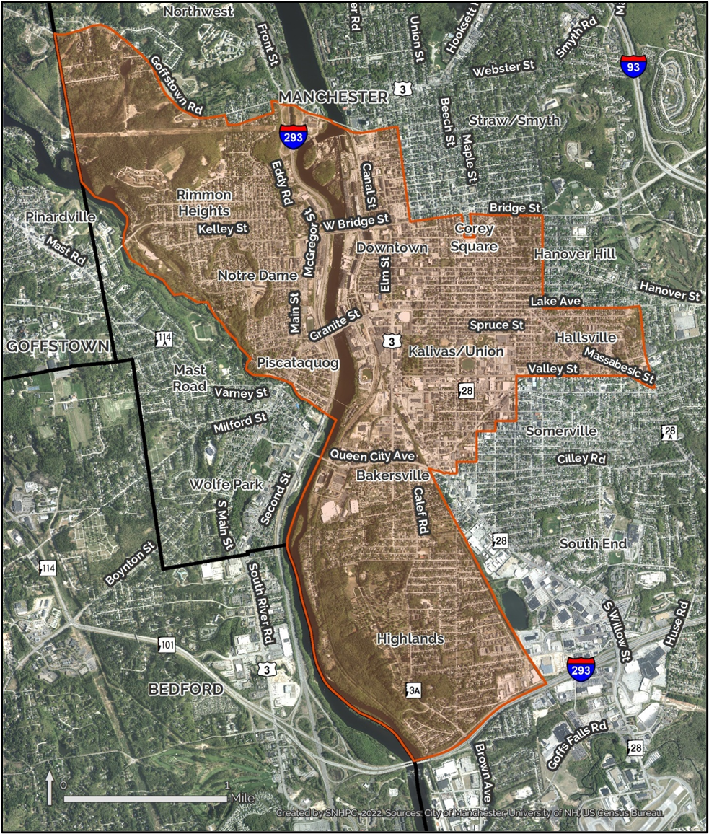
Figure 9: Equity Area

Housing Unit Trends and Characteristics

Housing Inventory
The 14-community SNHPC Region, as of 2020, hosts 115,580 housing units. These are comprised of single-family, two-family or duplex, or multi-family homes, as well as condominiums and manufactured homes. This is just about 18 percent of the homes in the State of New Hampshire. The region's communities vary in size from Francestown, the smallest, with an estimated 740 units to Manchester, the largest, with 51,440 units.
Table 23: Total Housing units
 | Total Housing Units
 | 2010 | 2020 | Change 2010-20
Auburn | 1,810 | 2,140 | 320 | 18%
Bedford | 7,630 | 8,280 | 650 | 8%
Candia | 1,490 | 1,570 | 80 | 5%
Chester | 1,600 | 1,850 | 250 | 16%
Deerfield | 1,740 | 1,920 | 180 | 10%
Derry | 13,280 | 14,010 | 730 | 6%
Francestown | 760 | 740 | -20 | -2%
Goffstown | 6,340 | 6,620 | 280 | 4%
Hooksett | 5,180 | 5,790 | 600 | 12%
Londonderry | 8,770 | 9,850 | 1,080 | 12%
Manchester | 49,290 | 51,440 | 2,150 | 4%
New Boston | 1,970 | 2,170 | 210 | 11%
Weare | 3,470 | 3,630 | 170 | 5%
Windham | 5,160 | 5,580 | 410 | 8%
SNHPC | 108,490 | 115,580 | 7,090 | 7%
NH | 614,750 | 638,800 | 24,040 | 4%
Decennial Census
Source: US Census Bureau

Number of Units Permitted
A common indicator of housing supply is building permit activity. All towns issue building permits for housing construction, although not every town issues a Certificate of Occupancy; therefore, while the number of permits issued may not equal the housing units being built, they are nevertheless an important data point.
Within the Southern New Hampshire region building permit activity declined sharply from 2000 to 2020. Based on U.S. Census data, there were 1,524 permits issued for all housing types in 2000, and in 2020 this number had fallen to 692. Within these two decades, the greatest decline was from 2000 to 2010, when the number of permits dropped to 388; by 2015 the number was up to 1,029, only to drop again in 2020.

Accessory Dwelling Units
Accessory Dwelling Units (ADUs) are a secondary home or apartment that shares a lot with a primary residence. In New Hampshire, allowing these units has been a statutory requirement since 2017; these units may either be attached to the primary residence or detached, and while communities may choose to allow both, they must allow the attached units.
In the Southern New Hampshire region, four of the 14 communities allow detached ADUs - Deerfield, Londonderry, Manchester, and New Boston. Manchester requires a Conditional Use Permit for these units, while the other three communities permit them by right.
Of the remaining 10 communities, four permit these units by right – Francestown, Bedford, Derry, and Windham, while the others require a special exception (Candia, Auburn, Chester, Goffstown, and Weare) or Conditional Use Permit (Hooksett). All 14 towns require that the ADU or the primary residence be owner-occupied.

Vacancy Rates (by Tenure)
Vacancy rates are calculated by dividing the number of vacant units by the total number of units. Vacancy rates are one indicator of housing supply. For example, a low vacancy rate is one indicator that there is a not enough supply to meet the demand. Nationwide and in New Hampshire vacancy rates are at historic lows, both for owner-occupied and renter-occupied units. A standard industry rate for a balanced housing market is 5% vacancy; this ensures that there is enough inventory for some movement of both renters and homeowners. Any number below 5% is considered to indicate a tight housing market with very little supply.
The U.S. Census tracks vacancies by various categories, including units that are for rent or for sale, or for seasonal or other use. In 2020 the Southern NH region had a total of 4,820 vacant housing unit, which represented 4% of the total housing stock. The percentage varied from 2% (Auburn and Chester) to 13% (Francestown). The 4% regional vacancy rate compares to a 13% statewide vacancy rate. Noteworthy is that the rate for both the region and the state declined from 2010, when the region had a rate of 6% and the state 16%, data that are consistent with other findings regarding the growing lack of housing supply.

Density of Housing
Housing density refers to the number of housing units per acre. The 2020 U.S. Census calculated that the Southern New Hampshire region had an overall density of 0.36 dwelling units per acre. Within the region, the numbers varied quite a bit, from a low of 0.04 in Francestown to a high of 2.43 in Manchester. Not surprisingly, the municipalities with water and sewer infrastructure (Manchester, Derry, Londonderry) had higher densities than the rural towns with no municipal infrastructure.
Density – or rather, the capacity for density is a factor in the supply of housing. Communities with water and sewer infrastructure are able to support a higher density, and therefore a greater number of housing units. Rural communities with limited or no water and/or sewer infrastructure tend to have larger minimum lot sizes that are intended to support on-site wells and septic systems.

Age of Housing Stock
The age of housing stock can be an indicator of its condition; for example, whether the house was built prior to the adoption of certain building and fire codes. Census data collected on age of housing stock uses pre-1940 as a starting point, and then counts the number of units constructed in every decade since. In 2020 19% of all occupied housing units in the Southern New Hampshire region were constructed prior to 1940. While the age does not necessarily mean that these houses are in poor condition, it does suggest that improvements or repairs could be more complicated since they were built prior to the existence of widespread building codes. Looking at the time of construction by decade, the bulk of the occupied housing units in the region were constructed in the 1970s through the 1990s. Since 2010, only 4% of the housing in the region has been constructed.

Distribution of Workforce and Affordable Housing Units
Workforce and affordable housing often mean the same thing, in that the relevant income levels are the same. By definition, “Workforce Housing” means for-sale housing that is affordable to a household of four earning up to 100% of the Area Median Income (AMI); or rental housing that is affordable to a household of three earning up to 60% of the average median income (AMI). “Affordable” is defined as spending no more than 30% of a household’s income on housing costs. (Ownership housing cost is defined as principal, interest, taxes and insurance; rental cost is defined as rent plus utilities.)
Notably, 62% of respondents who completed the employer survey stated they believe that a housing supply shortage impacts their ability to attract or keep workers. 65% of respondents described the availability of housing options in or near the area where their business is located as “very limited”. Availability of housing (for rent or purchase), cost of housing (rent or mortgage) and quality of housing were all identified as having a “high impact” on employers’ ability to attract or keep qualified workers.

Inventory of Income-Restricted Housing
Income-restricted housing – or assisted or public housing, is housing that is targeted toward very low- or low-income households. The approach provides housing support through income and rent restrictions, or a rent subsidy. Funding for these programs comes from a variety of sources, including the U.S. Department of Housing and Urban Development (HUD), USDA Rural Development, or the NH Housing Finance Authority. In New Hampshire, these programs are administered by the NH Housing Finance Authority, the NH Community Development Finance Authority, or local Housing and Community Development Authorities. Many housing projects use a combination of these funding sources.

Public Housing
Within the Southern NH planning region are hundreds of public housing units that are funded, owned and/or managed by the above-noted agencies. Manchester has the greatest amount of public housing (2,640 units), of all types, and most of that is owned and managed by the Manchester Housing and Redevelopment Development Authority. Outside of Manchester, there are 1,450 units of public housing located in Bedford, Goffstown, Hooksett, Derry, Londonderry and Windham.

Housing Vouchers
Housing vouchers – known as the Section 8 Housing Choice Voucher Program, is administered statewide by the NH Housing Finance Authority, and regionally by the Manchester Housing and Community Development Authority.
The Section 8 program provides housing vouchers to low-income families, which can be used in any approved rental unit with a landlord willing to participate in the program. The subsidy is paid directly to the landlord by the administering agency, and any difference between the subsidy and the rent is made up by the renters.
Table 24 shows the Section 8 units by town in the Region administered by the NH Housing Finance Authority as well as the units administered by the Manchester Housing and Redevelopment Authority. The large majority of these units are in Manchester, followed by Derry.
Table 24: Housing Choice Voucher Program (Section 8) Participant Housing Units by Municipality
Housing Choice Voucher Program (Section 8) Participant Housing Units by Municipality
 | NH Housing Finance Authority | Manchester Housing and Redevelopment Authority
Auburn | 3 | 1
Bedford | 20 | 10
Candia | 1 | 0
Chester | 0 | 0
Deerfield | 20 | 0
Derry | 225 | 0
Francestown | 0 | 0
Goffstown | 29 | 29
Hooksett | 31 | 20
Londonderry | 80 | 8
Manchester | 636 | 1,919
New Boston | 3 | 0
Weare | 7 | 0
Windham | 2 | 0
SNHPC | 1,057 | 1,987
NH | 4,083 | 1,995
Out of the State | 8 | 98
MHRA figures current as of October 2022. NHHFA figures current as of January 2021.
Sources: Manchester Housing & Redevelopment Authority; NH Housing Finance Authority; US Census Bureau.

It is worth noting that while there are a total of 3,050 Section 8 units in the region, there are 5,634 households on a waiting list and an additional 244 households that have been accepted but are still waiting for an available unit. The demand for assisted housing clearly outstrips the supply in this region.

Low-Income Tax Credits
The Low Income Housing Tax Credit Program (LIHTC) is different from the other programs described in that it serves as incentive to developers to create and/or preserve affordable rental housing. Developers receive a dollar-for-dollar reduction in their federal tax liability in exchange for developing affordable housing units. In New Hampshire it is administered by the NH Housing Finance Authority statewide, and regionally by the Manchester Housing and Redevelopment Authority.

Housing for Communities of Interest
As noted above, certain populations have been identified as being a “community of interest or concern”, based on various factors that put them at a disadvantage in securing safe and affordable housing. Table 25 presents data on the number of housing units in the Southern NH planning region that are designated specifically for those people that fall within one of the designated communities. The region has a total of 5,080 units for six different communities of interest/concern.
Table 25: NH Housing Finance Authority's Documented Assisted Housing Units 2022
NH Housing Finance Authority's Documented Assisted Housing Units
 | 2022
 | Total Assisted Housing Units | Elderly Units | Family Units | Special Needs Units | Rent Assisted Units | Accessible Units | Income Based Rent Units
Auburn | 0 | 0 | 0 | 0 | 0 | 0 | 0
Bedford | 90 | 50 | 40 | 0 | 90 | 5 | 50
Candia | 0 | 0 | 0 | 0 | 0 | 0 | 0
Chester | 0 | 0 | 0 | 0 | 0 | 0 | 0
Deerfield | 20 | 20 | 0 | 0 | 20 | 0 | 0
Derry | 1,160 | 180 | 980 | 0 | 440 | 80 | 180
Francestown | 0 | 0 | 0 | 0 | 0 | 0 | 0
Goffstown | 200 | 130 | 70 | 0 | 160 | 20 | 90
Hooksett | 190 | 70 | 120 | 0 | 160 | 10 | 110
Londonderry | 350 | 100 | 250 | 0 | 260 | 0 | 0
Manchester | 3,050 | 1,520 | 1,400 | 130 | 2,910 | 520 | 1,970
New Boston | 0 | 0 | 0 | 0 | 0 | 0 | 0
Weare | 0 | 0 | 0 | 0 | 0 | 0 | 0
Windham | 20 | 20 | 0 | 0 | 20 | 0 | 20
SNHPC | 5,080 | 2,100 | 2,860 | 130 | 4,060 | 640 | 2,420
NH | 22,750 | 11,490 | 10,740 | 520 | 20,350 | 2,840 | 14,240
Source: NH Housing Finance Authority

Case Studies of Workforce Developments
In 2010 the NH Legislature enacted the Workforce Housing Law (RSA 674:58-61), codifying and clarifying NH court cases regarding the obligation of municipalities to provide housing opportunities. The law requires municipalities to provide reasonable opportunities for housing alternatives affordable to the local workforce.
In 2021 the NH Housing Finance Authority commissioned a study to review the status of workforce housing availability in the 10 years since the passage of the law. The report highlighted 10 case studies in Bedford, Chester, Conway, Dover, Hanover, Lancaster, Londonderry, North Hampton, Pelham, and Rindge. Of these 10 towns, 9 have workforce housing projects that total 147 units, comprised of both rented and owned units.
In addition to the case studies, the report also assessed compliance with the law in 33 municipalities. One of the takeaways from this report was to identify the obstacles to development faced by both developers and local governments.

The Housing Market (Cost and Affordability)
If you Google “housing costs”, you will come upon treasure trove of articles highlighting soaring interest rates and the effects on mortgages, wages not keeping up with those interest rates, land costs and the price of zoning restrictions, even the lack of developer confidence to get housing approvals is discussed in detail. This has created a vortex of housing supply deficiencies and soaring costs. The stories paint a rather bleak picture of current conditions, and the following sections offer some additional insight into these various issues.

Housing Prices and Rents
What We Heard: According to the general public survey, approximately 45% of respondents overall housing costs are less than 30% of their household's income. Approximately 36% reported their overall housing costs account for between 30-50% of their household's total income and 12% reported spending greater than 50% of their household's total income. This means that nearly half of all respondents (48%) feel that they are housing burdened, meaning they are spending more than 30% of their household income on overall housing costs. For respondents in Manchester this number increases slightly to 50%, in medium size towns (Bedford, Derry, Goffstown, Hooksett, Londonderry, Windham) it is 48% and in small towns (Auburn, Candia, Chester, Deerfield, Francestown, New Boston, Weare) it is slightly lower at 44%. For young adults (under 18-34) living in the SNHPC region, 46% reported spending 30% or more of their household income on housing.
What Do The Numbers Say: Since 2000, there has been a decline in the rate of building permits issued in the SNHPC Region. Meanwhile, the average rate of property listings has declined by over 80% since 2010 resulting in a market where demand is high, and supply is low. As less homes are being built in the region, the price of homes continues to increase. Since 2010, the median home purchase price has almost doubled, from $200,000 in 2010 to almost $400,000 in 2021. Similarly, the median rent has increased almost 50 percent since 2010 in the SNHPC region. Additionally, median incomes in the SNHPC have only increased by around 20% since 2010, failing to keep up with increasing housing costs. These factors have resulted in a shortage of potential households affordable to those making less than 30% of the Region’s Area Median Income (AMI).
Figure 10: SNHPC Active Property Listings (12- Month Moving Average) | Figure 11: SNHPC Nominal Median Purchase Price (12- Month Moving Average)  Source: NH Housing Finance Authority

Income
Overall Median Household Incomes in 2020 ranged from $62,100 in Manchester, to $154,000 in Windham. Figure 13 illustrates median household income ranges for the SNHPC region. Median household income is increasing in NH and the SNHPC. However, the cost of goods and services has been increasing at a higher rate over recent years as a result of inflation.

Figure 12: Households by Income

Figure 13: Median Household Income
Area median income, often referred to as simply AMI, is a key metric in affordable housing. Area median income is defined as the midpoint of a specific area’s income distribution and is calculated on an annual basis by the Department of Housing and Urban Development. Low Income is considered to be at or below 80% of the AMI; Very Low Income is considered to be at or below 50% of the AMI; and Extremely Low Income is considered to be at or below 30% of the AMI. In the SNHPC region, 42 percent of households are considered to be Low Income; 25 percent are considered to be Very Low Income; and 13 percent of households are considered to be Extremely Low Income.
Table 26: Percent Households by Area Median Income (AMI) 2020
 | 2020
 |  | % Households by Area Median Income (AMI)
 | Total Households | <30% AMI | <50% AMI | <60% AMI | <80% AMI | <100% AMI | >100% AMI | >120% AMI
Auburn | 1,920 | 2% | 7% | 11% | 20% | 30% | 70% | 57%
Bedford | 7,910 | 7% | 12% | 15% | 23% | 32% | 68% | 60%
Candia | 1,480 | 12% | 22% | 28% | 37% | 46% | 54% | 46%
Chester | 1,740 | 3% | 10% | 13% | 20% | 28% | 72% | 64%
Deerfield | 1,650 | 8% | 19% | 24% | 31% | 38% | 62% | 53%
Derry | 12,710 | 12% | 23% | 30% | 43% | 53% | 47% | 38%
Francestown | 620 | 7% | 15% | 20% | 31% | 43% | 57% | 48%
Goffstown | 6,290 | 12% | 22% | 27% | 39% | 49% | 51% | 41%
Hooksett | 5,160 | 10% | 21% | 28% | 42% | 53% | 47% | 37%
Londonderry | 9,570 | 7% | 16% | 21% | 31% | 40% | 60% | 51%
Manchester | 47,240 | 18% | 34% | 41% | 55% | 66% | 34% | 25%
New Boston | 2,120 | 5% | 10% | 12% | 19% | 31% | 69% | 58%
Weare | 3,280 | 13% | 19% | 24% | 31% | 45% | 55% | 43%
Windham | 5,020 | 6% | 10% | 13% | 20% | 27% | 73% | 67%
SNHPC | 106,710 | 13% | 25% | 31% | 42% | 53% | 47% | 38%
NH | 539,120 | 15% | 28% | 34% | 47% | 58% | 42% | 33%
AMI determined by HUD Fair Market Rent Area value for a four-person household. 5-Year American Community Survey.
Sources: NH Housing Finance Authority; US Census Bureau.

Figure 14: Percentage of Households by Area Median Income (AMI) in the SNHPC Region

Figure 15: Percentage of Households by Area Median Income (AMI) in NH

Affordability in the SNHPC Region
Both home prices and rent have increased at a higher rate than incomes in the SNHPC region. What does this mean for the working person in our region? To get a better understanding of this question of affordability, Root Policy Research conducted an analysis to see if the median rent and median home prices are affordable to typical occupations in the SNHPC region. Occupations ranged from entry-level to experienced jobs in service and skilled labor sectors. Median gross rent figures for each region were supplied to Root Policy Research by NHHFA. The median gross rent for the SNHPC region was $1,510. Wage figures were provided by NH Employment Security (NHES) and reflect official income for real individuals.
The following table considers whether a single-earner household would be paying 30% or more of their wages on gross rent. If a household paid 30% or more, they would be considered housing cost burdened and the median rent would be considered unaffordable. Results are broken down by occupation as well by wage income level. NHES defines an entry level wage as the average of the lower third of the population in question. An experienced wage is the average of the upper two-thirds of the population. The difference between wages and the maximum gross rent a household could afford to pay is also listed with a negative value signifying that median rent is higher.
Table 27: Rental Affordability by Occupation (Southern New Hampshire Planning Commission)
Rental Affordability by Occupation (Southern New Hampshire Planning Commission)
 | Median Rent (2022)
 | $1,510
 | Is the Median Rent Affordable to...?
 | Entry Level Wage | Cost Difference | Median Wage | Cost Difference | Experienced Wage | Cost Difference
Assemblers & Fabricators | No | -$710 | No | -$480 | No | -$300
Cashiers | No | -$920 | No | -$850 | No | -$750
Childcare Workers | No | -$1,010 | No | -$890 | No | -$780
Construction Laborers | No | -$590 | No | -$410 | No | -$230
Electricians | No | -$440 | Yes | $130 | Yes | $440
Engineers | Yes | $250 | Yes | $1,050 | Yes | $1,650
Fast Food & Counter Workers | No | -$930 | No | -$830 | No | -$740
Heavy & Tractor-Trailer Truck Drivers | No | -$350 | No | -$160 | Yes | $120
Home Health & Personal Care Aides | No | -$790 | No | -$700 | No | -$620
Janitors & Cleaners, Except Maids & Housekeeping Cleaners | No | -$820 | No | -$680 | No | -$500
Office Clerks, General | No | -$680 | No | -$340 | No | -$160
Police & Sheriff's Patrol Officers | No | -$90 | Yes | $240 | Yes | $580
Registered Nurses | Yes | $120 | Yes | $590 | Yes | $880
Retail Salespersons | No | -$900 | No | -$710 | No | -$480
Waiters & Waitresses | No | -$1,020 | No | -$800 | No | -$460
Source: Root Policy Research
Review of Variables: Based on reported wages, median rent, single-wage earner, and to be affordable 30 % or less is dedicated towards rent.
Excluding entry-level engineers and registered nurses, median rent is unaffordable to occupations observed in this analysis. More occupations can afford the median rent at the median and experienced wage thresholds. However, 10 out of the 15 occupations considered would not be able to afford the median rent on a single-earner income, even at higher wage levels.
Performing a similar analysis for owner-occupied housing units is more complicated. The affordability of a purchased home is largely dependent on a homeowner's mortgage payment which is driven by interest rates and the downpayment provided. Changes in either can have significant effects on housing affordability. For the purposes of this analysis, the June 2022 30-year average was used. A downpayment amount of 30% was also selected. A downpayment of this size would likely not reflect a first-time homebuyer but someone bringing housing equity to the purchase. A scenario where the downpayment is only 10%, more reflective of a first-time homebuyer’s experience, can be found in Appendix C. 40% of a household’s wage income was also set aside to pay for other housing expenses like property taxes, utilities, and insurance. Another major difference from the rent affordability calculation is a household’s income was estimated assuming 1.5 wage earners. For example, the median income for construction laborers in the region in 2022 was $42,100. A household with 1.5 times a construction labor’s wage income would therefore be $63,100. Owner-occupied housing units more likely to have multiple wage earners and wage value of one and half was used to indicate that. Calculations instead using a single-wage earner can be found in Appendix C.
Median home prices were again supplied by NHHFA, with SNHPC’s median price totaling $387,000, and wages coming from NHES. The following table considers whether a 1.5 wage earner household would be paying 30% or more of their wages on a mortgage and other housing expenses. Households paying 30% or more would be considered housing cost burdened. Results are displayed by occupation and wage. An entry level wage is the average of the lower third of the occupation’s wages; an experienced wage is the average of the upper two-thirds. The difference between a household’s wage and the maximum housing costs a household could pay is also listed with a negative value signifying that the median home price is higher.
Under this scenario, fewer occupations could afford the median home price. No occupation could afford the median home price at entry level wages. Engineers and registered nurses could afford it at the median wage level with police & sheriff's patrol officers joining them at the experience level. The 12 other occupations could not afford the median price at any wage level.

Table 28: Purchase Affordability by Occupation (Southern New Hampshire Planning Commission)
Home Purchase Affordability by Occupation (Southern New Hampshire Planning Commission)
 | Median Home Price (2022) | Interest Rate | Downpayment | % of Payment Going to Property Taxes, Utilities, Insurance, etc.
 | $387,000 | 5.50% | 30% | 40%
 | Is the Median Home Price Affordable to...? (1.5 Wage Earners)
 | Entry Level Wage | Price Difference | Median Wage | Price Difference | Experienced Wage | Price Difference
Assemblers & Fabricators | No | -$221,738 | No | -$160,525 | No | -$117,033
Cashiers | No | -$265,217 | No | -$251,902 | No | -$228,813
Childcare Workers | No | -$284,587 | No | -$257,328 | No | -$233,367
Construction Laborers | No | -$198,247 | No | -$170,243 | No | -$128,261
Electricians | No | -$165,689 | No | -$52,348 | No | -$6,405
Engineers | No | -$24,330 | Yes | $161,025 | Yes | $275,712
Fast Food & Counter Workers | No | -$267,278 | No | -$246,559 | No | -$227,498
Heavy & Tractor-Trailer Truck Drivers | No | -$147,761 | No | -$111,796 | No | -$59,934
Home Health & Personal Care Aides | No | -$239,253 | No | -$222,687 | No | -$200,118
Janitors & Cleaners, Except Maids & Housekeeping Cleaners | No | -$245,641 | No | -$215,050 | No | -$176,005
Office Clerks, General | No | -$215,968 | No | -$163,446 | No | -$106,862
Police & Sheriff's Patrol Officers | No | -$93,979 | No | -$39,413 | Yes | $12,258
Registered Nurses | No | -$51,942 | Yes | $45,048 | Yes | $105,218
Retail Salespersons | No | -$261,302 | No | -$222,580 | No | -$170,870
Waiters & Waitresses | No | -$285,411 | No | -$244,590 | No | -$169,404
Source: Root Policy Research
Review of Variables: Based on reported wages, median house price, one and a half wage earners, 30% down payment, 5.5 % interest rate, 40% household income to taxes, utilities etc., to be affordable 30 % or less is dedicated towards rent.
Market conditions of 2020-2021 created an incentive for homeownership. In the midst of the COVID-19 Pandemic, New Hampshire renters, homeowners, and homebuyers were largely in a secure position. Record-low interest rates provided purchasing and refinancing opportunities for homebuyers. A state and federal eviction and foreclosure moratoria allowed renters and homeowners to stay in their homes despite potential income or work-hour loss from the COVID-19 Pandemic. Despite these opportunities, an extremely low inventory of houses and continued high demand have pushed the median home sales price to record highs. (Cite Oct 2020, June ‘22 NHHFA report)
According to the NH Business Review New Hampshire’s housing affordability index sank to an all-time low in September 2022. The affordability index is determined by calculating the amount of income needed to meet major monthly home ownership expenses — including mortgage (at prevailing rates), property taxes and insurance — on a median-priced single-family home. It assumed a 20% down payment and a 28% maximum “front-end” debt-to-income ratio. That required income was then compared to annualized average weekly wage data from the U.S. Bureau of Labor Statistics.
A value of 100 indicates that the typical median-income family has exactly enough money to qualify for a home. Any value below 100 means that a family may struggle to qualify for a mortgage on a home in a particular area. The lower the value, the greater the struggle to afford the mortgage. In September, the statewide value was 69 for a single-family home and 87 for a residential condo. The report shows that New Hampshire’s four most populated counties have become less affordable: Hillsborough, Merrimack, Rockingham, and Strafford, with Merrimack being the least affordable.
What We Heard: 95 public survey respondents stated that more affordable housing was needed for existing and future residents. Respondents stated many barriers to affordable housing, including a lack of options, the need for living wages, and high property taxes.
- “We need affordable housing, and living wages. We also need education on the importance of savings and finances.”
- “The cost of housing in NH is out of control. There are 4 people in my house, because my adult sons cannot afford apartments of their own.”
- “Taxes make it difficult to stay in your home as you age. The community does very little for the seniors”

Figure 16: US Construction Costs Have Historically Not Driven the Rising Cost of Housing
Source: Robert Shiller
The cost of constructing and buying a home spiked with the outbreak of the COVID-19 pandemic. One issue led to another as the pandemic and emergency measures led to labor shortages. This created supply complications: goods were unavailable and even if they were, their delivery system was interrupted. A rise in demand was also fueled in part by low interest rates. Despite the recent shortages, historically the increase in housing prices has not been cause by increases in construction costs. Between 1980 and 2020 the growth in real home prices greatly outpaced increase in real building costs. (See section VI for more in-depth look at the impacts and costs to housing supply).
According to the McKinsey Global Institute, the construction industry lags behind other sectors that have seen major improvement in productivity. Since 1945 in the United States, productivity has increased significantly in manufacturing, retail, and agriculture, growing by as much as 1,500%, while construction productivity has remained largely unchanged.
It is possible that a lack of competition in the homebuilding industry over the past decade has also contributed to fewer homes being built and for a higher price. It is possible that higher housing and land costs could be a cause of industry consolidation rather than an effect.

Current Housing Gaps
The ownership gaps analysis compares renters, renter income levels, the maximum monthly housing payment they could afford, and the proportion of units in the market that were affordable to them. Renters are used for the demand side of the ownership gaps because the analysis intends to capture renters’ ability to purchase a home (as opposed to measuring existing owners’ ability to buy and sell).
Maximum affordable home prices used for the analysis assume a 30-year mortgage with a 10% down payment and an interest rate of 5.5%.4 The estimates also incorporate property taxes, insurance, HOA payments and utilities—assumed to collectively account for 40% of the monthly payment.
- Demand side. The number of renter households at different income levels is estimated in the same manner as it is estimated for the rental gaps—using the maximum affordable home price for each income threshold, and assuming households spend no more than 30% of their income on housing costs. Once the number of renter households in each income bracket is estimated, the percent of renters in each income bracket is calculated.
- Supply side. The number of units affordable to renter households is calculated by adding the number of units that were sold at or below the corresponding affordable price threshold, using MLS data on sold properties in a specific year. Once the number of homes sold in each price bracket is estimated, the percent of units in each price bracket is estimated.
- Ownership Gaps. Finally, the ownership gap is calculated as the percent of units that sold at or below the maximum affordable home price for a particular income level (supply) minus the percent of renter households at or below the particular income level (demand). This renter purchase gap shows the difference between the proportion of renter households and the proportion of homes sold that were affordable to them. Negative numbers indicate a shortage of units at the specific income level; positive units indicate an excess of units.

Table 29: Potential Homeowner Gap
 | Potential Homeowner Gap
 | The Relative Market Mismatch Between Home Sales & Renting Households That May Want to Purchase Them
 |  | Positive Percentages Represent a Surplus of Units in That Price Range. Negative Percentages Represent a Shortage.
 |  | Household Income As % of Area Median Income (AMI)
 |  | 0-30% | 31-50% | 51-60% | 61-80% | 81-100% | 101-120% | 120%+
Manchester | 2010 | -30% | -10% | 2% | 9% | 12% | 8% | 9%
 | 2020 | -29% | -14% | -3% | -4% | 12% | 20% | 18%
SNHPC | 2010 | -27% | -11% | 0% | 6% | 9% | 8% | 15%
 | 2020 | -27% | -17% | -6% | -8% | 5% | 10% | 42%
CNHRPC | 2010 | -27% | -10% | 1% | 15% | 7% | 6% | 7%
 | 2020 | -34% | -14% | -3% | -3% | 9% | 13% | 32%
LRPC | 2010 | -29% | -12% | 0% | 12% | 9% | 3% | 17%
 | 2020 | -32% | -18% | -4% | -2% | 7% | 10% | 40%
NRPC | 2010 | -29% | -11% | 0% | 10% | 13% | 9% | 8%
 | 2020 | -33% | -19% | -5% | -1% | 10% | 18% | 29%
NCC | 2010 | -23% | -10% | -2% | 7% | 9% | 7% | 13%
 | 2020 | -32% | -13% | -3% | 2% | 4% | 9% | 33%
RPC | 2010 | -27% | -14% | -4% | 1% | 11% | 9% | 24%
 | 2020 | -28% | -18% | -6% | -9% | -2% | 8% | 56%
SWRPC | 2010 | -23% | -9% | 2% | 13% | 6% | 4% | 7%
 | 2020 | -30% | -15% | -2% | 3% | 11% | 13% | 18%
SRPC | 2010 | -30% | -8% | 1% | 12% | 12% | 6% | 8%
 | 2020 | -32% | -15% | -5% | -1% | 13% | 15% | 25%
UVLSRPC | 2010 | -22% | -9% | -2% | 2% | 3% | 5% | 23%
 | 2020 | -32% | -13% | 0% | 3% | 5% | 4% | 34%
Source: Root Policy
Across New Hampshire, there is an average 30% shortage of units for households making 0-30% of their AMI. In the SNHPC has the lowest unit shortage in the 0-30% AMI bracket compared to other regional planning commission regions. The gap analysis largely shows that there is a surplus in homes at a higher price range and a shortage in affordable units for households making 0-50% of the AMI.

New policies/laws enacted
The Housing chapter of the 2015 Southern NH Regional Comprehensive Plan includes a section that describes state laws in effect at that time that address various housing issues. Since 2015, one element that New Hampshire has embraced across the state is the allowance for one additional small dwelling on any given residential property, better known as the accessory dwelling unit.

Accessory Dwelling Units (ADUs)
The New Hampshire Housing and Finance Authority (NHHFA) published a legislative guide to the Accessory Dwelling Units statute. The following is an excerpt from the guide. The full Accessory Dwelling Units in New Hampshire – A Guide for Municipalities, can be found on the NHHFA website.
The New Hampshire Accessory Dwelling Units statute (RSA 674:71 - 73) became law on June 1, 2017. As expressed by the Legislature, the intent of the law is to expand the supply of housing in New Hampshire communities without further land development, as well as to encourage efficient use of existing housing stock and infrastructure and provide an affordable housing option in communities. Accessory dwelling units are residential living units attached to or associated with a single-family dwelling, providing independent living facilities for one or more persons (e.g., an apartment over a garage, in a basement, in an outbuilding). Under the law, homeowners statewide now have the right to create an ADU for a family member, caregiver, or as a rental unit, in accordance with local ordinances.

The Housing Appeals Board
In 2020 the NH Legislature established the Housing Appeals Board (HAB), whose responsibilities are to provide an alternative forum to the NH Superior Court in planning and zoning board cases that deal with housing and housing development. The Board is modeled after the Board of Land and Tax Appeals and is intended to settle disputes between developers and local land use boards without going to court. The Board is made up of three members who are appointed by the NH Supreme Court. One must be an attorney, one must be either an engineer or land surveyor, and all must have experience in land use or housing development.
The Board's purpose is to provide an alternative forum to the New Hampshire Superior Court in zoning and planning cases that are timely, fair, inexpensive, and accessible to affected property owners, abutters, other proper parties, and municipalities. The Board has a responsibility parallel to the Superior Court to hear appeals of all planning and zoning decisions as specified in NH RSA 679. Proponents of the Board see this as a way to help meet the state’s shortage of affordable housing. Specifically, the responsibilities of the Board cover:
- Planning board decisions on subdivisions or site plans.
- Board of adjustment decisions on variances, special exceptions, administrative appeals, and ordinance administration.
- The use of innovative land use controls.
- Growth management controls and interim growth management controls.
- Decisions of historic district commissions, heritage commissions, and conservation commissions.
- Other municipal permits and fees applicable to housing and housing developments.
- Matters subject to the board's authority may include mixed-use combinations of residential and nonresidential uses. Such different uses may occur on separate properties, provided such properties are all part of a common scheme of development.
An appeal before the HAB can be as short as six months, compared to potentially several years in court. The process is as follows:
- The aggrieved party files with the Board within 30 days of the final land use decision and notifies the local land use board of this action.
- Within 30 days of receipt of this notice, the local land use board must submit a certified record of the case to HAB.
- Within 90 days, HAB will hold a hearing and will render a decision within 60 days of the conclusion of the hearing.
Decisions of the HAB are appealable to the NH Supreme Court.
Since the Board began to take cases in 2021, it has heard and rendered decisions on 36 appeals. Six of these were dismissed for lack of jurisdiction or withdrawn by the applicant. The majority (21) are appeals from Zoning Board decisions, primarily denial of variances. Of the 30 decisions rendered, 10 affirmed the board decision, 11 reversed outright, and 9 were remanded back to the board. As of this writing, HAB has heard 12 more cases for which a decision has not yet been rendered, and five cases are in the queue waiting for a hearing.

Workforce Housing Incentives
Beginning July 1, 2023, incentives established for housing for older persons shall be deemed applicable to workforce housing development under RSA 674:17.IV. If a municipality allows an increased density, reduced lot size, expedited approval, or other dimensional or procedural incentive under this section for the development of housing for older persons, as defined and regulated pursuant to RSA 354-A:15, VIII, it may allow the same incentive for the development of workforce housing as defined in RSA 674:58, IV.

Housing Opportunity Zones
Effective April 1, 2022, a city or town can establish a Housing Opportunity Zone under the Community Revitalization Tax Relief Incentive (RSA 79-E: 4-c). No less than one-third of the housing units constructed can be designated for households with an income of 80 percent or less of the area median income as measured by the HUD, or the housing units in a qualifying structure shall be designated for households with incomes as provided in RSA 204-C:57, IV. A qualifying structure under this section can be eligible for tax assessment relief for a period of up to 10 years.

NH Update on Employer Housing
Business owners Maggie and John Randolph of Harmony Homes in Dover, NH, recognized that in order to attract staff to work at their assisted living facilities, they needed to build affordable housing for their staff. According to Maggie, “Harmony Place is the multi-use building we just constructed on the campus of our assisted living facility, Harmony Homes. It contains seven one-bedroom apartments, a child care, and office space all for our staff, the units of which are rented to staff at 30% of their pay.” Due to the success of this project, the Randolph family team decided to continue building affordable housing. Maggie described this second project: “The Cottages at Back River Road in Dover is now under construction, with site work hoping to be completed late summer/early fall 2022, with units starting to be built starting in April of 2023. They are planned in a ‘pocket neighborhood’ or ‘cottage court’ layout so as to allow residents their own living space as well as a feeling of community within the overall context of the surrounding neighborhood. These units will be open to anyone, not just employees of Harmony Homes.” The success of their projects is gaining the attention of businesses across New Hampshire. Thanks to the Randolph’s ingenuity and innovative zoning allowed by the City of Dover this project was allowed to happen.

NH Initiatives to support production
HB 1661. Section 78: Acquiring Property for Workforce Housing – Expands the definition of “public use” under the Tax Increment Finance (TIF) statute, RSA 162-K, to allow any party including a municipality to acquire real property – except by eminent domain – for the purpose of constructing housing units which meet the statutory definition of workforce housing. Said construction may occur either through private development or private commercial enterprise. This law went into effect on August 23, 2022.

Section V – Future conditions and housing projections
This section of this report is intended to discuss the impact various conditions are expected to have on the region’s housing supply. Based on the anticipated impacts, the region’s housing needs are projected through 2030. Specific conditions may affect some regions more than others.

Impacts to Future Housing Supply and Affordability

COVID-19
The COVID-19 pandemic had an impact on supply and availability of housing, materials and labor in the Southern New Hampshire region, as it did in all of New Hampshire, although it affected different areas in different ways. Some of the more noticeable impacts were increased household migration, limitations on housing availability, and challenges in housing affordability.
On June 30, 2021, many of New Hampshire’s most important for-profit and nonprofit developers gathered with2 St. Anselm College's Center for Ethics in Society The Housing We Need Task Force to discuss solutions to New Hampshire’s housing crisis. The developers agreed that the pandemic had turned the housing market upside-down. They noted that interest rates were favorable, which had encouraged more buyers to come out, but buyers with cash now have the upper hand. They also agreed that it is easy to sell anything that you build. The flip side is that due to the pandemic, the costs of labor and materials have risen. In normal times, the cost of land and approvals had driven development decisions, but currently, materials and workers are the chief barrier.
Household Migration: According to an article in the New England Public Policy Center (entitled “How the COVID-19 Pandemic Changed Household Migration in New England”; November 30, 2021) all of New England, but New Hampshire in particular, saw a more than 100% increase in net migration due to the pandemic. This was enabled in large part by the shift to remote work, which allowed many people to relocate from urban areas that were hard-hit by the pandemic to rural areas. In New Hampshire this was especially pronounced in communities with a large proportion of seasonal housing, and a location that was within a reasonable commuting distance from an urban area.
Housing Availability: Another dramatic impact of the pandemic has been its effect on housing availability and affordability. The in-migration to New Hampshire contributed to the strain on an already stressed housing market, with demand for housing outstripping availability of housing. One indicator of availability is a metric known as the Months of Supply Inventory (MSI). In a healthy market, a balanced MSI would be six months – meaning that there is enough supply to last on the market for six months. Data from NH Realtors show that in January of 2020, at the start of the pandemic, the state’s MSI 2.2, already low, and by September of 2022, that number was 1.7.
This was and continues to be more pronounced for people at lower income levels. Based on data from the NH Housing Finance Authority’s Housing Market Report of June 2022, of the nine essential workers surveyed, none of them earned enough to afford the median home price in the Southern New Hampshire Planning Commission region of $344,643.
A report by a housing initiative in the Upper Valley of New Hampshire and Vermont, details the loss of income for residents and the accompanying challenges faced by many people to remain housed. Although this report is specific to this region, the impacts described were felt state-wide, to varying degrees. As the report noted, housing availability was already problematic, with many people being “cost-burdened,” which means paying more than 30% of their income on housing. A shrinking housing supply simply exacerbates the problem.
Loss of Income: At the height of the pandemic (January to March 2021), New Hampshire lost more than 130,000 jobs . The state has largely recovered from this, with unemployment rates at nearly pre-pandemic levels, the economic impacts it had on housing can be expected to continue. In-migration and loss of jobs put many residents in precarious housing situations, including into homelessness. Nevertheless, housing costs continue to remain high and out of reach of lower income individuals (those that earn less than the median income for their area, as defined by Housing and Urban Development). Although Federal assistance in 2020 and 2021 helped to alleviate some of the economic hardships caused by the pandemic, these programs no longer exist and many households that struggled with housing prior to the pandemic are facing the same challenges.

Climate Change
Climate Migrants: Climate change will most assuredly have an impact on future housing supply and affordability. Sea level rise, wildfires, flooding, and drought are just a few of the conditions that will create climate migrants, not just from the affected areas in the United States, but presumably from other parts of the world as well. New England in general and New Hampshire in particular can expect to be the recipient of many of these climate migrants.
Impact on Infrastructure: The northeast historically deals with winter and summer storms, as well as the challenges of drought. For years, New Hampshire residents and businesses have also had to deal with an increased intensity and frequency of storms. The southwest region experiences on a fairly regular basis road closures due to flooding; many of which are due to culvert failure. According to the State of New Hampshire’s Multi-Hazard Mitigation Plan, aging infrastructure is a high risk for the entire state. Local Hazard Mitigation Plans are also acknowledging this issue. For example, the Town of Windham included in its 2019 Plan (1) Upgrade culverts on three specific roads, and (2) Identify aging infrastructure to reduce the potential impact of natural and human-caused disasters on the Town’s facilities and properties.
Housing Affordability & Availability: In-migration due to COVID-19 affected the supply and affordability of housing; it seems reasonable to assume that an influx of climate refugees will also add to the existing housing shortage. Even though an influx may be spread out over a protracted timeframe, it is also reasonable to assume that, at least in the early days, many of the new residents will be people with higher incomes who are in a position to purchase existing or new homes. As the changing climate renders some parts of the country unlivable for some, New England can expect to see an influx of new people, contributing to already strained resources. One example of this is a couple who moved to Rumney from Nevada because of the wildfire threats.
An increase in population, regardless of the cause, will create additional pressure on housing supply. Even without the coastal flooding and wildfire dangers faced by other parts of the country, New Hampshire is expected to experience hotter temperatures and periods of drought which will have a deleterious effect on water and food supply. Furthermore, sea level rise will result in increased tidal flooding; and even though southern New Hampshire has only a small amount of coastline, some inland areas will be affected by tidal flooding. It is anticipated that new housing construction will take challenges associated with climate change and expenses related to energy consumption into consideration by – among other things, building at elevations well above known and anticipated flood-prone areas, designing buildings to be energy-efficient, and utilize technologies that minimize water usage.

Federal Monetary Policy
Federal monetary policy is complex and has ramifications for many sectors of the economy. Pertinent to this report are four primary contributing factors: interest rates; limits on the provision of public housing units; Low Income Tax Credits; and Section 8 vouchers.
Interest Rates. In an effort to slow inflation, the Federal Reserve has been raising interest rates since early 2022, bringing it from 3.1% to 5.5%. To put this into perspective, the monthly payment on a 30-year mortgage for a $300,00 house with a 5% down payment at 3.1% would be $1,619. That same mortgage payment at 5.5% would be $2,029. This increase in rates is expected to slow the housing market, which can produce increased demand in the rental market, a market that is already in short supply.
Public Housing. Housing Authorities nationwide operate under what is known as the Faircloth Limits. This was an amendment to the Housing Act of 1937 which effectively capped the number of housing units owned or operated by public housing agencies to the number of units in existence as of October 1, 1999. This is consistent with federal policy over the last 20+ years, which has sought to discourage production of new public housing (to get away from concentrated ELI households in one location (a household of one or more persons wherein the adjusted family income is equal to or below the percentage of area median income for the county); but instead encourage production of mixed-income developments through HOPE VI, Choice Neighborhoods, and RAD (Rental Assistance Demonstration), with a mix of public and private financing sources. For more information see HUD’s frequently asked questions about the Faircloth Limit.
Low Income Tax Credits/Section 8 Vouchers. These two programs are mentioned here because of the impact federal monetary policy can have on them. In this case, these two programs were scheduled to receive significant increases from the 2021 Build Back Better Act; the allocated funds represented the single largest investment in affordable housing in U.S. history. Due to objections in the Senate, the bill was revised and amended dramatically, and the bill that was signed into law on August 16, 2022 as the Inflation Reduction Act contained no funding for public housing. This was a loss of $150 billion in housing-related funding.

Construction Costs
Contributing to the supply and affordability of housing is the soaring cost of construction. Since the onset of the pandemic, home purchase prices are at an all-time high. According to the Bank of America, from 2018 to 2021 the cost of materials for an average single-family home increased by 42%, translating to roughly $35,000 more to build the home.
Developers who gathered at the June 30, 2021 Housing We Need Task Force generally agreed that market conditions favor larger-scale projects now. Building small-scale projects, such as single detached homes or small single-family developments, is expensive because of the lack of economies of scale, and because approval processes are so burdensome. The costs of regulation are easier to bear when spread over many housing units.
Building Supplies: Building materials make up about one-third of the cost of construction; labor and land costs make up the rest, and they can vary widely by region. Freight costs are also a contributing factor, with costs for truck, rail, and water transportation all increasing significantly since 2021.
Associated with the rising costs are supply side shortages. Shortages result in higher demand which translates to higher costs. These shortages have also impacted the average time it takes to construct multi-family housing. The national average time to complete a multi-family building has been increasing steadily since 2013, although it has leveled off since 2019. These times vary by region, with the Northeast having the longest average time for completion.
Labor Shortages: According to a Portsmouth, NH company one of the biggest concerns for the construction industry is the same as it’s been for several years: lack of qualified tradespeople and an experienced workforce. These concerns are not new, as one industry publication expressed:
“A lack of skilled workers is nothing new to the construction industry. Trade organizations, hiring managers, and small businesses have been complaining that the trades just aren’t attracting young adults anymore, and the current workforce is aging out. But that labor shortage became even more apparent during the pandemic. With fewer people willing to risk going to work combined with a boom in residential construction, the labor shortage continued to grow.” These shortages appear to be driven in large part by four factors:
- Retirements. The average age of construction worker retirement is 61. Many construction workers at or close to retirement moved into retirement when they became unemployed during the pandemic.
- Lack of Young People. There is a very low percentage of young people going into the trades. The 20-24 demographic instead has focused on college.
- Market Competition. Many workers are leaving construction for jobs with better working conditions. For workers who choose to stay in construction, they may job-hop looking for better pay and benefits.
- Increased Demand. Despite the pandemic’s effect on some segments of the construction industry, residential demand boomed; people who were at home embarked on renovation projects, and people who moved into New Hampshire from urban areas built new houses.
There is an educational initiative, described in the online Manchester Ink Link, that is attempting to address this shortage by encouraging more people to explore careers in the trade industry.

Short-Term Rentals
What are they? Short-Term Rentals (STR’s) are generally defined as a residential property that is leased on a temporary basis. These rentals are distinct from conventional lodging facilities such as hotels, motels, and Bed & Breakfast establishments. The duration of an STR can vary from an overnight to several weeks, which further differentiates it from more traditional leasing arrangements, which tend to longer stays of weeks or months.
Short-term rentals have been a feature for quite some time, particularly in popular tourist towns. The rise of rental platforms such as Airbnb and VRBO (vacation rentals by owner) have triggered a dramatic increase in the use of STRs. This has been true around the country, and New Hampshire is no exception. While the White Mountains and the Lakes Region have the most STRs in the state, these rentals are also found in southern New Hampshire. According to AirDNA, as of May 2022, there were 205 STRs identified in the Southern NH Region; note that this number reflects entire houses and does not include private or shared rooms.
Advantages: There are certain economic benefits of these rentals, including increased economic activity in the community, additional income for homeowners, and the ability of visitors to stay in more accessible, non-tourist areas.
Disadvantages: Despite the potential for economic benefits, there are also economic disadvantages, such as reduced local tax revenue, artificial inflation of property values, competition with the traditional lodging industry, and the rise of corporate hosts/owners.
Another side effect of the rise of STRs is the impact they are having on housing availability and affordability. Renters tend to bear the brunt of this as traditional rentals are converted to short-term rentals. Also, these conversions tend to disproportionately affect lower-income neighborhoods. One study notes that as the number of short-term rentals increase, the quantity of affordable housing decreases. Further, as absentee landlords reduce the housing supply, the housing costs for local renters goes up. The difference between an absentee landlord and an owner-occupied rental unit is an important one. Absentee landlords are increasingly corporations who buy up housing stock for the sole purpose of using it for short-term rentals, which removes these units from the available supply in that community. An owner-occupied rental does not have the same impact, since the unit being rented might be within the home itself, or the home is being rented while the owner is away for some period of time.
Local Responses: Communities nationwide have been struggling with how to address the housing problems created by these rentals. In New Hampshire, 31 municipalities have adopted some type of amendment to their zoning ordinances that deals with STRs, from simply defining them, to allowing them subject to certain conditions, to requiring that the property be owner-occupied. In the Southern New Hampshire region Bedford, Candia and New Boston have adopted regulations for short-term rentals.

Student FlucTuation in College Towns
Impact on Housing: The presence of students in a college town can have significant impacts on the housing market. Colleges typically do not provide housing for all of its students; in fact, many only provide housing for freshmen and sophomores. Students who live off-campus will rent apartments and even in some cases a single-family home. This can have differing impacts, depending on the particular housing situation. In a weak housing market, this can provide needed income for older homes that might otherwise be neglected; in a strong market, however, the students represent competition for lower income households and often displace them. According to one study, regardless of the type of market, student housing raises the cost of rentals.
New Hampshire Examples: Colleges in New Hampshire have varied experiences when it comes to student housing. There is a lack of data specific to the Southern NH Region, however the following information has been gathered for the City of Manchester:
Of the seven institutions of higher learning in Manchester, four of them provide some housing for freshmen and/or sophomore students. Southern NH University has the largest student population of the seven and provides the most housing. In all cases, the on-campus students represent a small portion of the total school population. Of the remaining students who do not live on campus, they still may be living with family, or are renting apartments in the area. Since the schools do not collect data on the living situations of their students, complete information is not available.

Aging Populations/ Smaller HouseHolds
New Hampshire’s population is aging; the “Silver Tsunami” has been growing for some time, as the Baby Boomers (those born from 1946 to 1964) age into their 60’s and 70’s. This is not unique to New Hampshire, as the entire country is experiencing the same demographic changes. The most recent population projections developed by the NH Office of Planning and Development (see Table 30) indicated that the 65 and older cohort will increase by 52% between 2020 and 2050. The 85 and older cohort is projected to increase 238%; although this was a much smaller number to begin with in 2020.
The elderly population growth is having an impact on housing availability in the state. This effect has been carefully documented by the NH Center for Public Policy Studies in the 2014 Report “Big Houses, Small Households: Perceptions, Preferences and Assessment”. Key findings from this report include the misalignment of the state’s housing supply with evolving housing preferences. Older residents are looking to downsize because they can no longer manage their homes – either financially or physically and are looking for smaller houses or apartments/condominiums. At the same time, younger people just entering the workforce are looking for the same thing. Realtors in the region have shared that younger couples often compete with older couples for the few smaller, more manageable, and more affordable homes that come on the market. It is the older couple that wins the bid because the home they are downsizing from and selling has considerable equity. Town Planners in the region have also mentioned that people are getting married later, having kids later and living a more single and fluid lifestyle. The 2014 report also points out that, with seniors making up the largest age cohort in the state, they will also be occupying a larger proportion of the available housing units.
The need for smaller, more affordable, and more manageable homes was echoed at SNHPC’s municipal and rural virtual focus group meetings held in April 2022. Only a few residents from medium-sized communities were not in favor of this style housing, but more concerned with maintaining community character. Still, residents from all three focus groups shared the desire to age in place (or retire within their own community).

Demographic Changes
From 1990 to 2000, the SNHPC region’s population grew by 15 percent; from 2000 to 2010 the region grew by 6%; and from 2010 to 2020 the SNHPC region population grew by 7%. The Town of Auburn saw the largest increase in population from 2010 to 2020, by 20%, while the populations of Candia, Francestown, and Weare had the lowest growth in the SNHPC region, by 3%.
The NH Office of Planning Development has conducted population projections since 1964. The projections are used by government agencies and private interests to guide public policy, gauge market potential and estimate future target populations.
The projections are based on the 2020 US Census, with updated input of vital records information, migration data, and American Community Survey data. The projections at the state and county level combine census data with birth and death data from the NH Department of State/Division of Vital Records Administration and other sources. It is then used to develop survival and fertility rates and age-specific migration rates. The births and deaths span the decade, with rates specific to New Hampshire.
The SNHPC region population is projected to increase by 32,460 individuals by 2050 to a total population of 317,690. This represents an increase of approximately 11.4 percent. Communities projected to have the greatest amount of growth in the region from 2020-2050 are Goffstown (12.1 percent growth rate), Bedford (11.9 percent growth rate) and Manchester (11.9 percent growth rate). Communities projected to have the least amount of growth from 2020-2050 are Windham (9.7percent growth rate), and Hooksett (9.9 percent growth rate).
Table 30: Total Population
 | Total Population
 |  | Projected
 | 2020 | 2030 | 2040 |  | 2050 | Growth 2020 to 2050
Auburn | 5,950 | 6,400 | 6,610 |  | 6,560 | 620 | 10.4%
Bedford | 23,320 | 25,150 | 26,030 |  | 26,100 | 2,780 | 11.9%
Candia | 4,010 | 4,330 | 4,480 |  | 4,450 | 430 | 10.8%
Chester | 5,230 | 5,620 | 5,800 |  | 5,760 | 530 | 10.1%
Deerfield | 4,860 | 5,230 | 5,400 |  | 5,360 | 510 | 10.4%
Derry | 34,320 | 37,230 | 38,550 |  | 38,260 | 3,940 | 11.5%
Francestown | 1,610 | 1,730 | 1,790 |  | 1,790 | 180 | 11.5%
Goffstown | 18,580 | 20,060 | 20,760 |  | 20,820 | 2,240 | 12.1%
Hooksett | 14,870 | 15,900 | 16,350 |  | 16,340 | 1,470 | 9.9%
Londonderry | 25,830 | 27,940 | 28,890 |  | 28,680 | 2,850 | 11.1%
Manchester | 115,640 | 124,700 | 129,040 |  | 129,370 | 13,730 | 11.9%
New Boston | 6,110 | 6,540 | 6,740 |  | 6,760 | 650 | 10.7%
Weare | 9,090 | 9,750 | 10,060 |  | 10,080 | 990 | 10.9%
Windham | 15,820 | 16,950 | 17,470 |  | 17,350 | 1,540 | 9.7%
SNHPC | 285,230 | 307,540 | 317,980 |  | 317,690 | 32,460 | 11.4%
Source: NH Office of Planning & Development
Figure 17: New Hampshire's Population Growth Rate Over Time

Figure 18: SNHPC Age GroupS as a Percentage of the Total Population

Housing Needs Projections
As part of this Housing Needs Assessment, the State’s consultant, Root Policy Research, produced a Fair Share Housing Production Model to assist New Hampshire’s Regional Planning Commissions (RPCs) in determining the housing production needed to meet current and future demand.
The Fair Share Housing Production Model (“model”) projects the number of housing units, by tenure and Area Median Income (AMI) threshold, that jurisdictions should allow or accommodate to meet projected population and employment demand—and to support a more balanced housing market in New Hampshire.
The employment component is critical to support economic stabilization and growth, especially in the state’s small towns and rural areas. A model based solely on demographic projections—which are based on historical trends—would drive housing demand into urban areas and away from rural areas that are aging. This would result in rural economies that cannot support the needs of aging residents, tourism and recreation activity—including second and vacation homeowners—and economic development.

Fair Share Distribution
Adequate, affordable housing for everyone is a basic yet critical concept that is vital to the welfare and security of all those residing in the SNHPC region. In 2008 (effective January 1, 2010) the New Hampshire legislature enacted RSA 674:59, which states that:
“I. In every municipality that exercises the power to adopt land use ordinances and regulations, such ordinances and regulations shall provide reasonable and realistic opportunities for the development of workforce housing, including rental multi-family housing [emphasis added]. In order to provide such opportunities, lot size and overall density requirements for workforce housing shall be reasonable. A municipality that adopts land use ordinances and regulations shall allow workforce housing to be located in a majority, but not necessarily all, of the land area that is zoned to permit residential uses within the municipality. Such a municipality shall have the discretion to determine what land areas are appropriate to meet this obligation. This obligation may be satisfied by the adoption of inclusionary zoning as defined in RSA 674:21, IV (a). This paragraph shall not be construed to require a municipality to allow for the development of multifamily housing in a majority of its land zoned to permit residential uses.”
It is also important to note the definitions in RSA 674:58, where:
- Affordable housing is defined as “housing with combined rental and utility costs or combined mortgage loan debt services, property taxes and require insurance that do not exceed 30 percent of a household’s gross annual income.”
- Multi-family housing is defined as “a building or structure containing 5 or more dwelling units.”
- Workforce housing is defined as “housing which is intended for sale and which is affordable to a household with an income of no more than 100 percent of the median income for a 4-person household for the metropolitan area or county in which the housing is located as published annually by the United States Department of Housing and Urban Development. Workforce housing also means rental housing which is affordable to a household with an income of no more than 60 percent of the median income for a 3-person household for the metropolitan area or county in which the housing is located as published annually by the United States Department of Housing and Urban Development. Housing units that exclude minor children from more than 20 percent of the units, or in which more than 50 percent of the dwelling units have fewer than two bedrooms, shall not constitute workforce housing for the purposes of this subdivision.”
The results from the Roots model for the state, region, and individual municipalities can be found in Table 32 illustrates the cumulative number of new housing units needed over five-year periods out to 2040. That is, the SNHPC region is expected to produce around 7,200 new housing units between 2020 and 2025 and an additional 6,000 between 2025 and 2030. By the 2035 to 2040 period the number of additional units has decreased to 2,500. This slowdown in growth reflects decelerating population growth due to an aging population and a more balanced housing market. The full detailed breakdown by tenure and AMI can be found in Appendix C. The estimate produced by using the fair share model should be considered as a guide or goal for each community striving to increase the housing supply and provide decent, affordable housing for all levels of income.
 | Fair Share Cumulative Net New Housing Units
 | 2025 | 2030 | 2035 | 2040
Auburn | 142 | 262 | 343 | 388
Bedford | 572 | 1,044 | 1,374 | 1,581
Candia | 102 | 187 | 245 | 277
Chester | 115 | 212 | 278 | 315
Deerfield | 85 | 156 | 204 | 231
Derry | 848 | 1,559 | 2,043 | 2,309
Francestown | 35 | 65 | 85 | 98
Goffstown | 459 | 837 | 1,101 | 1,267
Hooksett | 357 | 656 | 857 | 968
Londonderry | 609 | 1,121 | 1,469 | 1,660
Manchester | 3,171 | 5,787 | 7,605 | 8,738
New Boston | 144 | 264 | 347 | 399
Weare | 230 | 419 | 551 | 634
Windham | 343 | 631 | 826 | 935
SNHPC | 7,212 | 13,197 | 17,327 | 19,800
NH | 32,704 | 59,919 | 77,969 | 88,363
Source: Root Policy Research
Table 31: Fair Share Cumulative Net New Housing Units

Table 32 displays the cumulative Fair Share numbers for SNHPC and its municipalities for owner-occupied housing units by income. The 100% AMI for a four-person household in the SNHPC region is $90,677. The 60% AMI for a three-person household in the region, the figure used for rental Fair Share figures, is $49,533. Therefore, the model forecasts that between 2020 and 2025, SNHPC municipalities should allow the construction of 4,885 owner-occupied housing units. Of these, 1,575 would need to be priced so that a four-person household making less than $97,677 would not spend 30% or more of their gross household income on housing costs.

Table 32: Fair Share Cumulative Net New Owner-Occupied Housing Units by Income
 | Fair Share Cumulative Net New Owner-Occupied Housing Units by Income
 | 2025 |  |  | 2030 |  |  | 2035 |  |  | 2040
 | Total | Below 100% AMI | Above 100% AMI | Total | Below 100% AMI | Above 100% AMI | Total | Below 100% AMI | Above 100% AMI | Total | Below 100% AMI | Above 100% AMI
Auburn | 97 | 23 | 74 | 178 | 43 | 135 | 232 | 56 | 176 | 260 | 63 | 197
Bedford | 386 | 89 | 297 | 701 | 161 | 540 | 916 | 211 | 705 | 1,045 | 241 | 804
Candia | 69 | 22 | 47 | 127 | 40 | 87 | 166 | 53 | 113 | 186 | 59 | 127
Chester | 79 | 22 | 57 | 144 | 40 | 104 | 188 | 53 | 136 | 211 | 59 | 152
Deerfield | 58 | 21 | 37 | 106 | 38 | 68 | 139 | 50 | 89 | 156 | 56 | 100
Derry | 579 | 208 | 372 | 1,062 | 381 | 681 | 1,385 | 498 | 887 | 1,553 | 558 | 995
Francestown | 24 | 9 | 15 | 43 | 15 | 28 | 57 | 20 | 37 | 65 | 23 | 42
Goffstown | 310 | 98 | 211 | 562 | 178 | 384 | 735 | 234 | 501 | 838 | 268 | 570
Hooksett | 242 | 78 | 163 | 442 | 143 | 299 | 573 | 186 | 387 | 641 | 208 | 434
Londonderry | 416 | 135 | 281 | 763 | 247 | 516 | 995 | 323 | 673 | 1,117 | 362 | 755
Manchester | 2,140 | 737 | 1,403 | 3,888 | 1,337 | 2,551 | 5,073 | 1,754 | 3,319 | 5,775 | 2,010 | 3,765
New Boston | 97 | 23 | 74 | 177 | 42 | 135 | 231 | 55 | 176 | 263 | 63 | 200
Weare | 155 | 48 | 106 | 281 | 87 | 194 | 367 | 115 | 252 | 418 | 131 | 286
Windham | 234 | 63 | 171 | 429 | 115 | 314 | 559 | 150 | 409 | 628 | 168 | 460
SNHPC | 4,885 | 1,575 | 3,310 | 8,904 | 2,869 | 6,035 | 11,615 | 3,756 | 7,859 | 13,156 | 4,270 | 8,886
NH | 22,102 | 8,815 | 13,287 | 40,331 | 16,073 | 24,258 | 52,095 | 20,727 | 31,367 | 58,456 | 23,221 | 35,234
Source: Root Policy Research

Table 33 and Table 34 demonstrate the average annual new housing growth by decade proposed under the model, in both absolute and relative terms. They also compare them to historical trends for context. For example, between 2000 and 2010, the SNHPC region on average built about 1,110 net housing units every year for a growth rate of 1.1%. By the following decade that number had fallen to 710 units built every year. Applying that same methodology to the Fair Share numbers, between 2020 and 2030, the SNHPC region is expected to add, on average, around 1,320 new housing units each year for an annual growth rate of 1.1%. Increases slow significantly between 2030 and 2040 for the same reasons that they do for the cumulative figures.
Table 33: Average Annual Net New Housing Units
 | Past Housing Growth and Projected Fair Share Growth
 | Average Annual Net New Housing Units
 | Historical |  |  |  | Projected
 | 1980 to 1990 | 1990 to 2000 | 2000 to 2010 | 2010 to 2020 | 2020 to 2030 | 2030 to 2040
Auburn | 40 | 30 | 20 | 30 | 30 | 10
Bedford | 130 | 220 | 120 | 60 | 100 | 50
Candia | 20 | 20 | 10 | 10 | 20 | 10
Chester | 30 | 30 | 30 | 30 | 20 | 10
Deerfield | 40 | 20 | 30 | 20 | 20 | 10
Derry | 460 | 90 | 50 | 70 | 160 | 80
Francestown | 20 | 10 | 10 | 0 | 5 | 5
Goffstown | 160 | 80 | 50 | 30 | 80 | 40
Hooksett | 100 | 80 | 90 | 60 | 70 | 30
Londonderry | 220 | 100 | 110 | 110 | 110 | 50
Manchester | 850 | 150 | 340 | 220 | 580 | 300
New Boston | 50 | 30 | 50 | 20 | 30 | 10
Weare | 100 | 40 | 60 | 20 | 40 | 20
Windham | 120 | 60 | 130 | 40 | 60 | 30
SNHPC | 2,320 | 960 | 1,110 | 710 | 1,320 | 660
NH | 11,730 | 4,340 | 6,760 | 2,430 | 5,990 | 2,840
Sources: IPUMS National Historical Geographic Information
System; Root Policy Research; US Census Bureau.

Table 34: Average Annual Net New Housing Units (%)
 | Past Housing Growth and Projected Fair Share Growth
 | Average Annual Net New Housing Units
 | Historical |  |  |  | Projected
 | 1980 to 1990 | 1990 to 2000 | 2000 to 2010 | 2010 to 2020 | 2020 to 2030 | 2030 to 2040
Auburn | 3.8% | 2.0% | 1.2% | 1.8% | 1.2% | 0.5%
Bedford | 4.5% | 5.4% | 1.9% | 0.8% | 1.3% | 0.6%
Candia | 2.0% | 1.6% | 0.8% | 0.5% | 1.2% | 0.5%
Chester | 4.0% | 3.5% | 2.8% | 1.6% | 1.1% | 0.5%
Deerfield | 4.8% | 1.5% | 2.4% | 1.0% | 0.8% | 0.4%
Derry | 6.3% | 0.7% | 0.4% | 0.6% | 1.1% | 0.5%
Francestown | 7.0% | 1.3% | 1.5% | -0.2% | 0.9% | 0.4%
Goffstown | 4.5% | 1.5% | 0.9% | 0.4% | 1.3% | 0.6%
Hooksett | 4.0% | 2.4% | 2.0% | 1.2% | 1.1% | 0.5%
Londonderry | 4.7% | 1.5% | 1.4% | 1.2% | 1.1% | 0.5%
Manchester | 2.4% | 0.3% | 0.7% | 0.4% | 1.1% | 0.5%
New Boston | 6.8% | 2.8% | 3.5% | 1.1% | 1.2% | 0.6%
Weare | 7.7% | 1.7% | 2.3% | 0.5% | 1.2% | 0.5%
Windham | 5.3% | 1.7% | 3.2% | 0.8% | 1.1% | 0.5%
SNHPC | 3.6% | 1.1% | 1.1% | 0.7% | 1.1% | 0.5%
NH | 3.0% | 0.9% | 1.2% | 0.4% | 0.9% | 0.4%
Sources: IPUMS National Historical Geographic Information
System; Root Policy Research; US Census Bureau.

Looking at individual communities, often there are decades in which housing growth varied widely. Often, this may be due to one multi-family project being built or a large subdivision that was approved in the past is finally being built out. Still, as this is focused on just housing numbers, many communities are near the growth rate projected for the next decade, while some communities have not had as much housing growth in recent years.

Figure 19: Average Annual SNHPC Net New Housing Units

Methodology
The Fair Share Housing Production Model is driven primarily by population and employment projections. A detailed description of the model’s methodology as explained in the model’s final report is provided here:
The model begins with projected population growth for 2025, 2030, 2035, and 2040 at the municipal level based on demographic projections that were conducted by RLS Demographics.
The RLS demographic projections included estimated numbers of people (not households) by age cohort. To form residents into households, the model applies a “headship ratio,” which converts people into households based on the share of people to households, by age cohort, in 2020. The age cohort considerations are important to adjust for the variance in household sizes and formation through lifecycles.
Component 1—Planning for Projected Household Growth. The model begins by considering projected household growth. Households include all types of people projected to live in a municipality: retirees, remote workers, unemployed people, and others.
To separate households into renters and owners, the model holds constant the statewide 2020 ownership rate, under the assumption that maintaining the current ownership rate is desirable. The statewide ownership rate is used to fairly distribute rental housing among regions and avoid replicating past exclusionary development patterns.
The model determines the share of owner and renter households that fall below and above the Area Median Income (AMI) categories of: 60% AMI for a 3-person household for renters, 100% AMI for a 4-person household for owners, with AMI defined by the regional AMI. This is consistent with RSA 674:58-61.
Component 2.—Planning for Employment Growth. The second part of the model allocates the remaining 50% of projected household growth weighted toward workforce housing needs, embracing the premise that workers should have the option to live within the labor market area in which they work.
There are two parts to Component 2. The state’s Workforce Housing Statute states that:
- “In every municipality that exercises the power to adopt land use ordinances and regulations, such ordinances and regulation shall provide reasonable and realistic opportunities for the development of workforce housing.” To satisfy this clause, the model considers the proportion of the state’s employment that exists in the labor market area (LMA) in which a municipality is a part.
- “A municipality’s existing housing stock shall be taken into consideration in determining its compliance...” The model then reapportions housing production to municipalities based on their proportion of the defined LMA housing units. The model effectively says that all municipalities should contribute to the workforce housing needed for a functioning labor market. Those municipalities that have not historically kept pace with growth will typically have very low vacancy rates; the model’s vacancy adjustment will correct for this lack of production.
A balanced approach. We recommend weighting Components 1 and 2 equally for
two reasons:
- Weighting household growth too heavily would perpetuate the state’s trends of declining workforce, which is linked to lack of affordable housing;
- Weighting household growth too heavily would create labor markets where older adults exist without the workforce needed for them to receive adequate health care, home care, and related supportive services as they age.
Therefore, the model assumes an equal balance between household growth and workforce growth.
The model also balances housing needed to accommodate future growth with existing needs and accounts for deficiencies in housing supply. The model includes a factor to bring the state’s housing vacancy rate up to a functioning level. Industry standards are used to determine functional vacancy rates of 5% for rental units and 2% for ownership units. This reflects current need, particularly the need for units in high demand, low vacancy municipalities. It also corrects for past activity that has resulted in a low supply of workforce housing units.
The model does not factor in housing in poor condition because public data are unavailable. As such, Regional Planning Commissions may consider assisting municipalities to account for units that are uninhabitable, not appropriate for workforce housing, and/or will be demolished.
Buildable land and infrastructure considerations. Housing production can be constrained by limited public infrastructure—water and sewer systems and roads—which is often costly to extend and maintain over time. A similar constraint is found in areas with physical limitations to development (e.g., wetlands, steep slopes, shallow depth to bedrock, etc.). Allocating an unrealistic number of units to municipalities where infrastructure and environmental constraints are major impediments could result in an underproduction of housing units statewide.
To address this, the Office of Planning and Development developed a worksheet that estimates the buildable area by municipality after accounting for environmental constraints (water bodies, wetlands, and steep slopes > 20%), public roads, and conservation/public land restrictions. The buildable land is categorized by the number of acres that are (1) within a 500-foot buffer of areas currently served by public water and sewer systems; or (2) within 500 feet of one but not both; or (3) outside a 500-foot buffer of areas currently served by public water and sewer systems. Buildable land includes land with existing housing or other structures since some of this land could lend itself to infill development.
This buildable land worksheet was used to check each municipality’s capacity to accommodate housing production targets. That exercise estimates new unit capacity based on two scenarios: four units/acre and one unit/acre and flags municipalities in which there may be insufficient capacity to meet the housing production targets.
Limitations of the model. Housing markets are very dynamic and subject to many factors—e.g., interest rates, health of the economy, public funding—that are difficult to predict. The model housing production targets model is based on future projected growth and resulting housing demand (v. speculating what is likely be built based on the current pipeline of workforce housing). The housing production targets are an indication of the amount of development that is needed to meet workforce housing needs.
There are many factors that will determine if/when housing units get built (e.g., developer interest, developer financing, building costs, economic development, public funding). An evaluation of point-in-time workforce housing needs should take into account actual housing unit production as well as wait lists, current vacancy rates, changes in job growth, and local economic conditions.

Section VI – Housing Choices, Opportunities AND BARRIERS
This section addresses some of the common factors that impact housing choice and opportunity, such as land use regulations (zoning, subdivision regulations). It also discusses opportunities as well as barriers to housing, reviews the fair housing law, and describes an approach to defining so-called “areas of opportunity” for housing choice.

Land Use Regulations and Other Controls
Ideally, regulations are a means to guide development toward a vision of how residents and business owners want to see their community grow. The creation of regulations, the impetus behind regulatory changes and adoptions are often the result of Master Plan recommendations, stakeholders wanting a change, or reactions to development. Some want more restrictive regulations, others want more flexibility, and a few want no regulations.
New Hampshire communities cover this wide spectrum of regulatory guidance: communities that fear the restrictions of zoning and have no zoning or regulations and others that see zoning as a mechanism to limit most development. In the SNHPC region, conversations with community planners about land use regulations often revolve around the desire for innovative ideas, concerns about regulation interpretations, and motivation to improve relationships between the development community and land use boards.
According to SNHPC’s 2017 Developers’ Survey, most participants saw the need for more diverse housing. When asked why more diverse housing wasn’t being built, including age-friendly housing, the number one response was zoning restrictions. Typically, developers consider local land use regulations as a barrier to housing and a reason for increased housing costs. As a blanket statement, this is not always applicable or fair as there are communities in New Hampshire that have no local land use regulations and still struggle with affordable housing costs. Also, there are many land use boards that are very flexible and often compromise with developers in guiding plans through the development process. Still, land use regulation standards and processes can create roadblocks, costs, and delays.
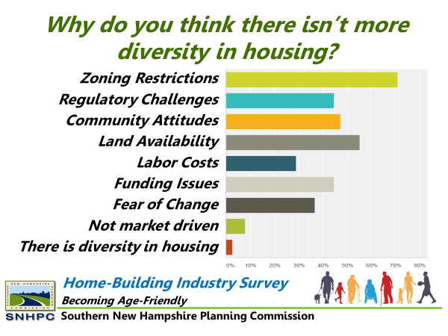
Figure 20: Home-Building Industry Survey Result
The challenge to New Hampshire and the SNHPC region is to produce the homes needed for its present population and coming to terms with whether or not local land use regulations will support the emerging demographics of housing need and demands including aging in place for senior homeowners. The traditional housing model presumes that different housing types, sizes and prices should be keyed to various life stages, with ownership progressing toward larger or more expensive units over time. But a new paradigm is emerging that calls for more efficient floor plans, more manageable, and more affordable units that can accommodate virtually any occupant regardless of age or dis/ability.
With consideration of the requirement that every community provide “reasonable and realistic opportunities for the development of workforce housing” (NH RSA 674:58-61), each community is challenged to meet the intent of these state requirements, to ensure that businesses have adequate home options for employees, residents are safely housed, and land and infrastructure are used efficiently.

Exclusionary Zoning Practices
The dictionary definition of exclusionary zoning is zoning that intentionally excludes certain types of land uses for the purposes of regulating racial and economic diversity. The most obvious example of this is the single-family home district, in which no other housing types are permitted. These types of policies tend to reduce or limit a community’s total housing supply, which results in higher housing costs. Along with the restrictive housing types, large(r) lot sizes also contribute to limiting housing choice to certain populations.
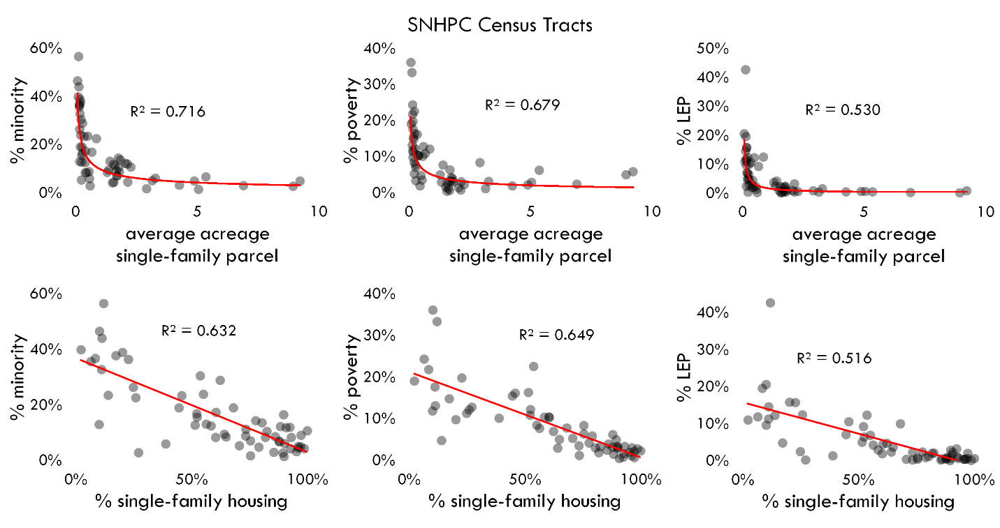
Figure 21: Title VI/EJ Population Concentrations for SNHPC Census Tracts
Typical zoning in the SNHPC region regulates use, density, height, coverage, and setbacks of development. These are important factors to regulate for any sized community. Regulating these factors may ensure adequate light and air quality, reduce traffic congestion, and maintain a sense of rural community – a value shared by many communities in the SNHPC region. Additionally, regulating density helps communities control capital planning for necessary facilities and utilities.
Regulating density can also have unintended consequences, typically impacting lower-income populations. Typically, larger plots of land have a higher purchase price value than smaller lots. Likewise, single-family homes on larger plots of land have a higher purchase price than those on smaller lots in most cases in the SNHPC region. When examining single-family parcels throughout the region, certain socio-economic trends become more visible. For example, there are fewer minority individuals living in single-family homes on larger plots of land. Poverty is more concentrated in single-family homes on smaller lots than on larger ones. Generally, it is less likely that minority populations are living in single-family homes. Similarly, populations living in single-family homes are less likely to be living in poverty.
These trends may seem obvious. Smaller lots of land are more affordable than larger lots. A multi-family unit is typically more affordable than purchasing a single-family home. It would make sense that lower-income populations would be living within their financial means. However, more rigid single-family oriented zoning can increase barriers to developing a variety of housing options for all income levels, resulting in concentrated areas of lower-income housing and poverty.

Impact on Affordability
Looking at the relationship between parcel size for single-family homes and their ultimate value, cost quickly grow with small increases in parcel size and then level off. This is less true for communities with fewer than 10,000 residents. The effect has a significant influence on home value, and subsequently affordability. This evaluation doesn’t include how the age of the structure plays into all this, but age, parcel size, and property value are all related. See Appendix C for additional information.
- Regional-wide, a single-family home of 1-acre costs around double that of a home on 1/10 of an acre or less, or an increase of $175,000.
- In Manchester, a single-family home on half an acre costs 50% more than of a home on 1/10 of an acre or less, an increase of around $80,000
- In SNHPC towns with more than 10,000 residents, a single-family home on 1.5-acres costs about 70% more than a home on a quarter acre or less, an increase of around $180,000.
- In SNHPC towns with less than 10,000 residents, a single-family home on 2-acres costs around 25% more than a home on half an acre, and increase of around $65,000.
Figure 22: Average Property Value by Acreage Decile for SNHPC Single-Family Homes
Reflects 2020 appraised values. Does not include property data from Candia.
Source: NH Department of Revenue

“Extensive research has found that compact development patterns, higher density, mixed uses, and other characteristics of smart growth development can reduce the costs of providing public infrastructure and delivering services. Many communities with conventional low-density, single-use development patterns are financially burdened by the cost of maintaining, and ultimately replacing, their existing infrastructure given the tax revenue this development generates.”

Figure 23: Derry Single-Family Homes: Value per Acre
For half a century, studies by federal and state governments, academics, consultants, think tanks, and advocacy groups have consistently found that urban and suburban sprawl is more expensive for governments to build and maintain compared to higher density development and fares far worse in generating enough tax revenue to cover its expenses.

Review of Local Land Use Practices
The following descriptions highlight zoning practices found in the SNHPC region. While not all-encompassing, these categories are the most commonly found districts and practices throughout the region.

Residential
Rural, Agriculture Residential
This zoning category includes agricultural uses, such as scattered farmland and related activities, and low-density residential development, primarily single-family. In comparing the existing land use patterns and zoning ordinances within the region, an overall density or minimum lot size of three or more acres is typical in these areas.
Low Density Residential
This land use category includes low density, single family residential with an overall density or minimum lot size of one to two acres of residential uses. This density is common throughout the communities in the region.
Medium Density Residential
Medium density residential refers to lot sizes ranging from one-half acre to one acre in size. This type of development can include both detached and attached single-family, duplex and multi-family development. Most medium density residential is located in the communities and land surrounding I-93 and Manchester. Limited medium density residential is found within Manchester, but outside the I-93 and 293 loops.
Medium Density Urban Residential
Located primarily within the City of Manchester this land use category consists of and provides for a higher medium urban residential density than typically found in surrounding communities.
Medium-High Density Residential
Medium-High density residential includes both detached and attached single-family, duplex and multi-family development much like Medium Density Residential development. However, lot sizes are typically less than one-half acre. Medium-High density residential is restricted to areas that have access to municipal water and sewer systems. This land use classification is primarily located in more densely populated communities such as Bedford, Derry, Hooksett and Londonderry.
High Urban Density Residential
Located primarily within the City of Manchester this land use category consists of and provides for a higher density urban residential development than typically found in surrounding communities.
Manufactured Housing Zone
A Manufactured Housing zone includes trailers or mobile homes as defined in RSA 674:31. Manufactured housing is also often allowed by Conditional Use throughout some communities.

Commercial
Commercial
This generalized designation includes all types of commercial and business land uses ranging from neighborhood and limited commercial areas to more intensive highway commercial corridors and shopping centers. All communities in the region have some area designated as commercial. Generally, areas identified are near municipal centers or along major corridors.
Central Business District
This zone represents larger areas that include a mix of office and commercial, most notably located within the hub/core of the municipality. Often these areas are also served by higher density housing.

Industrial
An industrial district is one that is designated for higher impact uses, such as manufacturing, warehousing and storage. Since these kinds of uses tend to have greater impacts in terms of heavy vehicle traffic, noise or light pollution, they are often located away from residential areas or a downtown.

Mixed-Use
A mixed-use district is one that would allow different types of land uses on a lot or in a building – for example, residential and some scale of commercial or business use. This approach is contrary to the conventional Euclidian zoning, whose primary tenet was to separate land uses because certain uses were deemed to be incompatible with one another. At one time, this was true, when industry was loud and dirty and did not make for a desirable neighbor to homes. Today, however, with appropriate performance standards in place, there are many non-residential uses that can exist in a residential area without being disruptive.

Village/Neighborhood Centers
A Village District or Neighborhood Center is similar to a Central Business District but on a smaller scale. A typical New England village will contain a mix of residential and non-residential uses (e.g., retail, personal services, church, school, post office) that can accommodate a smaller population than a Central Business District would serve. A Neighborhood Center also applies to a node that will contain some mix of uses, although typically fewer non-residential uses than a Village.

Conservation
A Conservation District intends to do what the name implies: conserve land. Such a district will include land that is already under some sort of conservation easement or ownership. In addition, the ordinance may also allow subdivision and other development, but with stricter controls in place than for other districts.

NH Office of Planning and Development Land Use Survey
The New Hampshire Office of Planning and Development acts as the state repository for all local land use regulations including master plans, zoning ordinances, historic district ordinances, capital improvement plans, building codes, subdivision regulations, historic district regulations, and site plan review regulations. RSA 675:9 also authorizes OSI to conduct an annual survey of all municipalities in order to collect information pertaining to new and/or amended land use ordinances.
In 2020, NH OPD published findings from the annual survey of 234 municipalities across New Hampshire.

Attitudes towards Growth
Attitudes towards growth vary significantly throughout the region. The range of attitudes can be bookended by progressive attitudes on one end and conservative on the other. Those that tend to be on the progressive side are typically open to innovative housing solutions and developing diversity in housing stock. To the extreme, this bookend would be at home with no or fewer regulations, building whatever and wherever. Those on the conservative side tend to be protective about their community changing, preferring minimal growth and typically similar styled homes with those existing in the community. To the extreme, this bookend could be considered exclusionary with a preference to no growth at all. Although these two extremes exist, typically, planning in the region tends to fall in the middle, with land use boards working with developers to guide growth that is reasonable and reflective of the values of the communities. Depending on the attitudes of the land use boards, their opinions on growth are often reflected in policies and regulations, and even in how land use boards work with builders and developers in guiding applications through the development process.
WHAT WE HEARD, THOUGHTS ON HOUSING: In April 2022, SNHPC staff met virtually with Town Administrators, Planning and Zoning board representatives, health/welfare departments and community organizations to collect input on various housing topics. Representatives from the City of Manchester reported that the attitude toward housing development is generally positive. The Planning Board is very receptive and responsive, and the majority of people speaking publicly on housing are advocating for more housing and more affordable housing and support the necessary policy changes. There is high demand for any and all types of housing in the city. This echoes the sentiments from Manchester Planning staff at the Town Planners Focus Group Meeting held in March 2022. The city has been collecting community input on housing as part of their 2021 Master Plan and the Manchester Zoning Ordinance revision and update.
NeighborWorks® Southern New Hampshire is a nonprofit organization that provides access to quality housing services, revitalizes neighborhoods and supports opportunities for personal empowerment. In working in the region, they have experienced a lot of NIMBY-ism (Not In My Backyard) regarding density and housing diversity.

“common perceptions are that high density residential development does not contribute sufficiently to the cost of schools, yet research shows such development actually subsidizes low density single family detached development.”
In some of SNHPC’s more medium-sized communities, participants in the SNHPC housing focus groups shared that many residents don’t want additional development, they want the community to remain as is and see workforce housing as an unwanted entity. These residents were worried about impacts to schools, the possible need for larger school districts, and the snowball effect of school and business growth resulting in more traffic. In some smaller towns, the public perception is that growth and density would change the character of the community.
Still, many participants in the housing focus groups, despite the size of community they lived in, shared in a common concern about the lack of options for those wanting to rent or buy their first home or those who want to age within their community but want to downsize.
During the spring of 2022, multiple surveys were developed by the regional planning commissions and their partners to provide common questions about housing to many different groups. The strategy was to coordinate the effort so that a comparison of regions could be made. These surveys were distributed statewide. Themes from the general public survey included the following:
- When choosing a neighborhood, top priorities are price and area safety
- 82% of respondents "agreed" (46%) or "strongly agreed" (36%) that more moderate-income housing is needed
- 64% of respondents "agreed" (25%) or "strongly agree" (39%) that more low-income housing units is needed
- 63% "agreed" (27%) or "strongly agreed" (36%) more rental housing is needed
- 62% "agreed" (31%) or "strongly agreed" (31%) that more senior housing is needed
- 62% of respondents "disagreed" (29%) or "strongly disagreed" (33%) that additional high end housing units are needed
- An open-ended question in the general public survey asked, “What desires/goals do you have for housing in the future?”. The responses were categorized by theme. Top 5:
  - Small or downsize (20.7%)
  - Affordable or efficient (12.8%)
  - Bigger or more land (9.8%)
  - Home ownership (9.2%)
  - Unknown or none (8.1%)
Comments from the City of Manchester municipal focus group meeting indicated there is an appetite for every type of housing in the city including affordable, multi-family and single family (including small, single-story units).
The small town municipal focus group meeting participants noted the community has expressed a desire or need for affordable apartments and small single family homes (anything from tiny homes to starter homes). Many community representatives at the medium town municipal focus group meeting noted that community residents are opposed to workforce housing, density increases or new housing.

Innovative Policies & Techniques
The State of New Hampshire, through RSA 674:21, grants municipalities the authority to implement various zoning techniques, known as Innovative Land use Controls. These techniques are intended to provide additional opportunities for housing creation that goes beyond conventional zoning. These are described briefly in the following section, along with other techniques not described in RSA 674:21.

Inclusionary Zoning
Inclusionary zoning is a means of encouraging private developers to provide housing for moderate, low-, and very low-income households. Inclusionary housing functions by granting zoning exemptions and density bonuses to developers that permit them to build at a higher density if a portion of the proposed development is reserved for elderly, handicapped, or moderate and lower-income households.
There are some challenges regarding the acceptance and use of inclusionary housing development. Some municipalities may encounter resistance when proposing zoning changes to provide density bonuses. While there are many who see the need for more diversity in housing, there are some who fear inclusionary housing. Stigmas against low-income housing are often based in the belief that their own housing values may be diminished or worse, that this housing will result in additional crime. Understanding that residents of moderate and lower income often include many of the service providers communities need to thrive can help balance, recenter, and minimize this argument.
Another challenge related to inclusionary housing development is in their administration. Although municipalities have the responsibility of ensuring that below-market units remain at target levels, the maintenance, management and marketing of the units remains a private responsibility. A local housing authority, community development department, or planning department may be involved in tracking and monitoring these units. Local ordinances usually include a provision requiring that below-market units, whether rental or owner-occupied, remain at below market levels for a fixed period, such as 10 to 99 years.
Despite these challenges, there are several benefits associated with inclusionary housing. First, the investment made by a developer in creating housing will include both market rate and inclusionary housing. As the developer and his investment team, they will want to maximize on the return of their investment. To do so, they will certainly create housing that will appeal to all income levels. Furthermore, they will ensure that the required management of any needed policies will be set in place to ensure safeguards are followed. An additional advantage is the housing needs of most family types, including various age and income groups, can be accommodated within a single residential development.

Community Highlight on Innovative Zoning:
From Open Space to Universal Design: Southern NH Planning Commission (SNHPC) Helps Chester Takes Steps to Diversify its Housing
In 2017, SNHPC started their Age-Friendly Pilot Program, which aimed to work with communities on specific goals and projects related to age-friendly planning. Community champions from the rural town of Chester had shared their frustration with the housing being built in the community: Why was so much of the new construction “McMansion” style housing? From early on, Chester’s Town Planner was interested in creating zoning allowances that would result in smaller homes that would appeal to older residents looking to downsize and to younger residents looking to buy their first home out of college.
Taking advantage of SNHPC’s Age-Friendly Pilot Program, the project would focus in on better understanding the type of housing that the community wanted and to create innovative regulations to allow for age-friendly housing. Over the course of two years, SNHPC staff conducted surveys, held a community forum, and hosted several public meetings with town staff, planning board representatives, local developers, Chester residents, and a local senior citizen group. Ultimately, through the hard work of the stakeholder group, age-friendly housing regulations were drafted and incorporated into Chester’s Open Space regulations. In May of 2019, the town officially adopted the regulations.
What is an Age- Friendly Neighborhood?
“…age-friendly neighborhoods are envisioned to consist of smaller, affordable, low-maintenance homes for all people regardless of age, ability, or disability.”

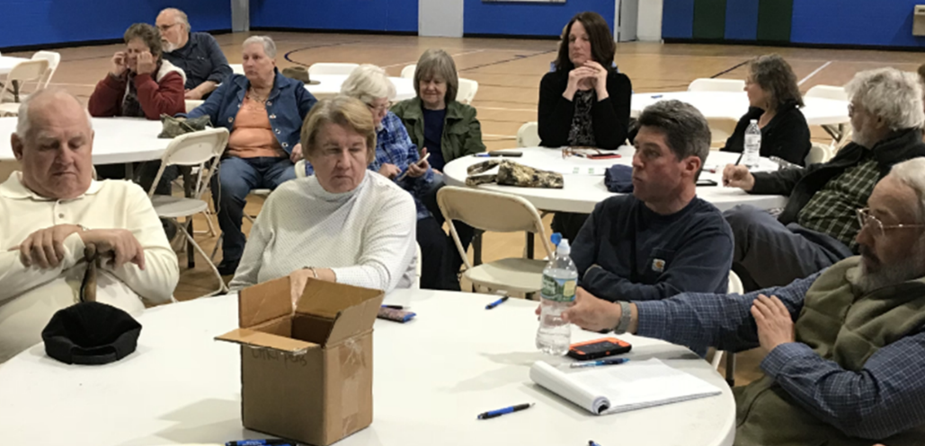
Figure 24: Chester Community Forum
The intent of the new regulations was to keep the units smaller and more affordable, ensure the units were built with universally design standards (designed for people with any ability or disability), and encourage multiple cost-saving elements such as shared amenities. Not only did the stakeholder group want to create regulations that would result in lower costs for construction, but also to minimize the physical burdens of maintaining a home. Some of the specific requirements include: increasing density, regulating maximum square footage, requiring accessible widths throughout, and ensuring first-floor main bedroom/baths.
The efforts made in Chester were designed to incentivize more affordable and accessible homes keep within reasonable design standards while maintaining the character of the town. It should be noted, Chester homes are typically built on well and septic systems, thereby creating some limitations for density.

Zoning Allowances and Innovative Policies

Cluster/Open Space Developments
Cluster housing provisions allow alternative design patterns which group housing units together with reduced lot size, frontage, and setback requirements while committing a percentage of the land to open space. The individual house lot or private yard area dedicated to each unit is smaller than in conventional developments while the overall density is typically the same. The advantage to this sort of development is that the developer can preserve a significant amount of land and thereby reduce the impact of the development on the environment. How one calculates the density, or number of allowed units is typically through a “yield plan”. The yield plan identifies the maximum number of conforming building lots that is reasonably achievable under conventional subdivision regulations.
Cluster developments can be designed for single family homes, duplexes, multi-family housing or a mixture of housing types, depending on the specifics of the ordinance. There are many nuances with cluster/open space housing. For example, most ordinances in the region calculate permitted densities by a formula that subtracts wetlands and steep slopes from the total land area to determine the buildable area, and then divides the remaining land by a minimum area-per-unit requirement. Some also subtract a percentage for allowance to build access roads. Each community is slightly different, but the outcome usually means smaller and more concentrated lots, less impact, preserved open space, and lower development costs.
The land saved from each individual lot is assembled to create common open space serving the entire development. Cluster is an ideal way of allowing development to occur with a minimum of disruption to the natural environment and is generally a far more efficient use of land than conventional grid development. Whereas conventional grid developments tend to divide land into numerous individual parcels, cluster development allows large and often contiguous areas to remain open and undeveloped. In this way, wildlife habitats are better preserved, and large areas can be set aside for both active and passive recreational uses.
Since overall densities are not usually higher than those allowed in the underlying zone, public water and sewer may not be prerequisites for cluster development. Many developments utilize community septic systems or wells.

Village Plan Alternative Subdivision
The intent of a village plan alternative subdivision is to promote a more efficient and economical method of land development. Similar to cluster development, it strives to consolidate physical development to reduce the cost and need for new roads, utilities, and infrastructure while preserving open space when possible. When this approach is used, the entire developed area must be confined to 20% of the site. A recorded easement shall reserve the remaining land, limiting future construction on the land to farming operations, forest management and conservation uses.
The submission and approval process remains the same as a conventional subdivision. However, the review process is to be expedited. The village plan alternative subdivision must still comply with existing subdivision regulations related to emergency access, fire prevention, and public health and safety codes. Underlying regulations on setbacks, lot sizes, and density do not apply to this type of subdivision.

Transfer of Development Rights
Transfer of Development Rights (TDR) is a technique used to redirect development from undeveloped, natural areas in one part of town to another (usually already developed) part of town. For example: A parcel in the Rural District is 20+acres in size and under the zoning ordinance, could have as many as 10 single-family homes. The owner of this parcel sells his right to create these units to someone with a parcel in the town center, allowing this lot to add the 10 units to what is already allowed for it under the zoning ordinance.
This approach allows for the permanent protection of the land that gave up its development rights. At the same time, it focuses development in an area that is already developed and has existing infrastructure, which contributes to the creation of housing stock without needing additional land.

Accessory Dwelling Units
Accessory Dwelling Units (ADUs) are independent living units that are accessory to a primary dwelling unit (e.g., single-family home). Depending on the community's zoning allowances, the unit may be either incorporated into the primary home’s existing structure, attached to it as an addition, incorporated into another existing structure on the property, such as a garage or barn, or built as a new separate structure on the property.
This type of housing is not new, and while some municipalities have included the use in their zoning ordinances, many more did not. In response to the growing and severe housing shortage in New Hampshire, the NH Legislature codified a law regarding this use in 2017 – RSA 674: 71-73. This law makes it illegal for any municipality to prohibit outright an ADU. The municipality may still implement certain restrictions (for example it does not have to allow detached ADUs), but the ordinance must allow the creation of ADUs in any district that permits single-family homes.

Cottage Courts
A cottage court is a type of housing development that emphasizes small(er) houses – usually less than 1,000 square feet in gross floor area, arranged around a common open space or courtyard. Unlike clustered/open space development, there is no requirement to set aside a certain amount of open space. Given the close proximity of the houses, this type of development is typically located where municipal water and/or sewer systems are available. If the soil allows, there are circumstances in which a community septic system is utilized. Cottage Courts add to housing diversity by making smaller and more efficient homes available, typically near a town center. These units often appeal to smaller households of either younger or older adults who do not have the time, energy, or desire to maintain a yard and prefer the efficiencies of a smaller home.

Live/Work Units
A live/work unit is simply a contemporary description of a building that is both the residence and the place of business of the owner. Historically, especially in more urban settings, business owners lived upstairs over the store, or at times in the back of the store. The advantage of this timeless setup is that the owner can simply “walk to work”, keeping at least one car off of the road network. Some urban centers, including Manchester, have been the home of live/work units and typically they sell out before they are built.

Infill Development and Redevelopment
Infill means making use of vacant or underutilized parcels in or near a downtown area that has existing water, sewer and road infrastructure. This approach typically allows smaller homes or even multi-family options, which contributes to increased housing diversity. Typically, smaller units attract younger adults wanting to purchase a first home and older adults wanting to downsize.
Similar to infill, the practice of redeveloping properties that are either underutilized or vacant and turning them into residential units is common across New Hampshire. This practice often targets old mill buildings, commercial or office buildings, even old school buildings and repurposes them into multi-family units. This is a very successful method in creating residential units that can be affordable, attractive to young people, and reinvigorate neighborhoods that may have struggled due to former vacancies.

Reduced Parking Requirements
A typical requirement for parking is two spaces per dwelling units, regardless of the size or type of unit. For some time, Planning Boards have supported reducing these standards, as they not only take up a lot of land area with impervious cover, but with smaller households and smaller dwelling units (e.g., ADUs), there is often a reduction in vehicle ownership. Reducing these requirements can go far to lowering the cost of housing development, reducing the impact of the development on the surrounding environment and neighborhood, and leaving potential green space for future residents.
Note: Planning Boards can reduce the requirement by putting parking standards in site and subdivision regulations versus in the zoning ordinance. Another method is to allow the Planning Board to grant a Conditional Use Permit by allowing the developer the option to provide evidence that typical parking standards are unwarranted based on similar residential conditions.

Adaptable Road Standards
Many municipalities in New Hampshire rely on standards for road construction that have been developed by the NH Department of Transportation. The DOT’s “Minimum Geometric & Structural Guides for Local Roads and Streets” provides recommended widths for rights-of-way, travelled way, and shoulder width that are based on average daily traffic (number of vehicles per day on the road). The recommended width for a right-of-way is 50 feet for most local roads, and the traveled way width ranges from a minimum of 18 feet to 24 feet. Thus, the minimum for a local road with no more than 50 vehicle trips per day is a 50-foot right-of-way with an 18-foot (gravel option) traveled way.
Common practice is to require the 50-foot right-of-way, even for the less-traveled roads, planning for future development, However, many communities will require a traveled way of 24 feet and that the road be paved. Typically, emergency management prefers a wider roadway to ensure fire trucks, ambulance and other emergency vehicles have plenty of room to maneuver. Road agents and public works departments have similar preferences due to plows.
Still, there are a variety of circumstances where reduced standards are reasonable, such as smaller developments that are under a certain threshold of units, long roadway sections that may just be needed to access the buildable areas, limited space due to lot configuration, and even environmental concerns. There are advantages to reducing the roadway width such as reduced casts, reduced runoff, allowing space for walking, and typically slowing traffic.

Resources
In 2008 the NH Department of Environmental Services, in cooperation with the NH Association of Regional Planning Commissions, the NH Office of Energy and Planning, and the NH Municipal Association published “Innovative Land Use Planning Techniques: A Handbook for Sustainable Development” which provides detailed information on most of the techniques discussed above, as well as a number of others. The Handbook provides context and legal basis for each technique, as well as a model ordinance, which makes this a valuable resource for planning boards in New Hampshire.

Workforce and Employment Constraints
To understand the role housing plays in workforce attraction and retention, an Employer Survey was developed by staff from the state’s nine regional planning commissions. In addition to social media and newsletters, this survey was shared with over 19,000 Businesses in Good Standing (BIGS) registered with the Secretary of State in the Southern New Hampshire Planning Commission region. 84 individuals provided responses to the Employer survey.
65% of respondents described the availability of housing options in or near the area where their business is located as “very limited”.
WHAT WE HEARD: During a Municipal Focus Group Meeting in April 2022, representatives from Hooksett acknowledged the need for housing as a result of their town’s commercial boom. New businesses need employees, but these employees are unable to afford housing nearby. Despite the need, public perception of new housing (including workforce housing) is generally negative. Concerns over traffic or lower-income end housing bringing in a “bad element” is often raised.
The Employer Survey results showed that only a small percentage of the region’s employees live in the same town/community as they work.

- 67% of employer survey respondents said that 25% of employees or less live in the same neighborhood/ area as their business
- 66% said that 25% of employees or less live in the same town/city
- 46% said that 25% of employees or less live in an adjacent town/city
- 52% said 25% of employees or less live in a non-adjacent town/city
In the general public survey, the majority of respondents (49%) said that being close to work was a high or very high priority when choosing a neighborhood to live in.

Workforce Attraction and Retention
WHAT WE HEARD: The employer survey revealed that 62% of respondents believe that a housing supply shortage impacts their ability to attract or keep workers. Additional comments mentioned the added financial hardship placed on employees who need to travel farther to work (high price of gas, vehicle maintenance, childcare, etc.), the struggles of small businesses to pay employees higher wages, and poor housing conditions for renters impacting their ability to work consistently. Whether renting or purchasing, availability, cost, and quality of housing were all identified as having a “high impact” on employers’ ability to attract or keep qualified workers.
In the employer survey, one employer stated that the lack of affordable housing is leading to “brain drain” or young people leaving the area due to affordability, which will ultimately undermine facets of growth. Another stated “We are in desperate need of skilled tradesmen. Without these workers, growth is not possible”.
Employers reported that all types of housing are helpful in supporting their efforts to recruit and retain employees. The most helpful types were identified as single-family homes (34.94%), multi-family homes (26.51%), multi-family apartment buildings (20.48%), other (i.e., all of the above, affordable, quality/price) (14.46%) and townhomes (3.61%).
While most employer attitudes towards new housing were supportive, nine out of 42 (or 21%) respondents shared additional comments that were negative or discriminatory in nature regarding workforce housing. Overall, employer comments ranged from “Better home options results in a more vibrant community.” to “Stop bringing immigrants here until we solve this problem locally. Closing the borders may help a bit.”.

Effect of job growth on housing needs
At the Manchester municipal focus group meeting, business growth was especially recognized as the impetus for more housing development. Many of the companies are attracting national if not international attention. Naturally, with this growth comes the need for increased housing opportunities. Participants from the medium-sized town municipal focus group meeting noted that housing is needed for visiting professionals who work at places like Parkland Medical Center and Dartmouth Hitchcock.

Employer assisted housing
WHAT WE HEARD: The results of the employer survey showed that some companies are currently using the following strategies to help employees secure housing:
- Homebuyer Education (16%)
- Rent Subsidy (10%)
- Employer Operated Housing (10%)
- Cash Contributions (8%)
- Down Payment and/or Closing Cost Assistance (6%)
- Low-Income Housing Tax Credit Investments (4%)
- Moving Cost Assistance (2%)
- Construction Financing (2%)
- Other: Match IRA Contributions (2%)
- Other: Pay Top Dollar (2%)
When asked what would help the most in achieving better housing solutions for employees, the majority of respondents (53.01%) do not see their company having a role in helping to address New Hampshire’s housing issue as it relates to employee attraction and retention. The next highest responses included 41% choosing housing diversity and at 32% was changes to policy and planning. Other responses included: subsidies or support (9.52%), more willing workers (4.76%) and transportation options (1.59%).

Transportation and housing
Transportation can impact housing choice and opportunities. If people cannot afford to live where they work, they must commute; if there is no public transportation available, they will need to drive. The costs of personal transportation including the cost of the vehicle insurance, and maintenance can add up. When these costs are added to housing costs, they increase the cost burden of a household.
Public Transit: Within the SNHPC region, the Manchester Transit Authority (MTA) operates fixed route transit service in the City of Manchester, as well as providing demand response bus service in southern New Hampshire. While nearly 70% of Manchester residents live within a quarter mile of a transit stop, only a very small percentage of residents utilize the services. According to the U.S. Census Bureau, 5.7% of Manchester residents commuted to work using a mode of transportation other than driving or carpooling. However, due to small sample sizes this category also includes bicycling, walking, motorcycling, etc. The H&T Affordability Index estimates that the percent taking public transit in Manchester is around 2%. Statewide, the number is 0.9%.
There are several reasons for this, including lack of routes to get people to work efficiently, long headway times (usually 1-hour between buses), and a residual social stigma that sees transit as a social safety net rather than a realistic or attractive option. Furthermore, many neighborhoods – especially outside Manchester – lack the density that would make transit a viable option. Other services, such as demand-response and volunteer driver programs, exist, but further outreach is needed for knowledge of these options to make their way into suburban and rural communities within the SNHPC region.
The percentage of New Hampshire households with at least one vehicle (95%) ranks among the highest nationally, tied with Colorado, Montana, and South Dakota; only Wyoming (96.2%), Idaho (96.1%), and Utah (96%) have higher rates.
Cost of Transportation: Transportation costs depend on several factors, including miles driven, vehicle condition, and cost of maintenance. Costs for personal vehicles can impact a household’s burden if those costs are excessive. The Center for Neighborhood Technology has developed an affordability index that incorporates the cost of transportation with the cost of housing, which provides a more comprehensive picture of housing affordability. According to the Center, traditional measures of housing affordability ignore transportation costs. Typically a household’s second-largest expenditure, transportation costs are largely a function of the characteristics of the neighborhood in which a household chooses to live. In other words, location matters. Costs for transportation in this analysis include maintenance and gas. The Center considers transportation costs to be affordable if they do not exceed 15% of annual household income.
As an example, the 14 communities of the Southern NH planning region have combined scores (average % of income for housing + average % of income for transportation) that range from a low of 40% (Manchester) to a high of 66% (Windham). Manchester as a whole spends a smaller percentage of income on housing (23%), and just slightly more (17%) on transportation. The low transportation costs are likely related to access to public transit. Windham, on the other hand, exceeds both the housing percentage (45%) and transportation (21%). These higher transportation costs are likely related to the number of residents (79%) who commute out of town for work. Worth noting is that no town in the region has an average transportation cost of 15% or less.
Building off the Center Neighborhood Technology’s methodology, the US Department of Housing and Urban Development has developed its own housing and transportation cost burden dataset, the Location Affordability Index. The index models cost burden for eight different family types making different income levels. Figure 21 is an example showing the cost burden for moderate-income families with one earner and that of dual professional families making more than the median income.
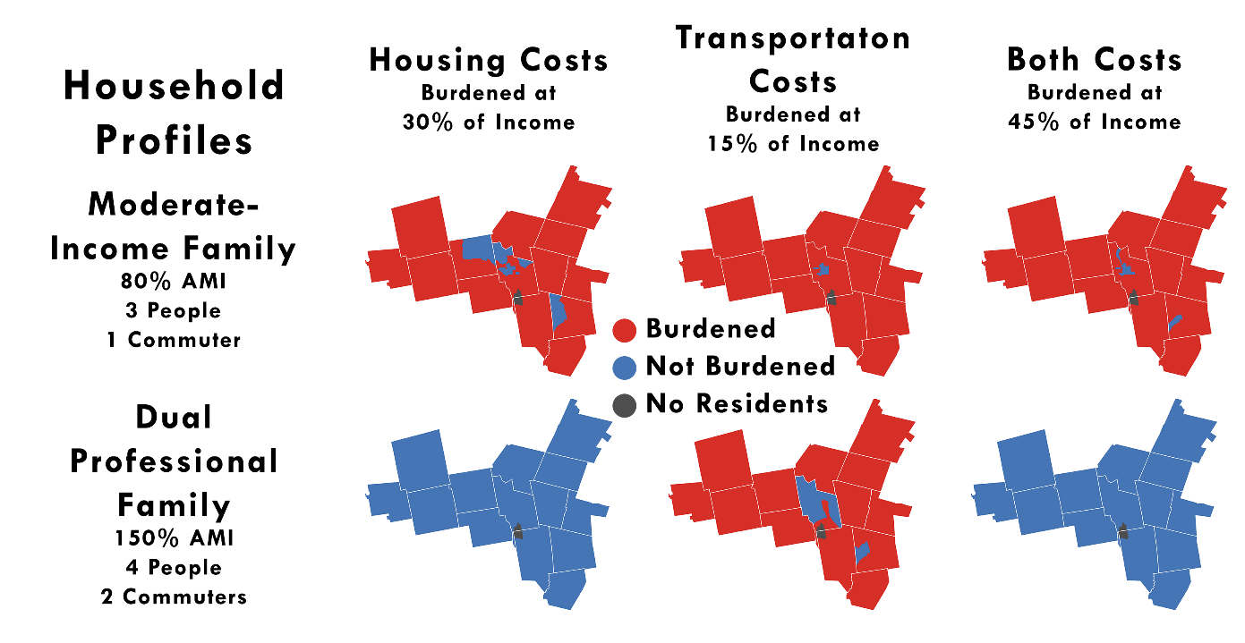
Figure 25: Cost Burdened Households
Reflects 2016 5-Year American Community Survey data. Sources: US Census Bureau; US Department of Housing & Urban Development.
Table 35 shows housing and transportation expenses as a percent of income for the United States. People in the lowest quintile of average income spend the highest percentage of their income on transportation, vehicles, public transit, and housing.
Table 35: Housing and Transportation Costs as a Percentage of Income
Cost Categories | All Units | Lowest Quintile | Second Lowest | Middle Quintile | Second Highest | Highest Quintile
Average Income After Taxes | $74,950 | $15,140 | $36,400 | $58,000 | $89,770 | $176,090
 | Percentage of Cost Attribution (After Taxes)
Transportation | 13% | 29% | 17% | 16% | 14% | 10%
Vehicles | 13% | 28% | 17% | 16% | 14% | 9%
Public Transit | 0% | 1% | 0% | 0% | 0% | 0%
Housing | 29% | 81% | 43% | 32% | 27% | 21%
Housing + Transportation | 42% | 110% | 60% | 48% | 41% | 30%
2020 housing & transportation costs for consumer units (households with shared expenses).
Source: US Bureau of Labor Statistics

Commuting Times
The mean commute time for the SNHPC region in 2020 was 28.3 minutes, slightly higher than the NH mean commute time of 26.1 minutes. The mean commute time rose in every SNHPC community from 2010 to 2020 with the exception of Deerfield (-2%) and Weare (-1%). For the entire SNHPC, the mean commute time rose by 9%, which is 2% higher than the state.
Table 36: Mean Commute Time (Minutes)
 | Mean Commute Time (Minutes)
 | 2010 | 2020 | 2010-20 Commute Time Growth
Auburn | 26.4 | 31 | 17%
Bedford | 25 | 28.6 | 14%
Candia | 26.5 | 33.3 | 26%
Chester | 34.1 | 36.3 | 6%
Deerfield | 36.7 | 35.9 | -2%
Derry | 30.4 | 32.7 | 8%
Francestown | 35.9 | 37.7 | 5%
Goffstown | 24.3 | 25.4 | 5%
Hooksett | 24.4 | 26.9 | 10%
Londonderry | 28.1 | 31.2 | 11%
Manchester | 22 | 24 | 9%
New Boston | 30.6 | 39.1 | 28%
Weare | 35.5 | 35.2 | -1%
Windham | 34.7 | 35.1 | 1%
SNHPC | 26.1 | 28.3 | 9%
NH | 24.4 | 26.1 | 7%
5-Year American Community Survey
Source: US Census Bureau

Availability of Bicycle/Pedestrian Infrastructure
Existing dedicated bicycle and pedestrian facilities within the region include:
- Goffstown Rail Trail
- Granite State Rail Trail (in Derry, Londonderry, Windham)
- Piscataquog Rail Trail which connects the Goffstown Rail Trail at the Manchester town line to downtown Manchester (this trail includes the Friends Across the Merrimack River Bridge and a bridge constructed over Kelly Falls Dam)
- Rockingham Rail Trail Portsmouth Branch (in Auburn, Candia, and Manchester)
- Rockingham Rail Trail Fremont Branch (in Derry and Windham)
- New Boston Rail Trail
For transportation purposes, the availability of sidewalks and on-street bicycle infrastructure must also be taken into consideration. According to Walkscore.com, most of the SNHPC region is car dependent, meaning that most errands require a car.

Table 37: Walk and Bike Scores by Municipality
Municipality | Walk Score (out of 100) |  | Bike Score (out of 100)
Auburn | 28 | Car-Dependent (Most errands require a car) | n/a
Bedford | 24 | Car-Dependent (Almost all errands require a car) | 7 | Somewhat Bikeable (Minimal bike infrastructure)
Candia | 35 | Car-Dependent (Most errands require a car) | 35 | Somewhat Bikeable (Minimal bike infrastructure)
Chester | 36 | Car-Dependent (Most errands require a car) | 22 | Somewhat Bikeable (Minimal bike infrastructure)
Deerfield | 1 | Car-Dependent (Almost all errands require a car) | 23 | Somewhat Bikeable (Minimal bike infrastructure)
Derry | 28 | Car-Dependent (Most errands require a car) | 35 | Somewhat Bikeable (Minimal bike infrastructure)
Francestown | 4 | Car-Dependent (Almost all errands require a car) | n/a
Goffstown | 56 | Somewhat Walkable (Some errands can be accomplished on foot) | 42 | Somewhat Bikeable (Minimal bike infrastructure)
Hooksett | 17 | Car-Dependent (Almost all errands require a car) | 15 | Somewhat Bikeable (Minimal bike infrastructure)
Londonderry | 14 | Car-Dependent (Almost all errands require a car) | 37 | Somewhat Bikeable (Minimal bike infrastructure)
Manchester | 51 | Somewhat Walkable (Some errands can be accomplished on foot) | 42 | Somewhat Bikeable (Minimal bike infrastructure)
New Boston | 34 | Car-Dependent (Most errands require a car) | 13 | Somewhat Bikeable (Minimal bike infrastructure)
Weare | 26 | Car-Dependent (Most errands require a car) | 30 | Somewhat Bikeable (Minimal bike infrastructure)
Windham | 37 | Car-Dependent (Most errands require a car) | 34 | Somewhat Bikeable (Minimal bike infrastructure)
Source: Walkscore.com

Figure 22 shows the relationship between transportation infrastructure and land use. The creation of the highway system in Manchester lead to the development of larger parcels of land further away from the city center after 1960.
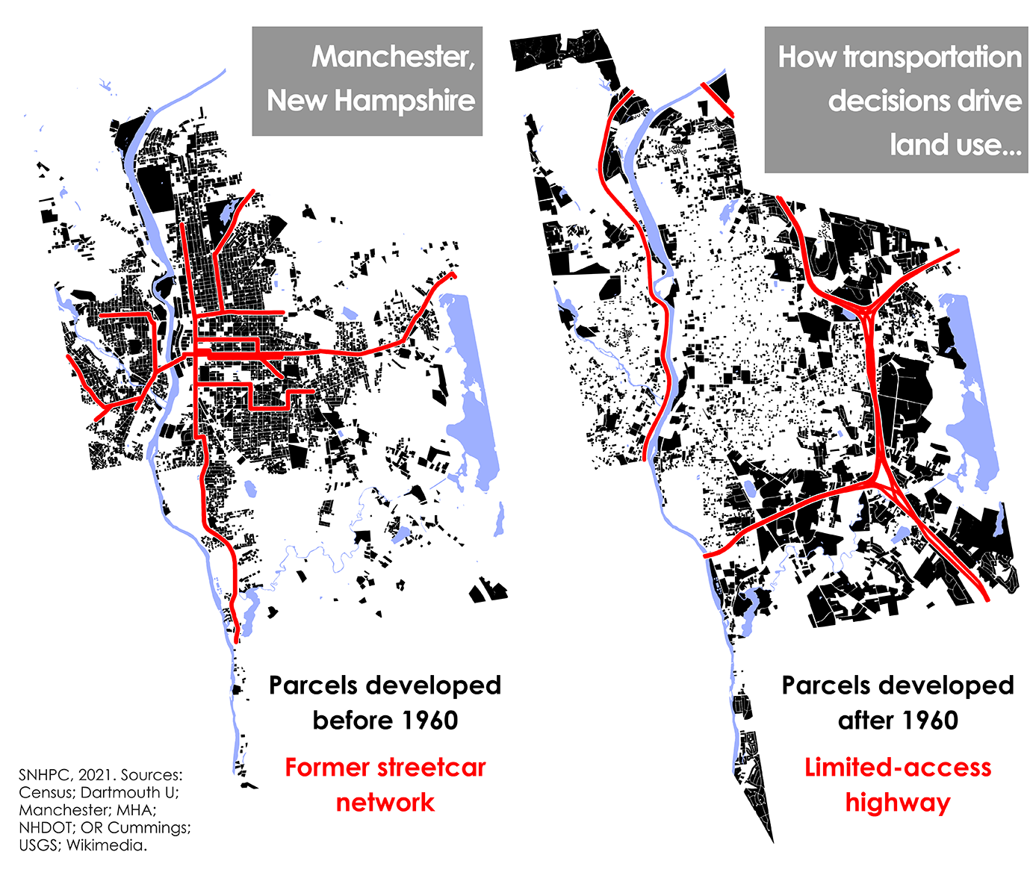
Figure 26: How Transportation Decisions Drive Land Use

As density decreases, an area becomes less conducive to walking, bicycling and public transportation. As private automobile dependency increases, the amount of infrastructure required to serve automobiles increases. Figure 23 illustrates the amount of space that is reserved for off-street parking and driveways in the downtown area of the City of Manchester, the densest and more valuable land in the region.
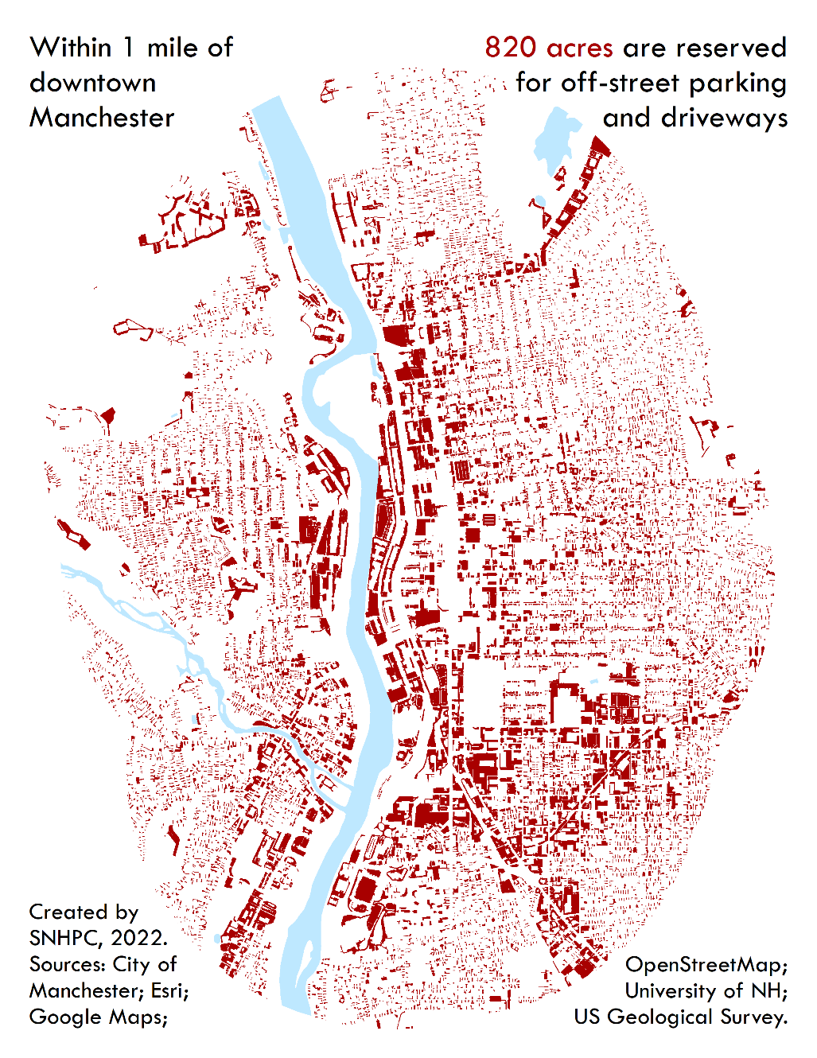
Figure 27: Off-Street Spaced Reserved for Parking in Manchester

Water and Sewer
The existence of water and sewer impacts the cost of housing and therefore the availability of housing stock. During the Small Towns Municipal Focus Group Meeting on April 18, 2022, a representative from Londonderry stated that infrastructure needs to move along ahead of development- it isn’t something that they can go back and fix later. The town currently has 900 residents who use bottled water for everything. In smaller communities like Chester, sewer and utilities are not available in town unless a developer puts them in (Municipal Focus Group Meeting- Small Towns).
It is difficult to increase density without water and sewer, and the ability to create density affects the affordability of housing. For example, infill development allows access to existing infrastructure and the opportunity for multiple units in a building or on a lot, both of which can help to reduce construction costs.

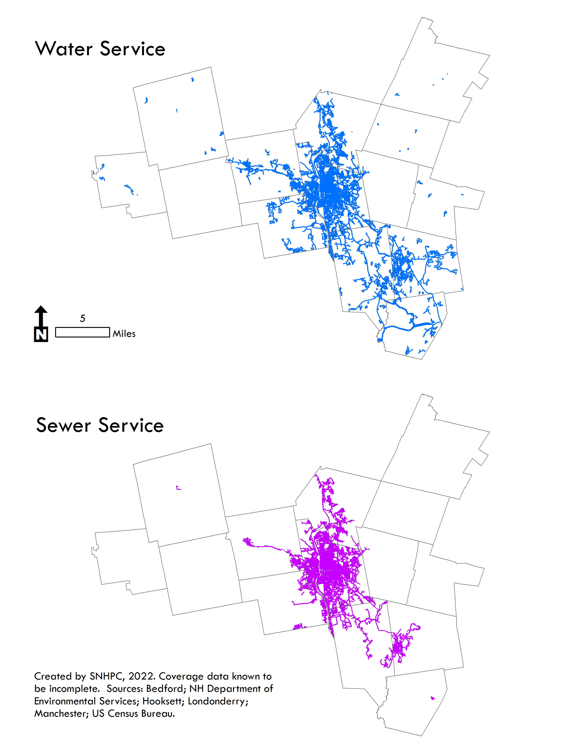
Figure 28: Water and Sewer Service

Service Coverage
The availability of water and sewer impacts both housing choices and availability. The lack of this infrastructure is a barrier to development by constraining land and new construction to rely on existing water supplies and septic systems. On-site wells and septic systems need more land area for housing than does housing that is served by a municipal or community system. In the SNHPC region, development density, including housing density, commercial and retail land uses are higher in areas with water and sewer infrastructure.

Broadband
Overview: As a component of public infrastructure, broadband access impacts neighborhoods and areas depending on its availability. The lack of broadband disproportionately affects neighborhoods with higher concentrations of poverty as well as people living in rural, underserved areas. The State of New Hampshire recognizes that access to broadband is essential for the state’s economy and to this end has allocated $50 million for the buildout of unserved and underserved locations in New Hampshire.
The importance of broadband for the economy extends to other areas as well that are impacted by economic health, such as education, property values, and telehealth. In short, broadband should be treated like any other public utility that is necessary for economic growth and development. In much the same way that electricity became a part of daily life in the early 20th century, today broadband is increasingly indispensable for conducting routine activities and meeting basic needs, such as:
- Remote workforce. Even before the pandemic, the percentage of employees working remotely was growing. The public health emergency only hastened that trend. If communities want to attract and retain these workers, high-speed internet is a must.
- Economic activity. Some businesses won’t even consider expanding or relocating to an area if high-speed internet isn’t available. Furthermore, many home-based businesses – integral to the New Hampshire economy, rely on internet connectivity.
- Property values. Lack of broadband can be a dealbreaker for many homebuyers.
- Education. Without broadband, accessing remote learning opportunities, conducting research, and participating in training can be difficult or impossible. This access is equally important to students and teachers alike.

Underserved Communities
The US Census American Community Survey provides data on households with computers and with internet (including broadband) service. These data are not broken down beyond the county level, however, so it is not possible to use the information to identify specific communities that may be underserved by broadband access. According to the Survey, a majority of all households in the three counties of the Southern NH Region planning area have one or more computers and have internet/broadband subscriptions (94-97%). However, these same data show that of all households earning less than $20,000 a year, 27-28% of them have no internet access.

Community Development
Government supported investments in underserved communities provide important and necessary financial resources that contribute to the provision of decent housing and livable environments, as well as expanding economic opportunities. The level of public investment in housing, economic, and community development affects the ability of households to access decent, safe, and affordable housing. In New Hampshire, the agencies that provide financing and support for affordable housing are:
- NH Housing Finance Authority (NHHFA). NHHFA is a self-supporting public corporation that provides financing to construct or support affordable housing statewide. It also manages both rental and home ownership programs that assist low- and moderate-income persons in attaining affordable housing.
- Community Development Finance Authority (CDFA). CDFA is a state agency that administers federal Department of Housing and Urban Development (HUD) grants as well as contributions from New Hampshire businesses and other partners to support community and economic development projects. A primary source of funding is the HUD Community Development Block Grant (CDBG) that provides millions of dollars annually to New Hampshire for various projects and programs, including those focused on housing.
Within the Southern NH region, most of the funding goes to Manchester, since this is where most of the housing in the region is located, in particular multi-family units that rely on municipal water and sewer.
The City of Manchester is one of five cities in New Hampshire that receives CDBG funding directly from HUD, which amounts to roughly $1million annually that is utilized for housing programs.
- NH Community Loan Fund (NHCLF). The NHCLF is a non-profit financial institution that relies on investments and donations to support its work in community and economic development. Since 2003, CDFA has awarded more than $161 million in these Block Grants across the state. The grants impact economic development, housing, and community-based projects and programs that primarily benefit low- and moderate-income people in the state.
One of the ways the agency supports housing in the state is to provide loans, training, and technical assistance to residents of manufactured home parks so they can buy and manage them on their own – thereby securing stability and affordability for their living situation. These parks are known as Resident-Owned Communities (ROCs), and there are 13 of them in six communities of the Southern NH region; together, these ROCs provide 835 units of housing.
- In addition to the above-cited agencies, the cities of Manchester and Derry have Housing and Redevelopment Authorities that administer federal housing programs.

Childcare
For working parents, childcare is essential, not only to allow the parents to participate in the economy, further their education and/or pursue career goals, but childcare programs also benefit the children by providing healthy learning environments. In other words, everyone benefits. The cost of childcare, however, can be a significant piece of the household budget, if it is even available. Lower income families tend to pay a higher percentage of their income on childcare than higher earners; in addition, they have fewer options for childcare.
NH Connections provides information on family services in the state, including childcare facilities. According to their 2020 data, there were 54,019 children under the age of 6 with both parents in the workforce; at the same time, there were 32,897 childcare spaces. The gaps between numbers of children and number of available spaces is illustrated on a map at the NH Connections website. For towns in the Southern NH region, the differences vary widely. Four towns stand out for the gap between childcare spaces and the numbers of children under 6 whose parents work: Chester – with only 20 spaces and 244 children; Francestown – with only 12 spaces and 22 children; Raymond – with 109 spaces and 443 children; and Weare – with 117 spaces and 264 children.

Food Access
Access to food is a critical component of a household’s or community’s wellbeing. Access to healthy food is even more important. Many parts of the country, especially low-income communities, do not have good access to food. Such areas are known as “food deserts,” which the USDA defines as areas where people have limited access to a variety of healthy and affordable food. Living in a food desert makes a person more likely to experience food insecurity, even when receiving food assistance because there are few places to use SNAP benefits (food stamps) where nutritious food is available.
In New Hampshire, access to food is defined not only by the lack of grocery stores in a particular area, but also by how far away the closest grocery store is in rural areas, and whether someone has transportation to get there. Seacoast Eat Local has developed a Food Access Map that depicts areas characterized by low-income and low access to food. In the Southern NH region, only Manchester is identified as having these two characteristics.
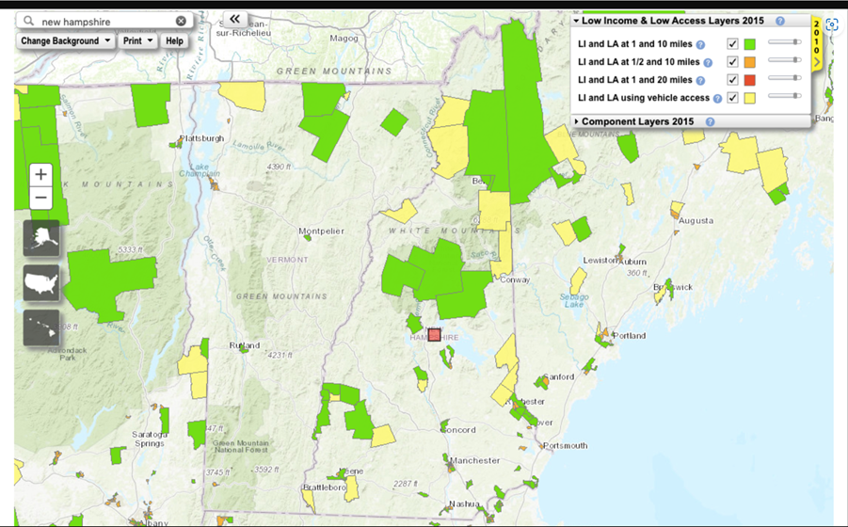
Figure 29: Food Access Map
Source: https://www.seacoasteatlocal.org/does-new-hampshire-have-food-deserts/
A national organization – Healthy Food Access Portal, also tracks food availability nationwide. The site has a tool that allows users to select a municipality, and then illustrates various factors related to food security and access. The data show how many full-service supermarkets, limited-service stores, SNAP Retailers, and Farmer’s Markets are in the community. Unfortunately, for most of the communities in the Southern NH region, no data is shown because either there is no data, or it has been suppressed for components of the area.

Parks and other Civic Resources
Public parks, recreational facilities and other civic resources are an integral component of social equity. They are places everyone can access and enjoy, regardless of their socioeconomic circumstances, thus making them particularly important for people of modest means. Unfortunately, these are the people who may not have the same access to public spaces, either in terms of quality or quantity.
In the Southern New Hampshire region, recreational facilities are being identified and mapped through a program called Pathways to Play. SNHPC was awarded a grant to work with local and regional stakeholders to identify recreation areas and programs and evaluate access to them for the 14 communities in the Commission region. In addition to mapping the recreation areas, the project will also map the transit, walking, biking routes, and parking facilities that people use to access them.

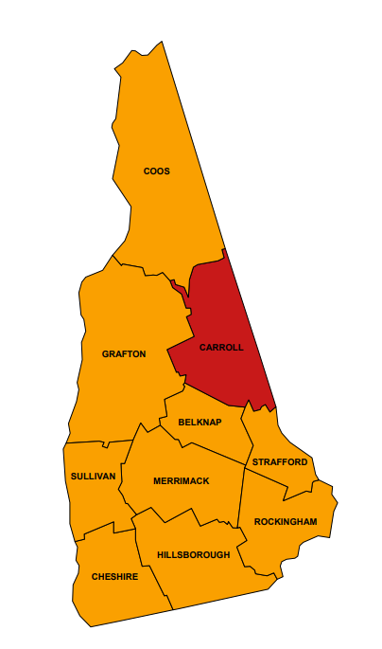
Housing related Health issues
The presence of certain elements in a dwelling can cause a variety of health problems, in particular from these three elements:
- Lead. Lead is commonly found in lead-based paint in older homes, and can have serious health effects for children, including growth and learning problems. Federal and state regulations have reduced the amount of lead in air, drinking water, consumer products, and other settings. However, if a home was built before 1978 – when the federal government banned the paint, it is more likely than not to have lead-based paint.
- Asbestos. Asbestos is used in a variety of building materials, particularly for insulation. Exposure to asbestos increases the risk of developing lung disease. Exposure only occurs when the material containing asbestos is disturbed or damaged in a way that releases particles and fiber into the air. Most uses of asbestos are not banned, although some are under federal regulations.
- Radon. Radon is a naturally-occurring radioactive gas. It is odorless, tasteless, and colorless and emanates from soil and bedrock, including granite – which makes it extremely prevalent in New Hampshire. It can seep into homes through foundations floors or walls, and may also be present in private well water. Radon is a known carcinogen. Unlike lead and asbestos, radon cannot be regulated; but there are construction techniques that can minimize radon entry into a home. Unless a home has been constructed using these techniques, all homes in New Hampshire are vulnerable to some amount of radon. The Environmental Protection Agency (EPA) produces state maps that show the radon risks by county. In New Hampshire, every county but Belknap is considered to have elevated risk for radon.
Figure 30: Radon Risk by County.
(The orange represents Zone 2, which has predicted average radon levels at or above the EPA’s action level.)

Fair Housing Approaches
Fair housing is the right to choose housing free from unlawful discrimination, specifically discrimination based on factors including race, national origin, religion, or disability. The following review of fair housing infrastructure is intended to further identify barriers and opportunities to the provision of housing choices in the region. This section examines the existing statutes and case law that shape housing choice; highlights the most common complaints/barriers to housing choice; and describes resources that exist to help overcome the barriers.

History of Fair Housing
Fair housing was first legislated in 1968 during the civil rights movement and in the wake of Dr. Martin Luther King, Jr.’s assassination. The Federal Fair Housing Act (FHA) was initially adopted to prohibit discrimination based on race, color, national origin, and religion. It has since been amended to further 75 include gender or sex, familial status, disability and gender identity. Combined these represent the “protected classes.” The Act’s goals were to promote integration and suppress segregation in housing and to stop discriminatory practices against these protected classes in the housing arena.
Since the enactment of the FHA, the Department of Housing and Urban Development (HUD) has been active in promoting fair housing practices and requires all grantees to further fair housing opportunities. To support improvements in Fair Housing, HUD also offers a fair housing complaint process which allows residents to bring fair housing issues to the forefront.
Local efforts to promote fair housing in New Hampshire predate the FHA with adoption of the State’s anti-discrimination laws in 1965 (RSA 354-A), which created a legal obligation for those renting or selling to do so independent of an individual’s race, color, national origin, religion, gender, disability or familial status, and including age, marital status, or sexual orientation. The New Hampshire Housing Finance Authority (NHHFA) was established in 1981 to further housing opportunities for NH residents. NHHFA furthers fair housing opportunities in the state through their grant funding programs for municipalities, affordable housing financing mechanisms, and education programs. They are also responsible for adoption of the State’s Analysis of Impediments to Fair Housing, which is the primary source for a complete understanding of fair housing barriers and opportunities in the State. Additionally, in 2014 NHHFA produced “Fair Housing for Regional and Municipal Planning: A Guidebook for New Hampshire Planners” that provides a full background of the legal history of federal and state fair housing law and case law, highlights of which follow.

Disparate Impacts and Discrimination
According to the New Hampshire Commission for Human Rights, there were 59 cases of housing discrimination in the state between 2015 and May 2022. Of these cases, the majority (75%) had a basis in disability discrimination. Other common bases were familial status (12%), retaliation (10%) and national origin (10%). Approximately 78% of social service workers surveyed in the SNHPC region reported that demand for housing units greatly exceeds supply and approximately 74% said that the number of individuals/families facing housing challenges has increased over time. It was reported that the people who have the hardest time finding and keeping housing in our area include people who receive assistance (like vouchers), have poor credit, eviction history, and domestic violence history. In contrast, the majority of respondents to the general public survey (26%) stated that "housing discrimination" is a challenge that "does not apply to my community". Homelessness was an important topic at the Manchester municipal focus group meeting as well as with the Manchester Housing Commission.

Municipal Data
The 2020-2024 Manchester, NH Analysis of Impediments to Fair Housing Choice includes a review of applicable City policies, practices, and procedures resulting in the development of a plan of action to eliminate or improve identified conditions that limit fair housing choice.
According to the report, from January 2013 to December 2019 NHLA handled a total of 146 fair housing cases related to discrimination in the City of Manchester, of which 18 cases involved discrimination in more than one protected class. Close to half of these were related to the protected class of those with a mental disability (68 cases). The protected class of those with a physical disability was also largely represented in this timeframe with 45 cases.
Although there were 779 home mortgage denials in Manchester in 2019, the evidence indicates that mortgage denials do not disproportionately affect mortgage applicants based on race or ethnicity.

Violations
From 2014-2022 there were 262 fair housing complaints filed with New Hampshire Legal Assistance within the SNHPC region. The protected class with the highest number of complaints filed was Mental Health Disability (45%).
Table 38: Fair Housing Complaints in SNHPC Region 2014-2022
2014-2022
Protected Class | Number of Complaints
Mental Health Disability | 118
Physical Disability | 76
Race | 42
National Origin | 27
Familial Status | 25
Sex | 10
Sexual Orientation | 4
Age | 3
Marital Status | 1
Source: New Hampshire Legal Assistance

Federal Cases
New Hampshire has had three housing discrimination cases filed with the United States Department of Justice. One of these was in the SNHPC region (Manchester) and was a violation the Fair Housing Act based upon sex. In the case United States v. Mills d/b/a Chestnut Properties (D. N.H.), the property owner and former rental manager were found guilty of sexual harassment and sexual assault against female tenants. The tenants were primarily, if not all, Section 8 tenants.

HUD Discrimination Cases
Between 2014 and the first half of 2022, there have been 58 cases of discrimination filed with the U.S. Department of Housing and Urban Development (HUD) in the SNHPC region. The most common base for the complaints was disability (76%).
Table 39: HUD Discrimination Cases 2014- Q2 2022
2014 to Q2 2022
Base | Number of Cases
Disability | 44
Familial Status | 7
Retaliation | 6
National Origin | 6
Race | 5
Sex | 4
Religion | 2
Color | 1
Source: US Department of Housing & Urban Development

Initiatives to respond to unfair housing
The Sustainable Communities Initiative (SCI) is a joint program among HUD and the U.S. Department of Transportation and the federal Environmental Protection Agency. The goal of the program is aimed at improving “regional planning efforts that integrate housing and transportation decisions, and increase state, regional, and local capacity to incorporate livability, sustainability, and social equity values into land use planning and zoning”.
SCI provides grants to improve regional and local planning efforts that integrate housing and transportation decisions, and increase the capacity to improve land use and zoning to support market investments that support sustainable communities. For more information on the program and applicant eligibility, please visit https://www.hud.gov/hudprograms/sci.

Access to Opportunities
High opportunity areas often provide access to certain amenities or community attributes that are believed to increase economic mobility for their residents. As a result, development in these areas can be impeded by high costs of living and dense populations.
Consider where you live and ask yourself, does my neighborhood have access to transportation options, employment, better performing schools, medical and shopping options, clean park and areas to recreate, lower crime and greater availability of quality, affordable housing options? If you had to move, could you find options that included these elements? Access to these opportunities varies for every neighborhood and every community. Further, depending on the individual or family situation, the critical elements would vary and may only include a few of the elements to ensure a higher quality of life. Children growing up in higher opportunity neighborhoods generally have better education, a high quality of health, and opportunities later in life of upward economic mobility.
Unfortunately, low-income residents and people of color disproportionately face the challenges of living in low opportunity neighborhoods. This contributes to negative long-term educational, economic and health outcomes.
Naturally, one of the challenges to housing is to ensure new development is focused in higher opportunity areas. According to Freddie Mac’s Spotlight on Underserved Markets, Affordable Housing in High Opportunity Areas,
More than 56 million people live in communities that are classified as high opportunity areas. These neighborhoods often provide access to certain amenities or community attributes that are believed to increase economic mobility for their residents. However, they are also often encumbered by high costs of living and dense populations. As a result, the supply of affordable housing is unable to support the demand. In an effort to combat this, there has been an increased focus from research, policy and affordable housing groups on deconcentrating poverty and promoting affordable housing in high opportunity areas.

Areas of High Opportunity
High Opportunity areas are typically determined through an assembly of data sets, developing specific criteria, and analyzing outcomes via a mapping exercise that provides a visual result that showcases areas where accessibility to multiple opportunities exist. This sounds complicated and it is. There are a variety of resources available that provide the user with various results depending on the specific resources criteria focus. For example, Enterprise Community Partners is a nonprofit program which seeks to understand what makes communities effective in promoting positive outcomes for its residents and, what hinders residents from achieving these positive outcomes. HUD is another agency that also provides insight through their own set of indices. Included here are a variety of resources which provide opportunities for exploration.
Resources:
https://htaindex.cnt.org/
https://www.opportunityatlas.org/
https://mobilitytoolkit.enterprisecommunity.org/resources-for-housing-and-education-partnerships

Identifying Opportunity Areas
As determining opportunity areas is dependent on the data sources and year the data is obtained, variables used, scores for each variable, and other factors, the resulting opportunity areas can differ widely. For the purposes of providing an example of how one agency has determined opportunity areas, we’ve provided the opportunity index created by New Hampshire Housing and Finance Authority, NHHFA, whose team developed their indices specific to New Hampshire. This index focuses on four specific variables with multiple elements within each of the categories. The main categories include economic prosperity, health, education, and housing. High index scores indicate high levels of opportunity, while lower index scores suggest possible barriers in access to opportunity. The scores for the four opportunity indices have been added up to create a total opportunity score throughout the region. By applying the NHHFA Opportunity Index to the SNHPC region the following map emerges, showing that many of the regions indicate areas of opportunities with Auburn, Bedford, Chester, Deerfield, and Londonderry scoring the highest.
For further examination, follow the link provided and query any of the communities in New Hampshire. From there you can review the scores given to the four categories as mentioned above.
Resource: https://www.nhhfa.org/new-hampshire-housing-opportunity-index/

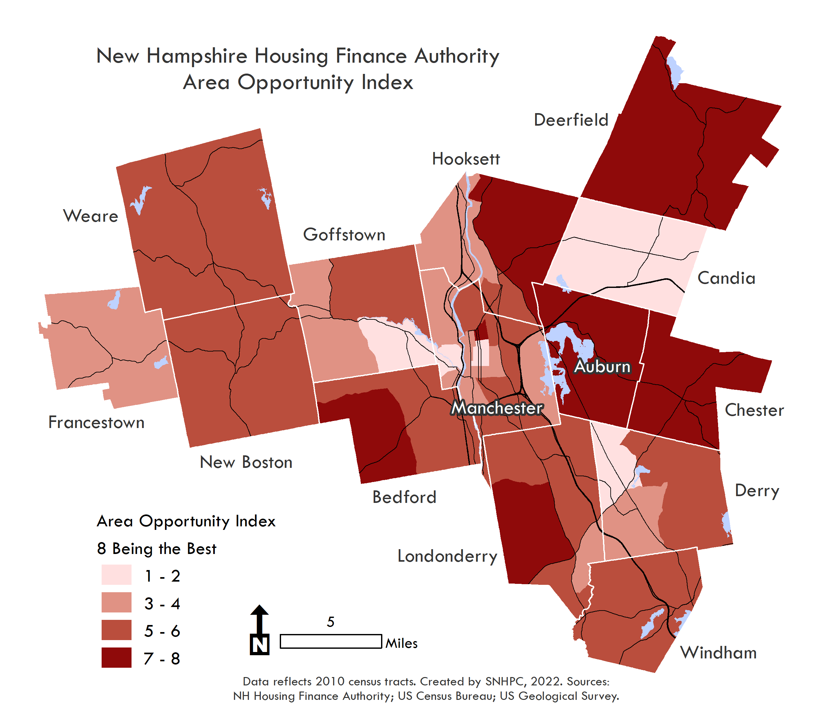
Figure 31: New Hampshire Housing Finance Authority Area Opportunity Index

Framing approaches to access
The 2020-2024 Manchester, NH Analysis of Impediments to Fair Housing Choice identifies seven impediments to fair housing with proposed actions.
- Insufficient Quality Affordable Housing
One proposed action is to continue balancing funding between the revitalization of impacted areas and the creation of new affordable housing in non-impacted areas. Other actions focus on education around rental assistance programs and lead hazards as well as providing support to prevent homelessness. Mixed use developments in commercial areas are encouraged to allow people to live near transit lines and employment centers.
- Crime and Safety
Proactive policing measures and neighborhood watch groups are proposed actions that could benefit inner city neighborhoods, suburban and rural areas.
- Housing Options for the Homeless/At-Risk of Homeless
In Manchester, continuing community partnerships and funding for housing assistance and services can help prevent homelessness for families and individuals.
- Language and Cultural Barriers
- Insufficient Fair Housing Information, Training, Education and Outreach
- Insufficient Public Transportation and Services Outside the Center City Discrimination Practices

Section VII – Housing Toolkit
This section offers specific implementable/actionable recommendations, opportunities and approaches communities can utilize to plan for housing. Topics addressed in this section should include municipal impacts of housing and initiatives, nonprofit and private property owner activities to promote housing options, strategies which engage employers and address the link between worker and housing shortages, and inter-municipal approaches to address regional housing issues. The use of examples/case studies of innovative housing policies, regulations, and developments which address housing needs of different subpopulations/communities of interest is encouraged. Inclusion of the role of public outreach and engagement in implementing solutions is encouraged.

Section IX - Conclusions
Conclusion and Outline for Next Steps:
Approximately eight years ago, the Housing Chapter of the Regional Comprehensive Plan for 2015 was adopted and the title of the work was, Moving Southern NH Forward. The conclusion of that effort stated the following:
The overarching theme of the input received throughout the Granite State Future process was the Southern New Hampshire region is a convenient and desirable place to live, work and play. There are many characteristics that draw people to our region, including the proximity to the mountains, the coast, the City and to numerous recreational opportunities. While there are many opportunities in the region, there are also a number of challenges surrounding housing choices, opportunity and affordability. Local government, regional organizations and the State can play a large role in assisting the needs of housing in the region.
Much of this statement still rings true: the communities within the SNHPC region are desirable places to live, work, and play. There is much within the region that keeps people here and that draws new neighbors and businesses to our communities. The challenges that were listed in 2014: housing choices, opportunity, and affordability, not only persist but according to the data presented throughout this report, have increased in severity.
If you have looked for a home to buy within the last few years, whether for the first time or the last, there are far fewer homes on the market, they are far less affordable, and they sell within hours or days at most. The competition is fierce. If the buyer doesn’t have equity to put towards the purchase, they are at a significant disadvantage. If you are looking to rent in any price range, the choices are almost non-existent.
How do we as a state attract a workforce to fill the many vacant positions that exist in almost every industry? Lines at the grocery stores are longer because of the shortage of cashiers, restaurants are closed more often than their owners care to be because cooks and servers are hard to come by, and try hiring a plumber, electrician, or carpenter-- it’s near impossible. Although the latter may be more than a housing issue, housing for the service industry and most young adults wanting to begin their career is extremely challenging.
We know from the various surveys and outreach efforts conducted in 2022 that opinions vary regarding housing: locally and regionally. (See Appendix B) The following highlights some of the findings of those surveys.
For developers there was general agreement that market conditions favor larger-scale projects such as multi-family, but that opposition by residents were a barrier as well as over-burdened planning and zoning boards.
For social service providers, 89% reported that demand of units exceeds or greatly exceeds supply and 82% said there has been an increase in housing challenges since the start of the COVID-19 pandemic. It was reported that those who have the hardest time keeping and finding housing included individuals with mental health issues (32%), low-income families (30%), those with substance use disorder (25%), and families with children/ single parents (22%).
Residents had multiple opportunities to provide input, both via surveys as well as in virtual community conversations. One of the many questions asked was, when thinking about housing in your community, please indicate your level of agreement with the need for additional units for each stated housing type. As shown in Figure 27, participants indicated that moderate and low-income, rental and senior housing are the most needed.
Figure 32: General Public Survey Response on level of agreement for housing types

Many of the people participating in the survey shared their stories, here are just a few that explain how they ended up in their present living conditions:
Forced to buy and build due to lack of available inventory and soaring housing prices and mortgage rates.
We were expecting a baby and wanted a bigger and nicer apartment, as we were not able to buy a house with all the buying competition. We know we were very lucky to find our current apartment and intend to be there for many years.
Our lease was up and we couldn’t find an affordable house to buy. We ended up renting again. Our preference would have been to purchase a single-family home in Concord and surrounding towns.
Applied to lower income housing in the area, was only one in Hooksett that had availability and been here for over 3 years now.
I lived in a rural area where rent was affordable until a rent increase. I moved to the city where I rented an apartment on the third floor with lower rent. During the 4 years I have lived there the rent increased without any upgrades or repairs. My rent is above what I can afford to live comfortably. I am now being evicted so the landlord can do renovations. There are a few apartments available for my needs but they are at or above the rental cost that I am paying now. There is no adequate housing for fixed income (SSI, Disability, Single Adults with or without children) recipients.
Had to move up for my job and couldn’t find a liveable place to buy within our budget. Took a place “just for now” and have been stuck here for 2 years paying almost half my salary and can’t find anyplace cheaper. Developers need to stop buying rental houses so that people can actually afford houses of their own.
I am living with an abusive partner. I have to remain in this situation because I can’t find housing I can afford AND in an area I would feel safe being on my own.
Worked nights as a laborer until I could afford to go to grad school full time from rural NH - moved to Manchester to a tenement after becoming enrolled. Stayed in the same studio despite significant income increases due to lack of reasonable alternatives that wouldn't eat up a huge chunk of income gains.
We could not find a reasonable single-family home so we decided to rent. We’ve been searching for over three years being out bid many times by cash buyers.
When my sons and grandkids were evicted my husband and I had to go too. They are still homeless Manchester will not help to get them affordable housing.
It was the only apartment we could find that we could even close to afford. We planned to get a roommate but were unable to find one due to COVID. So now we pay 35% of our income toward rent.
I left an abusive relationship with my kids and had nowhere to live. We are staying in a small hotel room until we can find housing, which is proving to be virtually impossible.

Going back to the conclusion in 2014, a thorough and very thoughtful list of goals and recommendations were provided. The topics and calls to action are outlined here:
Goal 1: Encourage development of a variety of affordable housing choices in every community of the region
This was to be accomplished through incentives for investment in reuse and redevelopment of existing structures, through the allowance of cluster housing, through the creation of walkable “village neighborhood” development to enhance employment and housing opportunities, and through more expansive single-family zoning definitions which would allow for flexible multi-generational housing, in-law and accessory apartment living arrangements. Finally, zoning ordinance reviews were to be conducted and recommendations to provide for workforce housing were to be developed.
Goal 2: Develop and implement a comprehensive public outreach campaign to increase education and training opportunities for fair housing and housing needs in the region
This was to be accomplished through educational workshops and training sessions on housing resources, law and fair housing issues, through the development of “best practices” resource guide that highlights what other states are doing to encourage/incentivize/require affordable housing, such as 40-B in Massachusetts, and through an education effort for local officials and residents on the differences between manufactured and mobile homes, and through the promotion of “inter-generational communities”.
Goal 3: Work to address statewide housing issues impacting the Southern NH region
This was to be accomplished through an effort to balance existing HUD entitlement funding between the revitalization of impacted areas (those with housing problems, minority and/or low-income concentrations) and the creation of new affordable housing in non-impacted areas, and through encouragement of public transportation services of all forms including Rideshare.
Goal 4: Monitor statewide, regional and local trends to ensure housing needs are being met
This was to be accomplished through encouraging communities to conduct a spatial inventory of where development was occurring, as well as an inventory of affordable housing units, through a Regional Housing Needs Assessment to determine where regional cooperation was needed in order to meet housing needs, and through working with NHHFA to incorporate statewide trends, results and data into regional analysis in order to guide regional and local recommendations and plans.
Next Steps for communities:
Each community in the region might consider conducting their own scorecard on how they have or haven’t addressed these goals. Some may wonder if the goals are still relevant, if the situation calls for more immediate action, or if there are newer more urgent means to address these goals.
It took several staff a year to coordinate, analyze, engage, research, and consider the housing needs within the SNHPC region. The subject has been the focus of local, regional and state committees and councils. Considering 2023 will be the year each region in the state will be updating their regional plans, which will include a pilot program to address issues realized during this housing needs assessment, it may be worthwhile to take on the task of evaluating and updating this list, and creating a reasonable yet effective approach and call to action for addressing housing needs.
LOW HANGING FRUIT: The work, guidance, and allowances provided by Planning Boards, Zoning Boards, and Community Planners is critical in how the development community can respond to the housing crisis. Within the toolkit are numerous implementable ideas that these key stakeholders can utilize. Some specific ideas include:
- Begin with community goals in mind:
  - Update the Master Plan and ensure community engagement and input guides master plan recommendations.
  - Conduct a regulation assessment and identify roadblocks.
  - Ensure the community’s Master Plan is in sync with zoning and other land use regulations.
- Create flexibility in regulations:
  - Utilize the Conditional Use Permit method to allow for case-by-case considerations.
  - Support incentives for investment in reuse and redevelopment of existing structures. Increase density allowances and allow soils-based methodologies to verify density distribution. Consider starting out with minimal allowances such as adding the allowance for duplexes where presently only single-family homes exist.
  - In-fill development is typically difficult. Often open lots are in the oldest portion of a community, and those existing businesses and homes were built prior to zoning. Provide allowances whereby in-fill development can match the abutting property setbacks and instead place the emphasis on ensuring neighborhood character is matched or enhanced.
- Consider the needs of the community:
  - Encourage and promote employer-based housing.
  - Create Age-friendly housing and neighborhoods by ensuring homes and subdivisions are accessible to people of all ages and abilities.
  - Encourage walkable “village neighborhood” development to enhance employment and housing opportunities.
- Take small steps toward increasing density:
  - Expanding ADU allowances to allow detached ADUs.
  - Base density on science utilizing soil-based equations to verify the land can handle the use.
  - Encourage more expansive single-family zoning definitions which would allow for flexible multi-generational housing, in-law and accessory apartment living arrangements.
- Share with the development community what type of development the community wants:
  - Research what other communities in New Hampshire are doing and see examples of housing being built in the state.
  - Consider developing a visual guide for developers to show them the types of housing that the various members of your community would like to see built.

Appendix A – Glossary of Terms

Appendix B – Engagement Process
Found Here: N:\Housing\HousingNeedsAssessment\2021 Housing Needs Assessment\Outreach\PDFs for Appendix B\RHNA Appendix B.docx

Appendix B.1 – Engagement Documentation

Appendix C – Quantitative Data

Appendix D – Qualitative Data

Appendix E – Regional Housing Entities and Services

This report makes extensive use of US Census Bureau data. The main sources for these are the decennial census and the American Community Survey. These two sources use very different methodologies and may at times disagree with each other. At the time of the release of this report, most 2020 decennial results had not yet been released. The American Community Survey is released annually in 1-Year and 5-Year editions. As it is a survey and therefore extrapolates a sample to the larger population, margins of error can be significant. Particular caution and skepticism is required when examining the figures for smaller municipalities and populations.
Executive Order 2020-22- An Order Establishing the Council on Housing Stability https://sos.nh.gov/media/qvje3deb/sununu-2020-22.pdf
Council on Housing Stability Strategic Plan 2021-2024 https://nhchs.org/wp-content/uploads/2021/07/Council-on-Housing-Stability-2021%E2%80%942024-Strategic-Plan.pdf
A Wealthless Recovery? Asset Ownership and the Uneven Recovery from the Great Recession https://www.federalreserve.gov/econres/notes/feds-notes/asset-ownership-and-the-uneven-recovery-from-the-great-recession-20180913.htm
U.S. Department of Housing and Urban Development Annual Homeless Assessment Report https://www.huduser.gov/portal/datasets/ahar.html
A Wealthless Recovery? Asset Ownership and the Uneven Recovery from the Great Recession https://www.federalreserve.gov/econres/notes/feds-notes/asset-ownership-and-the-uneven-recovery-from-the-great-recession-20180913.htm
Most Americans Say There Is Too Much Economic Inequality In The U.S., But Fewer Than Half Call It A Top Priority https://www.pewresearch.org/social-trends/2020/01/09/trends-in-income-and-wealth-inequality/
https://www.snhpc.org/
ABLE NH 2021 Disability Housing Survey Report: A Severe Crisis is Upon Us https://www.ablenh.org/wp-content/uploads/2022/03/Housing-Survey-Report-FINAL-2021.pdf
Where We Live, Where We Age: Trends in Home and Community Preferences https://www.aarp.org/research/topics/community/info-2021/2021-home-community-preferences.html
A Home for Everyone: A 10-Year Plan to End Homelessness in the City of Manchester https://www.nhceh.org/wp-content/uploads/2012/01/2008MANCPLAN.pdf
Incarceration Trends in New Hampshire https://www.vera.org/downloads/pdfdownloads/state-incarceration-trends-new-hampshire.pdf
Religious Landscape Study https://www.pewresearch.org/religion/religious-landscape-study/state/new-hampshire/
Adult LGBT Population in the United States https://williamsinstitute.law.ucla.edu/wp-content/uploads/LGBT-Adult-US-Pop-Jul-2020.pdf
How Many Adults and Youth Identify As Transgender In The United States? https://williamsinstitute.law.ucla.edu/wp-content/uploads/Trans-Pop-Update-Jun-2022.pdf
LGBTQ Equity and Housing Fact Sheet https://www.opportunityhome.org/resources/lgbtq-rights-and-housing-fact-sheet/
Title 42 - The Public Health and Welfare https://www.govinfo.gov/content/pkg/USCODE-2016-title42/html/USCODE-2016-title42-chap45-subchapI.htm
Southern New Hampshire Planning Commission Equity Analysis Report https://www.snhpc.org/about-snhpc/files/snhpc-regional-transportation-equity-analysis-aug-2022
New Hampshire’s Workforce Housing Law https://www.nhhfa.org/wp-content/uploads/2019/06/NH_Workforce_Housing_Law_Summary.pdf
New Hampshire’s Workforce Housing Law https://www.nhhfa.org/wp-content/uploads/2021/12/Workforce-Housing-Law-Report-12.2021.pdf
Recent reports document New Hampshire’s struggle with home affordability https://www.nhbr.com/recent-reports-document-new-hampshires-struggle-with-home-affordability/
Reinventing Construction: A Route to Higher Productivity https://www.mckinsey.com/~/media/mckinsey/business functions/operations/our insights/reinventing construction through a productivity revolution/mgi-reinventing-construction-executive-summary.pdf
Accessory Dwelling Units https://www.nhhfa.org/housing-challenges-solutions/accessory-dwelling-units/
NH RSA 679 http://www.gencourt.state.nh.us/rsa/html/LXIV/679/679-mrg.htm
Title LXIV Planning and Zoning Chapter 679 Housing Appeals Board http://www.gencourt.state.nh.us/rsa/html/LXIV/679/679-mrg.htm
Title LXIV Planning and Zoning Chapter 674 Local Land Use Planning and Regulatory Powers https://www.gencourt.state.nh.us/rsa/html/LXIV/674/674-17.htm
Title XXXI Trade and Commerce Chapter 354-A State Commission for Human Rights http://www.gencourt.state.nh.us/rsa/html/XXXI/354-A/354-A-15.HTM
Title LXIV Planning and Zoning Chapter 674 Local Land Use Planning and Regulatory Powers http://www.gencourt.state.nh.us/rsa/html/lxiv/674/674-mrg.htm
Title V Taxation Chapter 79-E Community Revitalization Tax Relief Incentive http://www.gencourt.state.nh.us/rsa/html/v/79-e/79-e-mrg.htm
Title XVII Housing and Redevelopment Chapter 204-C Housing Finance Authority https://gencourt.state.nh.us/rsa/html/XVII/204-C/204-C-mrg.htm
http://www.harmonyhomesnh.com/
New Hampshire House Bill (HB) 1661: Summary of Changes Table https://www.nh.gov/osi/resource-library/legislation/documents/hb-1661-summarytable.pdf
Title XII Public Safety and Welfare Chapter 162-K Municipal Economic Development and Revitalization Districts https://www.gencourt.state.nh.us/rsa/html/XII/162-K/162-K-mrg.htm
NH Monthly Indicators https://www.nhar.org/assets/pdf/marketdata/NHAR_MMI_2022-09.pdf
NH Housing Finance Authority’s Housing Market Report https://www.nhhfa.org/wp-content/uploads/2022/06/NH-Housing-Market-Report-06-2022.pdf
Pandemic and Future Shocks https://www.keystothevalley.com/report/pandemic-future-shocks/
Workforce Issues Exacerbated By the Pandemic https://indepthnh.org/2021/07/04/workforce-issues-exacerbated-by-the-pandemic/
State of New Hampshire’s Multi-Hazard Mitigation Plan https://prd.blogs.nh.gov/dos/hsem/wp-content/uploads/2015/11/State-of-New-Hampshire-Multi-Hazard-Mitigation-Plan-Update-2018_FINAL.pdf
https://www.snhpc.org
As Climate Change Drives Migration To N.H., Towns Face Tension And Opportunity | WBUR News https://www.wbur.org/news/2021/01/12/new-hampshire-climate-migrants
Home-building costs rise at ‘unprecedented rate,’ Bank of America says. These materials are proving particularly expensive https://www.marketwatch.com/story/the-cost-to-build-a-home-in-the-u-s-has-risen-at-an-unprecedented-rate-bank-of-america-says-11654897304
Rapidly Rising Building Materials and Freight Prices Push Construction Costs Higher https://eyeonhousing.org/2022/06/rapidly-rising-building-materials-and-freight-prices-push-construction-costs-higher/
Worker Shortages Weighing on the Construction Industry https://crg-nh.com/new-england-construction-2/worker-shortages-construction-industry/
How Severe is the Construction Industry’s Labor Shortage? https://jonaspremier.com/how-severe-is-the-construction-industrys-labor-shortage/
The State We’re In: NH Labor Shortage and how the ‘I Build New Hampshire’ initiative could help https://manchesterinklink.com/the-state-were-in-nh-labor-shortage-and-how-the-i-build-new-hampshire-initiative-could-help/
https://www.airdna.co/
Affordable Housing and the Impact of Short-Term Rentals https://mrsc.org/stay-informed/mrsc-insight/december-2021/affordable-housing-and-the-impact-of-short-term-re
The Role Student Housing Plays in Communities https://shelterforce.org/2019/09/06/the-role-student-housing-plays-in-communities/
“Big Houses, Small Households: Perceptions, Preferences and Assessment” https://www.nhhfa.org/wp-content/uploads/2019/06/BigHouses_SmallHouseholds.pdf
State of New Hampshire State, County, and Municipal Population Projections: 2020-2050, Robert Scardamalia RLS Demographics, Inc. and New Hampshire Department of Business and Economic Affairs https://www.nh.gov/osi/data-center/population-projections.htm
The 2020 headship ratio is required for the calculation of the number of future households. Since household sizes vary depending on the age of the people that make them up (e.g., larger households are more likely to be composed of people of child bearing age partners and their children), the age distribution in the future will help to determine the total number of house units needed.
US EPA. 2014. Smart Growth and Economic Success: Benefits for Real Estate Developers, Investors, Businesses and Local Governments. https://www.epa.gov/sites/default/files/documents/smart_growth_and_economic_success.pdf.
see Real Estate Research Corporation. 1974. The Cost of Sprawl: Environmental and Economic Costs of Alternative Residential Development Patterns at the Urban Fringe. https://pdxscholar.library.pdx.edu/cgi/viewcontent.cgi?article=1025&context=oscdl_planning; Burchell, Robert W. et. al. 1989. Transportation Cooperative Research Program Report 39: The Cost of Sprawl Revisited. https://www.trb.org/Publications/Blurbs/153808.aspx; Carruthers, John I et. al. 2003. "Urban Sprawl and the Cost of Public Services". Environment and Planning B: Urban Analytics and City Science, vol. 30. https://doi.org/10.1068%2Fb12847; Muro, Mark et. al. 2004. Investing In A Better Future: A Review of the Fiscal and Competitive Advantages of Smarter Growth Development Patterns. The Brookings Institution. https://www.brookings.edu/wp-content/uploads/2016/06/200403_smartgrowth.pdf; US EPA. 2012. Smart Growth And Economic Success: Benefits For Real Estate Developers, Investors, Businesses, And Local Governments. https://www.epa.gov/sites/default/files/documents/smart_growth_and_economic_success.pdf.
Municipal Land Use Regulation Annual Survey https://www.nh.gov/osi/planning/services/mrpa/land-use-survey.htm
Arthur C. Nelson et. al. 2022. Rational for Smart Growth Fiscal Impact Analysis and Model Fiscal Impact Assessment Ordinance. Smart Growth America. https://smartgrowthamerica.org/wp-content/uploads/2022/06/Rationale-for-Smart-Growth-Fiscal-Impact-Analysis-and-Model-Fiscal-Impact-Assessment-Ordinance.pdf
Housing and Transportation (H+T®) Affordability Index https://htaindex.cnt.org/
Housing and Transportation (H+T®) Affordability Index https://htaindex.cnt.org/
Location Affordability Index https://www.hudexchange.info/programs/location-affordability-index/
Southern New Hampshire Planning Commission. 2021. 2021-20245 Metropolitan Transportation Plan. https://www.snhpc.org/sites/g/files/vyhlif5006/f/uploads/snhpc_mtp_adopted_fy21-45.pdf.
New Hampshire First State to Implement Broadband Expansion https://www.governor.nh.gov/news-and-media/new-hampshire-first-state-implement-broadband-expansion
NH Child Care Desert Map https://www.nh-connections.org/communities/nh-child-care-desert-map/
Does New Hampshire Have Food Deserts? https://www.seacoasteatlocal.org/does-new-hampshire-have-food-deserts/
Healthy Food Access https://www.healthyfoodaccess.org/about-portal-partnership
Public Parks and Social Equity https://sportsfacilities.com/public-parks-and-social-equity/#:~:text=The%20Benefits%20of%20Public%20Parks%20to%20Communities
New Hampshire Commission for Human Rights https://www.nh.gov/hrc/decisions/year.html
Manchester, NH Analysis Of Impediments To Fair Housing Choice https://www.manchesternh.gov/Portals/2/Departments/pcd/CIP/AnalysisofimpedimentstoFairHousingChoices-Final.pdf
New Hampshire Housing Finance Authority. 2014. Fair Housing for Regional and Municipal Planning A Guidebook for New Hampshire Planners. https://www.nhhfa.org/wp-content/uploads/2019/06/Fair_Housing_Guidebook.pdf
Spotlight on Underserved Markets, Affordable Housing in High Opportunity Areas https://mf.freddiemac.com/docs/Affordable_Housing_in_High_Opportunity_Areas.pdf
Spotlight on Underserved Markets, Affordable Housing in High Opportunity Areas https://mf.freddiemac.com/docs/Affordable_Housing_in_High_Opportunity_Areas.pdf

